3rd International Conference

on Forensic Research & Technology

May 17-18, 2021 | Singapore

Abstract Template

Title: Monitoring cryptocurrencies exchanges to trace cybercrime activities
Eric Bärenzung

Abstract Body (up to 250 words)
Cybercrime is a growing threat. No industry is safe from such threat, in particular ransomware that represented about a quarter of the cyberattacks in 2020 .With the exploding double-extortion ransomware attack, the attackers demand a ransom not just to decrypt the stolen data but to refrain from releasing it publicly.
Cybercriminals are more and more often asking for payment though bitcoins. With an increasing bitcoin price, the number of ransomware infections is expected to explode in 2021.
How to trace these payments to collect evidence on the cybercrime organizations behind these?
This presentation is providing an introduction to the topic:
- The cryptocurrency market related to cybercrime activities
- A technical overview on how cryptocurrencies exchange is working
- How can investigators trace transactions?
- The challenges
- Some tools and companies providing such solutions and services.

Image
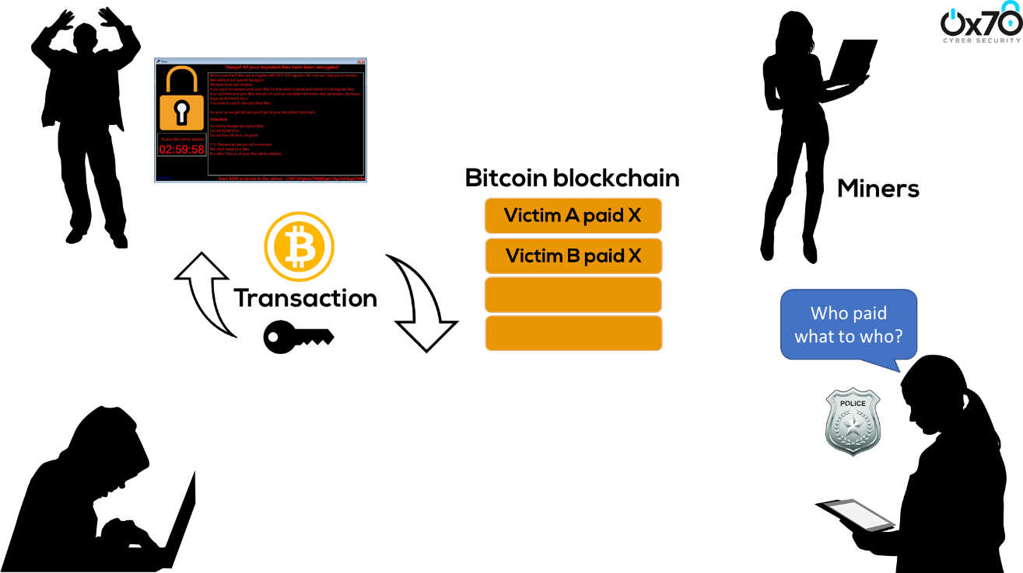

Biography (Up to 100 words)
Over the last thirty years, Eric Bärenzung has worked across four continents on delivering large scale projects among other roles. From aeronautics to PayTV industry, including retail, he moved to the cybersecurity domain in 2014.
Eric Bärenzung participated to different International Telecommunication Union (ITU) cybersecurity related events, in particular on IoT security. He also spoked at events such Africacom (South Africa) and CyberSecure (Nigeria) on European GDPR.
Since 2018, Eric is a senior cybersecurity consultant in the financial services industry.

Research interest: Forensic cybersecurity / cryptocurrency / blockchain

Presenting author details
Full Name: Eric Bärenzung
Contact number: +3378804188 (for organizers only)
Twitter account: @EricBarenzung
Linked In account: hhttps://www.linkedin.com/in/ericbaerenzung/
Session name/ number:
Category: (Oral presentation/ Poster presentation): Oral
Passport Number:

