Title: High Voltage Suicidal Electrocution

Sharma R¹, AB Khalifa²,

¹Department of Forensic Medicine, Forensic Centre, Ministry of Interior, Doha, Qatar
²Department of Forensic Medicine, Forensic Centre, Ministry of Interior, Doha, Qatar

Keywords: High Voltage, Electrocution, thermal burns, Streamlined nuclei, Depression, blunt injuries.

- Abstract Body (up to 250 words)
In the world vast majority of cases of deaths due to electrocution are accidental. Suicidal electrocution and that too by high voltage is one of the rarest methods adopted for the purpose. We report the case of a 36-year-old male who committed suicide by climbing up a 10-meter-tall electric tower carrying live cables of high voltage of 40,000 volts. He was found lying dead on the ground with multiple burns all over the body, and with multiple blunt injuries. Examination and Autopsy revealed multiple burns with charred, thickened skin, singed hairs and underneath coagulation of tissues and muscles over various areas of the body. Underlying adipose tissue was melt and oily liquid was seen. Signs of trauma as multiple lacerated wounds and fractures of skull, face, ribs and right upper limb were seen but they did not contribute to the cause of death. Histopathology from skin tissues over multiple burnt sites confirmed the loss of epidermis, with collagen in epidermal and subepithilial layers with elongation of nuclei “stream of nuclei”. Features were consistent with changes induced by electrical burns. These atypical findings on the body can be explained by the proximity to electric arc produced by high voltage current and the electromagnetic field generated by it. Police investigations showed that the deceased was under severe depression because of his personal problems. The method adopted and the findings make this case a rare scientific report.

- Image:

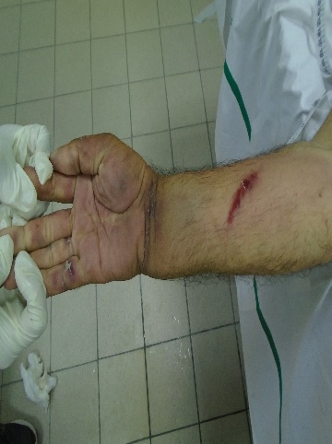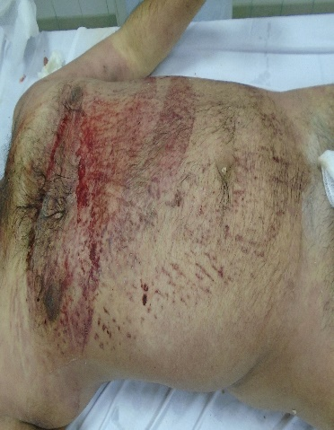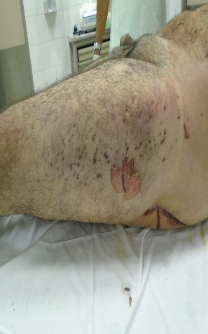

- Reference:

- Vij K. Death of electrocution. In: Vij K,ed. Textbook of Forensic Medicine and Toxicology.4th ed. New Delhi, India: Elsevier;2008:232-240.
- Khandekar I,Tirpude BH,Murkey PN,et al. Suicide by electrocution with high voltage current: an unusual way of suicide.J Indian Acad Forensic Med.2008;30:145-148
- Das S,Patra AP,Shaha KK ,Sistla, SC,Jena MK,etal. High Voltage Suicidal electrocution with multiple exit wounds. Am Forensic Med Pathol.2013;34:34-37

- Biography:
- Dr. Rajeev Sharma has received his post-graduation in Forensic Medicine and Toxicology from Lady Harding Medical College, Delhi and also obtained degree in Law from Delhi University, India. His role has been instrumental in many high profile Forensic Cases. He has undertaken several thousand autopsies and received extensive training abroad in managing wide range of Forensic cases related to natural, unnatural deaths and other medico-legal scenarios. He has been a teaching faculty to both undergraduate and postgraduate medical students and has published numerous papers and articles in the national and international journals of repute. He has served as teaching faculty in both Government and private Medical colleges of India and of late has been working as Senior Forensic Physician with Ministry of Interior, state of Qatar.

- Dr. Anis Ben Khalifa has received his post-graduation in Forensic Medicine from both Tunisian Ministry of Public Health and Monastir University - Tunisia and also obtained degree of Clinical Toxicology from Louis Pasteur University of Strasbourg, France. His role has been forensic practitioner in many high profile cases and has undertaken several thousands of different kinds of autopsies in different Governmental Hospitals in Tunisia and of late has been working as Consultant Forensic Medical with Ministry of Interior of State of Qatar .He has been a teaching faculty to high schools of Police to both undergraduate and postgraduate medical students and officers of Police. He has published numerous papers and articles in the National and International Journals of repute.

- Presenting author details


Full Name: Dr Rajeev Sharma
Contact number: +97433025745
Twitter account: @ Dr RajeevSharm18
Linked In account: Dr Rajeev Sharma
Session name/ number:-
Category: (Oral presentation/ Poster presentation)- Poster presentation
Passport Number: Z2401681
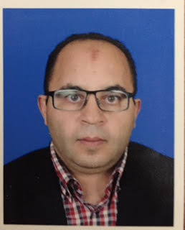
Full Name: Dr Anis Ben Khalifa
Contact number: +97455081588
Twitter account: NA
Linked In account: NA
Session name/ number:-
Category: (Oral presentation/ Poster presentation)- Poster presentation
Passport Number: X201698

