Abstract Template

Title: To study the difference between three types of tears: using Reverse Phase- High Performance Liquid Chromatography (RP-HPLC)

Anshumali M. Gaikwad¹, Romila Lemos², Dr. Sopandeo N. Kharat³
¹Department of DNA, Directorate of Forensic Science Laboratories, Hans Bhugra Marg, Kolivery Village, Yashwant Nagar, Kalina, Santacruz East, Mumbai-400098,
(Maharashtra-India).

²Department of Biology, Institute of Forensic Science, 15, Madame Cama road,
Mumbai-400032 (Maharashtra-India).

³Department of Botony, The Institute of Science, 15, Madame Cama road, Mumbai-400032 (Maharashtra-India).

Abstract:
The precorneal film present on the human ocular surface constantly does the function of keeping the eye orbit moist and lubricated. The precorneal film has three layers; mucin layer, aqueous layer and lipid layer. Each layer is dependent on each other to keep human eye immune and together mixture of components. These chemical components get secreted in the precorneal film at a constant rate under normal condition known as Basal tears or continuous tears and gets altered when subjected to reflexes, known as Reflex tears. Humans project their thoughts in the form of lacrimation (crying), in either a positive way or negative way, known as Emotional (psychic) tears. As each type of tear shed, are spilled on subjection to various stimuli, will change chemicals in each tear and this fact has formed the base of this study, to differentiate tears on the basis of concentration of ascorbic acid present and test this hypothesis by using statistics parameters, which on completion of this experiment was found to be true and significantly different.
Keywords: Precorneal film, Basal tears, Reflex tears, Emotional tears, mucin, lipid, proteins, ascorbic acid, HPLC.

Images:
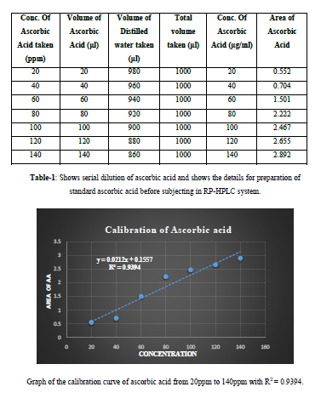
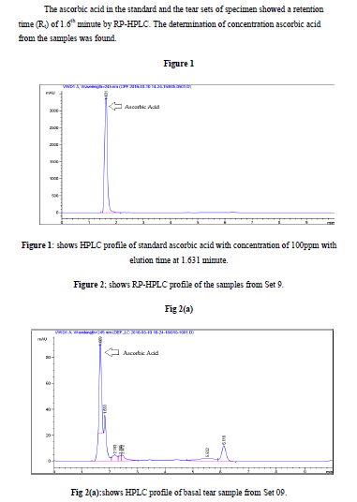
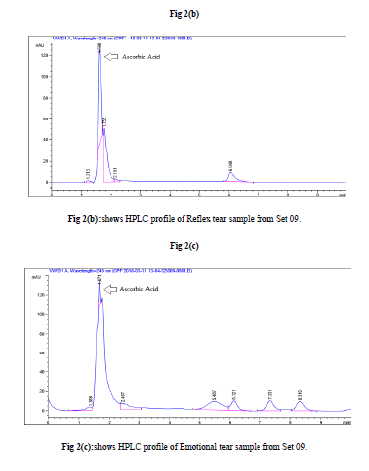
Presenting author details:
Full Name | Contact number | E-mail Id | Session name/ number | Category
¹Ms. Anshumali Mauti Gaikwad | +917208245070/ 9096161072 | ansgaikwad15@gmail.com | Forensic Science | Oral presentation
²Ms. Romila Lemos | +917219146721 | romilalemos@gmail.com | --- | ---
Mr. Sopan N. Kharat | +918275931166/ 7021853326 | sopankharat@gmail.com | --- | ---

References:
1) “The Total Osmotic Pressure of Tears in Normal and Various Pathologic
Conditions”.Gary j. Mastman, (MD); Edward J. Baldes, (PhD), and John W.
Henderson, (MD), Rochester, Minn.Volume 65, April 1961, 71-74.
(http://archopht.jamanetwork.com/ by a University of California - San Diego).
2) “Methionine-Enkephalin and Leucine-Enkephalin in Human Sympathoadrenal
System and Pheochromocytoma”. TakaakiYoshimasa, Kazuwa Nakao, Hitoshi
Ohtsuki, Shozo Li, and HirooImura. The American Society for Clinical
Investigation; Volume 69; March 1982; 643-650.
3) “Origin and Biosynthesis of Human Tear Fluid Proteins”. Peter T Jonssen and O.Paulvan Dijsrerveld Investigative Ophthalmology & Visual Science; Volume 24, May 1983, 623-630.

4) “Lactoferrin levels in normal human tears”. A. Kijlstra, S. H. M. Jeurissen, and K. M. Koning. British Journal of Ophthalmology; Volume 67, 1983, 199-202. DOI: 10.1136/bjo.67.3.199 http://bjo.bmj.com/content/67/3/199.

5) “Dynamics of ocular surface pH”. William H. Coles and Patricia A. Jaros.
British Journal of Ophthalmology, Volume 68, 1984, 549-552.

6) “Biological variations of lysozyme concentration in the tear fluids of healthy
persons”. D. K Sen and G. S Sarin. British Journal ofOphthalmology, Volume 70,
1986, 246-248.

7) “Ascorbic acid and the eye with the special reference to the lens”. ShambhuVerma.
Department of Ophthalmology, University of Maryland School of Medicine,
Baltimore. Annals of the New York Academy of Sciences, February 1987, 280-304.
Impact Factor: 4.38 DOI: 10.1111/j.1749-6632.1987.tb23768.x · Source: PubMed

8) “Electrophoresis combined with immunologic identification of human tear proteins.”
P.K Coyle, Pattrick. A Sibony, and Cynthia. Johnson. Investigating ophthalmology
and Visual Science,Vol. 30, No. 8, August 1989, 1872-1882.

9) “Protein Levels in Non-stimulated and Stimulated Tears of Normal Human
Subjects”. Roderick J. Fullard and Christopher Snyderj. Investigative Ophthalmology
& Visual Science, Vol. 31, No. 6, June 1990, 1119-1126.

10) “Changes in Human Tear Protein Levels with Progressively Increasing Stimulus”
Roderick J. Fullard and Denise L. Tucker. Investigative Ophthalmology & Visual
Science, Vol. 32, No. 8, July 1991, 2290-2300.

11) “SDS-Mini-gel Electrophoresis of Human Tears (Effect of Sample Treatment on
Protein Patterns)” Ab Kuizenga, Nicolaas J. Van Haeringen, and AizeKijlsfraf
Investigative Ophthalmology & Visual Science, Vol. 32, No. 2, February 1991, 381-
386.

12) “Post-mortem chemistry update Emphasis on Forensic application.” John Coe. The
American journal of forensic medicine and pathology,Vol.14, No. 2, 1993, 91-110.

13) “The Psychophysiology of Crying”. James J. Gross, Barbara L. Frederickson and
Robert W. Levenson. Psychophysiology, Vol. 31, 1994, 460-468.

14) “Fibronectin in the Tear Film.”Masahiko Fukuda, Roderick J. Fullard, Mark D. P.
Willcox, Cristina Baleriola-Lucas, FakhryBestaxvros, Deborah Sweeney, and Brien
A. Holden. Investigative Ophthalmology & Visual Science, Vol. 37, No. 2, February
1996, 459-466.

15) “Methods in Biostatistics for Medical Students and Research Workers.” B. K
Mahajan, 6th Edition, Jaypee Brothers Medical Publishers (P). Ltd. 1997, 131-151,
329.

16) “Water soluble antioxidants in mammalian aqueous humour: interaction with UV B
and hydrogen peroxide.” Stuart P. Richer and R.C. Rose. Vision Research, Vol. 38,
1998, 2881–2888.

17) “Origin and types of emotional tearing.” J. Murube, L. Murube, A. Murube
European Journal of Ophthalmology, Vol. 9, No. 2, 1999, 77-84.

18) “Ascorbic Acid Concentration and Total Antioxidant Activity of Human Tear Fluid
Measured Using the FRASC Assay.”CamusKar Man Choy, Iris Frances Forster
Benzie, and Pauline Cho. IOVS, Vol. 41, No. 11, October 2000, 3293-3298.

19) “Water-Soluble Antioxidants in Human Tears: Effect of the Collection Method.”
Camus Kar Man Choy, Pauline Cho, Wai-Yuen Chung, and Iris F. F. Benzie.
IOVS, Vol. 42, No. 13, December 2001, 3130-3134.

20) “Detection of Natural Peptide Antibiotics in Human Nasolacrimal Ducts.” Friedrich
P. Paulsen, Thomas Pufe, Ulrich Schaudig, Janka Held-Feindt, Jan Lehmann, Jens-
Michael Schroder, and Bernhard N. Tillmann IOVS, Vol. 42, No. 10, September
2001, 2157-2163.

21) “Male and female tears: Swallowing versus shedding?”Bekker, M. H. J, &
Vingerhoets, A. J. J. M. Adult crying. A bio-psychosocial approach. A. J. J. M.
Vingerhoets, & R. R. Cornelius (Eds.), Vingerhoets, Ad Publication, 2001, 91-114.

22) “Presence of oestrogen receptor type β in human retina.” Carine Munaut, Vincent
Lambert, Agnès Noël, Francis Frankenne, Manuel Deprez, Jean-Michel Foidart,
Jean-Marie Rakic. Br J Ophthalmology 2001; 85: 877–882. DOI: 10.1136/bjo.85.7.877.

23) “Substance P and Its Metabolites in Normal Human Tears.” Masakazu Yamada,
Masaro Ogata, Masataka Kawai, YukihikoMashima, and Teruo Nishida
IOVS, Vol. 43, No. 8, August 2002.

24) “Reflex Tear Ascorbate in Hong Kong Chinese Subjects: Method Comparison and
Biological Variation.” Camus Kar Man Choy (PhD), Pauline Cho (PhD), Wai Yuen
Chung (PhD) and Iris F. Benzie (DPhil).
Optometry and Vision Science, Vol. 80, No. 9, September 2003, 632-636.

25) “The Tear Film.”Raymond E. Records, Chapter-3, Medicinal Ophthalmological
Encyclopaedia, Volume 8, 2003.
(http://80.36.73.149/almacen/medicina/oftalmologia/enciclopedias/duane/pages/v8/v
8c003.html)

26) “Is ascorbate in human tears from corneal leakage or from lacrimal secretion?”
Camus Kar Man Choy BSc(Hons) (PhD) Iris Frances Forster Benziet (MPhil)
(DPhil) FIBMS Pauline Cho (PhD)
Clinical and Experimental Optometry, Volume 87, No. 1, 2004, 24-27.

27) “Crying at the Movies: A Physiological and Emotional Connection.” Paul Glover
(Assistant Professor) Henderson State University, Volume 6, No. 13, 2005, 1-15.

28) “Prodynorphin transcripts and proteins differentially expressed and regulated in the
adult human brain.” Andrej Nikoshkov, Yasmin L. Hurd, Tatiana Yakovleva,Igor
Bazov, ZoyaMarinova, GvidoCebers, Natalia Pasikova, Anna Gharibyan, Lars
Terenius, and Georgy Bakalkin.The FASEB Journal express article
Volume 19, 1543-1545. http://www.fasebj.org/cgi/doi/10.1096/fj.05-3743fje; DOI:
10.1096/fj.05-3743fje

29) “Identification of 491 proteins in the tear fluid proteome reveals a large number of
proteases and protease inhibitor.” Gustavo D‟Silva, LyrisD‟Godoy, Matthis Mann.
Article R72, Genome Biology 2006, Volume 7, No. 8, R72.1- R72.11.
http://genomebiology.com/2006/7/8/R72

30) “Applying Magnetic Bead Separation / MALDI-TOF Mass Spectrometry to Human
Tear Fluid Proteome Analysis.” Eiichi Sekiyama, Yumiko Matsuyama, Daisuke
Higo, Takashi Nirasawa, Masaya Ikegawa, Shigeru Kinoshita, and Kei Tashiro
Journal of Proteomics & Bioinformatics, Volume 01, No. 7, October 2008, 368-373.
www.omicsonline.com

31) “Investigation of the human tear film proteome using multiple proteomic
approaches.”Kari B. Green-Church, Kelly K. Nichols, Nan M. Kleinholz, Liwen
Zhang, Jason J. Nichols, Molecular Vision, Volume 14, March 2008, 456-
470.http://www.molvis.org/molvis/v14/a55

32) “Determination of uric acid concentrations in human tear fluid, aqueous humour and
serum.”JuttaHorwath-Winter, SieglindeKirchengast, Andreas Meinitzer, Christine
Wachswender, Christoph Faschinger and Otto Schmut.
ActaOphthalmol. Volume 87, 2008, 188–192. DOI: 10.1111/j.1755-3768.2008.01215.x

33) “Psychology”Sundra K. Ciccarelli and Glenn E. Meyer. The University of Mumbai
Edition, Chapter- 2, 52-84. Published by Dorling Kindersley (India) Pvt. Ltd.,
Lincensees of Pearson Education in South Asia. Copyright © 2008 Dorling
Kindersley (India) Pvt. Ltd

34) “Tear ascorbic acid levels and the total antioxidant status in contact lens wearers: A
pilot study.”SaiJyothiAluruVenkata, AngayarkanniNarayanasamy, Vidhya
Srinivasan, Geetha Krishnan Iyer, RamakrishnanSivaramakrishnan, Madhumathi
Subramanian, RajeshwariMahadevan. Indian Journal of Ophthalmology. Volume 57.
No. 4, 289-292.

35) “Stress biomarkers in the tear film.” Linda K. Banbury. Southern Cross University
ePublications@SCU October 9, 2009, 16-
22.http://epubs.scu.edu.au/cgi/viewcontent.cgi?article=1119&context=theses

36) “Analysis and Comparison of Proteomic Profiles of Tear Fluid from Human, Cow,
Sheep, and Camel Eyes.” Farrukh A. Shamsi, Ziyan Chen, Jingwen Liang, Kaijun
Li, Ali A. Al-Rajhi, Imtiaz A. Chaudhry, Mingtao Li, and Kaili Wu.
IOVS, Volume 52, No. 12, November 2011, 9156-9165.

37) “Immunohistochemical Detection of Estrogen and Progesterone Receptors in the
Human Lacrimal Gland.” JasminaGligorijević, M. Krstić and GordanaBabić.
Arch. Biol. Sci., Belgrade, Volume 63, No. 2, 2011, 319-324.

38) “Human Tears Contain a Chemosignal.”ShaniGelstein, YaaraYeshurun,Liron
Rozenkrantz, SagitShushan, IdanFrumin, Yehudah Roth, Noam Sobel. Science
Express, 2011, 226-230. DOI: 10.1126/science.1198331.

39) “Detection of Prosecretory Mitogen Lacritin in Non-primateTears Primarily as a CTerminal- Like Fragment” Diane E. Laurie, Rebecca K. Splan, Kari Green, Katherine
M. Still, Robert L. McKown, and Gordon W. Laurie Investigative Ophthalmology &
Visual Science, Volume 53, No. 10, 2012, 6130-6136.

40) “Cell Hydrogen Oxidation.”Thiyagarajanbabu, Chidambaram
IOSR Journal of Dental and Medical Sciences (IOSR-JDMS) e-ISSN: 2279-0853, p-
ISSN: 2279-0861. Volume 8, No. 1, 2013, 10-16.
www.iosrjournals.org

41) “Tear Secretion-A Short Review.” J. Lakshmi. Journal of Pharmaceutical Sciences
and Research, Vol. 6, No. 3, 2014,155-157.

42) “Vitreous Humour: A Short Review on Post-mortem Applications.” Baniak N,
Campos Baniak G, Mulla A and Kalra J BaniakN.Journal of Clinical and
Experimental Pathology. Volume 4, No. 6, 2014, 1-7. DOI:10.4172/2161-0681.1000199

43) “Point-of-service, quantitative analysis of ascorbic acid in aqueous humour for
evaluating anterior globe integrity.” Manas R. Gartia1, Santosh K. Misra1, Mao
Ye1, Aaron Schwartz-Duval, Lisa Plucinski, Xiangfei Zhou, David Kellner, Leanne
T. Labriola&Dipanjan Pan. 2015, 1-12.
www.nature.com/scientificreports/2015. http://www.nature.com/articles/srep16011

44) “Extensive characterization of human tear fluid collected using different techniques
unravels the presence of novel lipid amphiphiles” Sin Man Lam, Louis Tong, Xinrui
Duan, Andrea Petznick, Markus R. Wenk, GuanghouShui. Journal of Lipid research.
Web access: 25thNovember, 2015. www.jlr.org

