Role of soil fertility management and biochar on crop yield, quality and food safety
USE OF BIOCHAR TO INCREASE
SOIL FERTILITY AND MORE CROP PRODUCTION
Image

Pravin Patel¹ Professor, PhD, Parul University, India
Vikram Parmar² Asstt.Prof.PhD, Parul University, India.
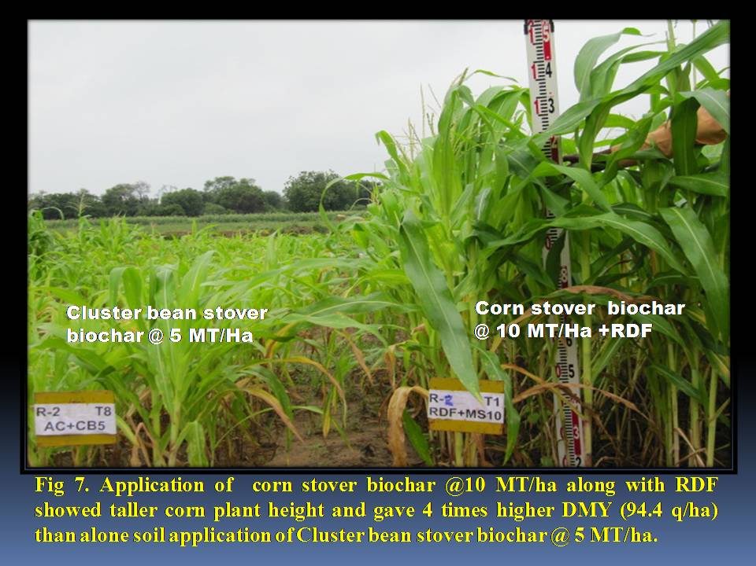

Abstract (300 word limit)
To achieve future food security for increasing the world population, soil management in a sustainable manner will be the challenge. We have to keep soil healthy by good soil fertility management ensures that mineral elements do not become deficient or toxic to plants. Healthy soils have fewer incidences of diseases and pest as compared to unhealthy soil. Farmers are advised to carry out soil analysis before sowing of crops and apply recommended dosages of nutrients in soil as per soil test basis for higher crop production and improving soil health. Now, peoples are conscious for their health so globally more emphasis has been given on organic farming to get safety food. Incorporate crop residue in the field for restoration of plant nutrients.Indiscriminative use of high analysis chemical fertilizers in intensive farming creates multi-nutrient deficiency in soil resulted in low crop production.
Integrated farming system seems to be the answer to the problems of increasing food production, for increasing income and for improving nutrition of the small scale farmers with limited resources without any adverse effect on environment and agro- eco-system. Use site specific nutrient management practices for feeding of crop with nutrients as and when needed. Water tables are going down and land degradation and soil salinization are on the rise so educate to farmers to judicious use of water in agriculture.
We have observed in field trial that soil application of corn stover biochar @ 10 MT/ha along with recommended dose of fertilizer (RDF) increased corn dry matter yield & crude protein yield than cluster bean stover biochar, Prosopis julifera wood biochar and farmyard manure. This study highlights the importance of mixing of biochar along with RDF on its synergistic effect on sandy loam soil nutrient retention, OC content and WHC hence, the amendment value of biochar in sandy loam soil.

. Recent Publications (minimum 5)
1. Patel, P. C., Patel, M. S. and Kalyansundram, N.K. (2001)Response of chlorotic acid lime to iron and sulphur fertilization. I. Indian Soc.Soil Sci. 49: 295-300.
2. Patel, P.C.,Yadavendra, J. P.and Kotecha, A.V. (2004) Effect of source and level of sulphur on seed yield and nitrogen and sulphur uptake by lucerne (Medicago sativa), Indian Journal of Agronomy. 49:128-130.
3. Patel, P.C. (2013) Use of biochar for
increasing soil fertility and mitigation of climate change.
https://www.youtube.com/watch?v=m1UZOUoyx5M
4. Patel, P. C. and Kotecha, A. V. (2006) Forage yield and quality of Lucerne as affected by phosphorus and potassium application. Forage Res.31: 269-270.
5. Patel, P. C., Patel, K. P., Yadvendra, J. P. Patel, K. C. and Kotecha, A.V. (2003) Effects of zinc and boron application on seed yield of lucerne (Medicago sativa L.). J. Indian Soc. Soil. Sci. 51:320-321.

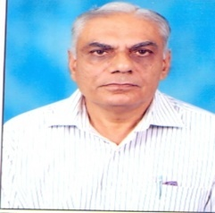
Biography (150 word limit)
Pravinchandra C. Patel is a Professor at College of Agriculture, Parul University, Vadodara, Gujarat, India from 2016 to till todate. He holds a PhD in Soil Science as a major subject & Agronomy as a minor. He has a experiences of 42 years of agriculture teaching, research, extension, farm development, soil fertility management and farming of different crops. Dr Patel have 25 years’ experience in forage crops production & forage quality. Dr Patel obtained Hari Om Ashram Ayojit J. P. Trivedi Award during 2006 for the best contribution in Soil Science research. He has participated in 18th World Congress of Soil Sci., Frontiers of Soil Sci. Technology and the Information Age at Philadelphia, Pennsylvania ,USA in 2006 & presented 3 research papers. He has contributed 52 research papers, 2 books, 3 bulletin, and 40 popular articles.

Email: patelpc12@gmailcom

Notes/Comments:

