Validation of Molecular Markers Linked Fusarium Wilt Resistance in Chickpea (Cicer arietinum L.) Using Recombinant Inbred Line

Dalpat Lal^{1,2}, R.L. Ravikumar² and P.N. Kalla¹
¹Department of Agriculture, Faculty of Science, Jagannath University, Jaipur, India
²Department of Plant Biotechnology, University of Agricultural Sciences, GKVK, Bengaluru, India

Key words: Chickpea, Fusarium wilt, Recombinant inbred lines, Validation
- Abstract Body
Fusarium wilt (FW) caused by Fusarium oxysporum f. sp. ciceri, is one of the major soil borne disease of chickpea and it causing significant yield losses annually. Till date eight races of the pathogen have been reported and race 1A is a more prevalent in India. Molecular markers closely linked to Fusarium oxysporum f. sp. ciceri resistance in chickpea were identified by several independent studies earlier. With an objective to validate reported linked markers for resistance to race 1, a new recombinant inbred line (RIL) mapping population (F11) derived from JG62 (FW susceptible) and WR315 (FW resistant) were developed. The RILs were phenotyped for FW resistance over two seasons in a wilt sick field at ICRISAT and in wilt sick pots under the green house condition. From literature survey, 42 markers linked to Fusarium wilt (FW) resistance in chickpea were selected for validation. Nineteen markers were not polymorphic in the parents and hence these markers are not diagnostic across genotypes. The genotyping data together with phenotyping data over two seasons and wilt sick pots identified 12 markers linked to wilt resistance by single marker analysis. The markers TA96, CS27, TA110 and TA59 were more consistently related to FW resistance in present and previous studies. The composite interval mapping has identified two major loci; one each in LG1 and LG2 flanked by markers H4G11 and CaM1402 and H3A12 and CS27, respectively. These two loci are considered as major loci for FW resistance explaining up to 76.66% of phenotypic variation for FW resistance. The results of present studies confirm the earlier workers and emerging picture of two hotspots in chickpea genome for Fusarium wilt resistance. The QTL flanking markers, H4G11, CaM1402, CS27, and H3A12 are most promising and reliable for resistance breeding in chickpea.

- Image

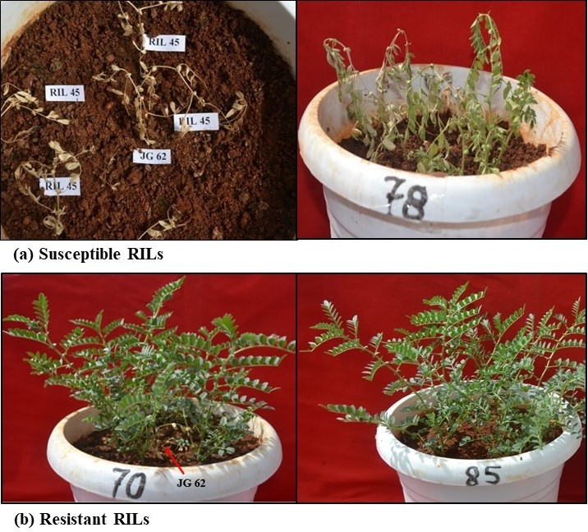

- Reference

- Gowda SJM, Radhika P, Kadoo N, Mhase L, Gupta V (2009) Molecular mapping of wilt resistance genes in chickpea. Mol Breed 24:177-184.
- Jingade P, Ravikumar RL (2015) Development of molecular map and identification of QTLs linked to Fusarium wilt resistance in chickpea. J Genet 94: 723-729.
- Haware M, Nene Y, Pundir R, Narayana RJ (1992) Screening of world chickpea germplasm for resistance to Fusarium wilt. Field Crops Res 30(1): 147-154.
IV Biography
Dalpat Lal has completed his Ph. D at the age of 27 years from University of Agricultural Sciences, GKVK, Bengaluru, India. He is working as an Assistant Professor in Jagannath University, Jaipur, India. He has published more than 10 papers and 20 popular articles in reputed journals and has been serving as an editorial board member for Biomolecule Reports: An International e- Newsletter and member of Indian Society of Genetics, Biotechnology Research and Development. He has participated in more than 15 International and National conferences and seminars. He has awarded three times as young scientist in both the national and international level.

V Presenting author details


Full Name: Dr. Dalpat Lal
Contact number: +91 9482288505
Twitter account:
Linked In account:dalpat.lal@jagannathuniversity.org
Session name/ number: Other
Category: Oral presentation
Passport Number:K 2658582

