Risk assessment of some pesticide residues in freshly home food for infants
Lamia Ryad, PhD, Egypt

Abstract (300 word limit)
Ready-to-eat baby foods should be free of pesticide residues according to the extremely low Maximum Residue Limits 0.01 mg/kg (MRLs) established by the European Community (2006). In the present work, aliquid chromatography tandem mass spectrometry (LC–MS/MS) and GC-MS/MS has been developed for the multiresidue of 420 pesticides in fruit and vegetables-based baby foods. The developed method is based on a simple sample treatment (QuEChERS), which consists of a liquid–liquid extraction using acetonitrile, followed by a clean-up step based on dispersive solid-phase extraction with primary secondary amine (PSA). Matrix effects were evaluated in LC–MS/MS mode experiments, obtaining a reduction of these effects when working in MS/MS mode for most of the analytes. Finally, the proposed method was applied to 73 fruits and vegetables based baby food samples obtained from local markets, 44% of samples were completely free from any pesticides. While the others 56% contained detectable residues and 34% (25 samples) had residues above the permissible limits. The most commonly detected pesticides were chloropyrifos then malathion and profenofos.
The exposure to pesticide residues was calculated on a total of 16 residues. The estimated pesticides mean daily intake through the consumption of this kind of food has been calculated taking into account body weight and food consumption data for children aged 6–12 months. In order to assess the health risk derived from the exposure to these pollutants in children during the first year of life.

Image
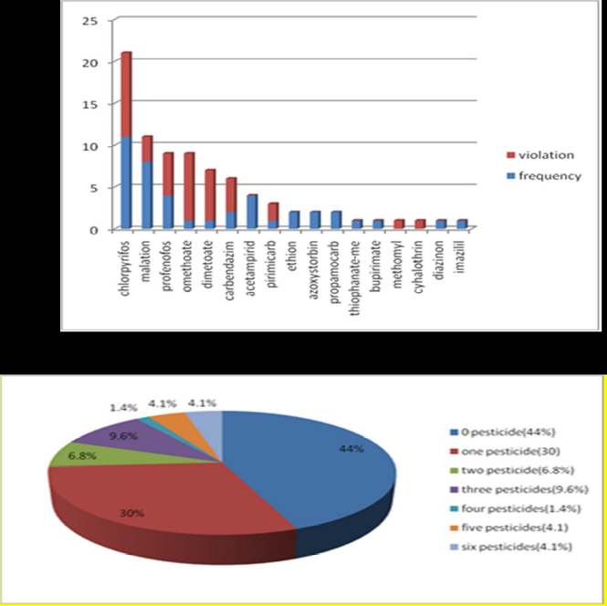
Recent Publications (minimum 5)
- Berrada, H., M. Fernandez, M.J. Ruiz, J.C. Molto, J. Manes and G. Font, (2010) Surveillance of pesticide residues in fruits from Valencia during twenty months (2004/05). Food Control., 21:36-44.
- EFSA, (2013) Scientific Colloquium Summary Report. Cumulative Risk Assessment of Pesticides to Human Health.
- FAO/WHO, (2010) Pesticide residues in food and feed. Acceptable Daily Intake; Codex Alimentarius Commission, FAO/WHO Food standards.
- Jardim, A.N.O. and E.D. Caldas, (2012) Brazilian monitoring programs for pesticide residues in food- Results from 2001 to 2010, Food Control, 25: 607-616.
5. Knezevic, Z., M. Serdar and M. Ahelm, 2012. Risk assessment of the intake of pesticides in Croatian diet. Food Control, 23: 59-65.

Biography (150 word limit)
Dr. Lamia Ryad has her expertise in in accredited lab (QCAP) from 1996 in method development, validation and risk assessment of residues of pesticides, and veterinary drugs in food.
Email: lamia.ryad@gmail.com

Notes/Comments:

