

Title: Oak flour as a replacement of wheat and corn flour to improve biscuit antioxidant activity
Mitra Parsaei 1, Mohammad Goli 1* , Hajar Abbasi¹
1Department of Food Science & Technology, Isfahan (Khorasgan) Branch, Islamic Azad University, Isfahan, Iran

Keywords: Antioxidant activity, Biscuit, Oak flour replacement, Peroxide value, Sensory evaluation

- Abstract
Due to the high antioxidant activity of oak fruits, the partial substitution effects of wheat flour (WF) or corn flour (CF) with oak flour (OF) have been investigated. WF or CF was replaced by OF at levels of 0%, 15%, 30%, and 45% in the biscuit formulations to prevent the spontaneous oxidation of lipids, and the characteristics, including peroxide value,
antioxidant activity, and sensory properties, were evaluated during 28 days storage. According to the results obtained, biscuit samples with higher OF percentage had higher
antioxidant activity and less peroxide value. In terms of sensory evaluation, no adverse effect was observed in the samples containing OF. Therefore, it could be introduced as a good natural source of antioxidant compounds for use in food formulations.
- Reference
- AACC. 2000. Approved methods of the American Association of Cereal Chemists. St. Paul, Minnesota, USA
- AOAC. 1990. Official Methods of Analysis. Association of Official Analytical Chemists, 15th ed. Washington, DC., USA
- Bonoli, M., E. Marconi and M.F. Caboni, 2004. Free and bound phenolic compounds in barley (Hordeum vulgare L.) flours: Evaluation of the extraction capability of different solvent mixtures and pressurized liquid methods by micellar electrokinetic chromatography and spectrophotometry. J. Chromatogr. A.,1057, 1-12
- Byrd, S. J. 2001. Using antioxidants to increase shelf life of food products. CFW, 46, 48-53
- Cantos, E., J. C. Espín, C. López-Bote, L. de la Hoz, J.A. Ordóñez and F.A. Tomás-Barberán, 2003. Phenolic compounds and fatty acids from acorns (Quercus spp.), the main dietary constituent of free-ranged Iberian pigs. J. Agric. Food. Chem., 51, 6248-6255
- Dillard, C. J. and J.B. German, 2000. Phytochemicals: nutraceuticals and human health. J. Sci. Food Agric., 80, 1744-1756
- Fardet, A., E. Rock and C. Rémésy, 2008. Is the in vitro antioxidant potential of whole-grain cereals and cereal products well reflected in vivo. J. Cereal Sci., 48, 258-276
- Korus, A., D. Gumul, M. Krystyjan, L. Juszczak and J. Korus, 2017. Evaluation of the quality, nutritional value and antioxidant activity of gluten-free biscuits made from corn-acorn flour or corn-hemp flour composites. Eur. Food Res. Technol., 243, 1429-1438
- Liu, Q. and H.Yao, 2007. Antioxidant activities of barley seeds extracts. Food Chem., 102, 732-737
- Ghaderi, G. M., M. Alami, M.A. Sadeghi, M. Azizi and M. Ghorbani, 2012. Effects of phenolic compounds extraction from acorn fruit’s (quercus branti var persica lindl.) with different solvents on antioxidant activity in oxidative stability of sunflower oil. Iranian J. Med. Aromat. Plants, 28, 59-72
- Majzoobi, M., S. Hedayati, M. Habibi, F. Ghiasi and A. Farahnaky, 2014. Effects of corn resistant starch on the physicochemical properties of cake. J. Agri. Sci. Technol., 16, 569-576

- Mildner‐Szkudlarz, S., R. Zawirska‐Wojtasiak, W. Obuchowski and M. Gośliński, 2009. Evaluation of antioxidant activity of green tea extract and its effect on the biscuits lipid fraction oxidative stability. J. Food Sci., 74, 362-370
- Molavi, H., J. Keramat and B. Raisee, 2015. Evaluation of the Cake Quality Made from Acorn-Wheat Flour Blends as a Functional Food. J. Food Biosci. Technol., 5, 53-60
- Muchuweti, M., A.R. Ndhlala and A. Kasiamhuru, 2006. Analysis of phenolic compound including tannins, gallotannins and flavanols of Uapaka kirkiana fruit. Food Chem., 94, 415-419
- Polimac, M. and D.K. Komlenic, 2015. Acorn flour, naturally gluten free. In Proceedings of the 8th International Congress “Flour-Bread” Opatija, Croatia, 10th Croatian Congress of Cereal Technologists, 177-181
- Polimac, M., D.K. Komlenic and J. Lukinac, 2015. Possibilities of using acorn flour in products based on flour. In Proceedings of the 8th International Congress “Flour-Bread” Opatija, Croatia, 10th Croatian Congress of Cereal Technologists, 33-48
- Rakic, S., D. Povrenovic, V. Tesevic, M. Simic and R. Maletic, 2006. Oak acorn, polyphenols and antioxidant activity in functional food. J. Food Eng., 74, 416-423
- Reddy, V., A. Urooj and A. Kumar, 2005. Evaluation of antioxidant activity of some plant extracts and their application in biscuits. Food Chem., 90, 317-321
- Sabrin, M.D., 2009. Characterization of acorn meal (Doctoral dissertation, uga). Master of Science, The University of Georgia, Athens, Georgia
- Salmanian, S., A.R., Sadeghi-Mahoonak, M., Alami and M. Ghorbani, 2014. Phenolic content, antiradical, antioxidant, and antibacterial properties of hawthorn (Crataegus elbursensis) seed and pulp extract. J. Agri. Sci. Technol., 16, 343-354
- Silva, S., E.M. Costa, A. Borges, A.P. Carvalho, M.J. Monteiro and M.M.E. Pintado, 2016. Nutritional characterization of acorn flour (a traditional component of the Mediterranean gastronomical folklore). J. Food Meas. Charact., 10, 584-588
- Soong, Y.Y., S.P. Tan, L.P. Leong and J.K. Henry, 2014. Total antioxidant capacity and starch digestibility of muffins baked with rice, wheat, oat, corn and barley flour. Food Chem., 164, 462-469
- Sudha, M.L., R. Vetrimani and K. Leelavathi, 2007. Influence of fiber from different cereals on the rheological characteristics of wheat flour dough and on biscuit quality. Food Chem., 100, 1365-1370

Biography:
Mohammad Goli (associated professor in food science and technology) has completed his PhD at the age of 38 years from Islamic Azad University of research and Science Branch, Tehran, Iran. He was the head of Department of Food Science and Technology in Islamic Azad University, Isfahan(Khorasgan)Branch, Isfahan, Iran ( Jun 2015 - Jan 2018). He has published more than 18-20 papers in reputed journals(Cited in Google Scholar) and has been serving as an editorial board member of some repute journals.

Presenting author details


Full Name: Mohammad Goli
Contact number: +989132252910 +983135002200
Category: (Oral presentation)
Passport Number:
Y44701685

- Image:

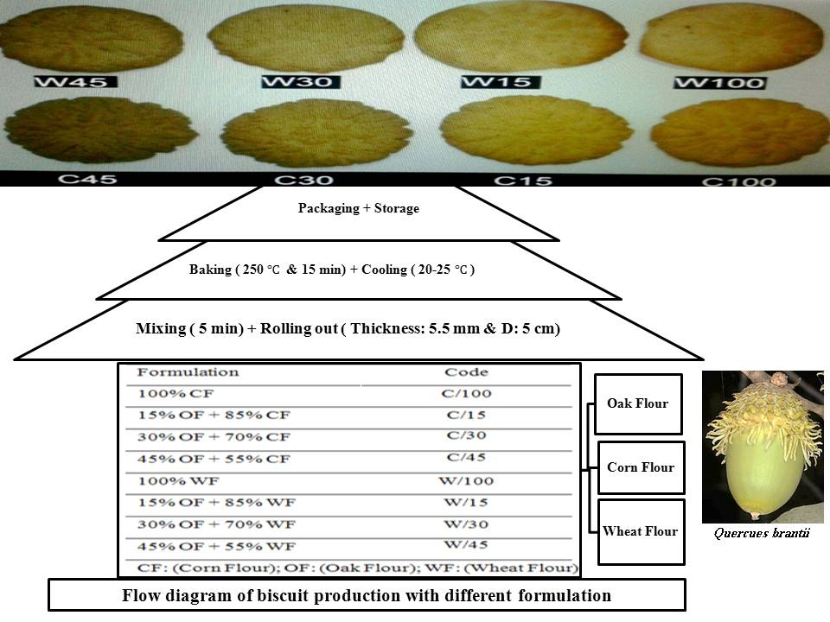
Copyright © 2016-2018 Meetings Int PTE Ltd, All Rights Reserved.
Meetings Int.Pte Ltd

Company Registration No: 201524282R,28 MAXWELL ROAD, #03-05 RED DOT TRAFFIC, SINGAPORE (069120)
Tel: +1-302-231-6756 ; +6531080483| Toll Free no. +800-852-6126
Web: http://www.meetingsint.com/conferences/foodtechnology | E-mail foodtechnology@meetingseries.org

