

Title: The effect of replacing oil with water and NaCl with KCl on soybean oil hydrolysis and oxidation in canned skipjack tuna fish at the end of the 18-month shelf life
Forouzan Nazari1, Mohammad Goli 1
1Department of Food Science & Technology, Isfahan (Khorasgan) Branch, Islamic Azad University, Isfahan, Iran

Keywords: canned tuna fish, potassium chloride, hydrolysis, oxidation, thiobarbituric acid

- Abstract
The effects of replacing oil with water (0, 3, 6, and 10% based on total net weight of the product) and replacing NaCl with KCl (0, 50, and 100%) at different replacement levels were surveyed. Hydrolysis (acidity number), peroxide value, and thiobarbituric acid (TBA) index were evaluated at the end of the 18-month shelf life in canned skipjack tuna fish. Results showed that the TBA index was not affected, whereas the peroxide value was affected by replacing oil with water and NaCl with KCl (p<0.05), so that by increasing in replacing oil with water and replacing NaCl with KCl, the peroxide value was significantly decreased (p<0.05). Hydrolysis (acidity number) was affected by replacing oil with water (p<0.05); however, it was not affected by replacing NaCl with KCl (p>0.05). It was found out the best suggestion is 10% replacing oil with water and 50% replacing NaCl with KCl.
- Reference:

1 Garcia, M.T., E. Alvarez, M.C. Garcia, F.M.C. Garcia and F.J. Sanchez, 2003. Cooking-Freezing-Reheating(CFR) of sardine fillets. Effect of different cooking and reheating procedures on the proximate and fatty acid composition. Food Chem., 83: 349-356
2. Sakanaka, S., Y. Tachibana and Y. Okada, 2005. Preparation and antioxidant properties of extracts of Japanese persimmom leaf tea (Kakinoha-cha). Food Chem., 89: 569-575
3. Hras, A.R., M. Hadolin, Z . Knez and D. Bauman, 2000. Comparison of antioxidative and synergistic effect of rosemary extract with a-tochopherol, ascorbyl palmitate and citric acid in sunflower oil. Food Chem.,71:229-233
4. Calligaris, S. and M.C. Nicoli, 2006. Effect of selected ions from lyotropic series on lipid oxidation rate. Food Chem., 94:130-134
5. Desmond, E. 2006. Reduction salt: A challenge for the meat industry. Meat Sci. 74:188-19
6. Egan, H., R.S. Kirk, R. Sawyer, 1987. Pearson’s Chemical Analysis of Foods. 9th ed. Harlow: Longman Scientific and Technical. pp. 609 -34
7. Erickson, D.R. 1990. Edible fats and oils basic principles and modern practices. Library of Congress Cataloging in Publication Data. pp. 83-90
8. He, Y. and F. Shahidi, 1997. Antioxidant activity of green tea and tea catechins in fish meat model system. J. Agric. Food. Chem., 45: 4262-4266
9. Gall, K.L., S. Otwell, J.A. Koburger and H. Apledorf, 1983. Effect of four cooking methods on the proximate, mineral and fatty acid composition of fish fillets. J. Food Sci., 48: 1068-1073
10. Matlock, R.G., R.N. Terrell and J.W. Savrell, 1984. Factors affecting properties of pre cooked frozen pork-sousage patties made with various Nacl/Phosphate combination. J. Food Sci., 49:1372
11. Jin, G., L. He, J. Zhang, X. Yu, J. Wang and F. Huang, 2012. Effects of temperature and NaCl percentage on lipid oxidation in pork muscle and exploration of the controlling method using response surface methodology (RSM). Food Chem., 131: 817-825
12. Sahoo, J., R.K. Kawasra and S. Hooda, 2004. Studies on atocopherol acetate as antioxidant in chichen mince on its quality during refrigerated storage. J. Food Sci. Technol-Mysore., 41: 240-243
13. Wu, H., H. Zhuang, Y. Zhang, J. Tang, X. Yu, M. Long and J. Wang, 2015. Influence of partial replacement of NaCl with KCl on profiles of volatile compounds in dry-cured bacon during processing. Food Chem., 172: 391-399
14. Karacam, H. and M. Boran, 1996. Quality changes in frozen whole and gutted anchovies during storage at -18℃. Int. J. Food Sci. Technol., 31: 527-531

Biography:
Mohammad Goli (associated professor in food science and technology) has completed his PhD at the age of 38 years from Islamic Azad University of research and Science Branch, Tehran, Iran. He was the head of Department of Food Science and Technology in Islamic Azad University, Isfahan(Khorasgan)Branch, Isfahan, Iran ( Jun 2015 - Jan 2018). He has published more than 18-20 papers in reputed journals(Cited in Google Scholar) and has been serving as an editorial board member of some repute journals.

Presenting author details

Full Name: Mohammad Goli
Contact number: +989132252910 +983135002200
Category: (Oral presentation)
Passport Number:
Y44701685

Image:
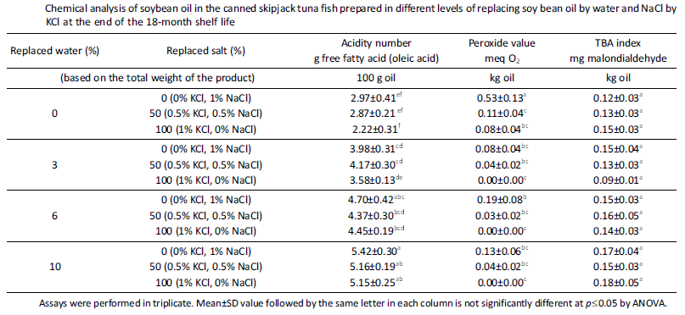

Copyright © 2016-2018 Meetings Int PTE Ltd, All Rights Reserved.
Meetings Int.Pte Ltd

Company Registration No: 201524282R,28 MAXWELL ROAD, #03-05 RED DOT TRAFFIC, SINGAPORE (069120)
Tel: +1-302-231-6756 ; +6531080483| Toll Free no. +800-852-6126
Web: http://www.meetingsint.com/conferences/foodtechnology | E-mail foodtechnology@meetingseries.org

