Effect of Malathion on yield and AMF colonization in Coriandrum sativum (coriander).

SHOWKAT HUSSAIN MIR¹, AHMAD TARIQ², AVINASH TIWARI¹, MANSHA FATIMA³.

1. Department of Botany, Jiwaji University, Gwalior (M.P) INDIA.
2. Department of Microbiology, Sher-e-Kashmir University of Agricultural Sciences and Technology, Srinagar INDIA.
3. Department of Agricultural Microbiology, Aligarh Muslim University, Aligarh (U.P) INDIA.

Key words: Arbuscular Mycorrhiza Fungi (AMF) colonization, Malathion, Coriandrum sativum

- Abstract
Malathion is a non-systemic broad spectrum organophosphate insecticide which is used for controlling sucking and chewing insects on fruits and vegetables. It has been analyzed that effects of different concentrations of malathion on yield and AMF colonization in Coriandrum sativum. It was found that, at recommended and low dosages, coriander does not show any significant reduction in yield and AMF infection percentage, but higher concentrations reduced yield and AMF infection percentage of coriander.

After I sampling, the maximum AMF infection percentage was observed in Control and M ½ ND (62% and 52% respectively) and least was observed in M2ND (i.e., 38%). After II sampling, the AMF infection percentage decreased in MND (i.e., from 50% to 48%) and M2ND (i.e., from 38% to 36%) plants. In Control plants the AMF percentage increased from 62% to 68%, although M ½ ND also recorded a slight increase in AMF infection percentage from 52% to 54%. After III sampling, the maximum AMF percentage colonization was observed in Control (74%), M2ND (42%) treatment showed least AMF percentage colonization. Similar trend was also observed after 95 days (IV sampling) i.e., maximum in Control (76%) and least in M2ND (48%).
II. Images
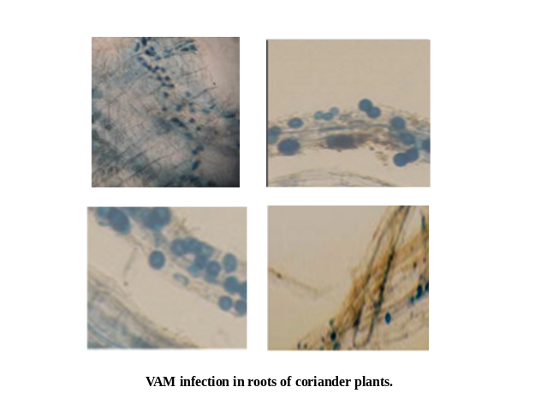
III. REFERENCES.
Aissaoui A, J. E. Hilaly, Z. H. Israili and B. Lyoussi 2008. Acute diuretic effect of continuous intravenous infusion of an aqueous extract of Coriandrum sativum L. in anaesthetized rats. Journal of Ethnopharmacology. 115: 89–95.
Cabello M. N. Hydrocarbon pollution: its effect on native arbuscular mycorrhizal fungi (AMF). FEMS Microbiol Ecol.22: 233–236.

Cairney J. W. G, A. Meharg 1999. Influences of anthropogenic pollution on mycorrhizal fungal communities. Environ Pollut. 106: 169–182.

Chamber H W 1992. Organophosphorus compounds. An overview. Academic: San Diego, C A; PP: 3-17.
Dhanapakiam P, J. M. Joseph, V. K. Ramaswamy, M. Moorthi and A. S. Kumar 2008. The cholesterol lowering property of coriander seeds (Coriandrum sativum): Mechanism of action. Journal of Environmental Biology. 29(1): 53-56.
Emamghoreishi M and G. H. Hamedani 2006. Sedative-Hypnotic Activity of Extracts and Essential Oil of Coriander Seeds. Iran J Med Sci. 31(1): 22-27.
Evans W. C, Trease and Evans 2002. Pharmacognocy. Fifteenth International edition, W.B. Saunders, Edinburgh, London, New York. 2002; 262.
Finlay R, T. Boller and M. Elfstrand 2010. Functional diversity in arbuscular mycorrhizae-the role of gene expression, phosphorus nutrition and symbiotic efficiency. Fungal Ecology. 3: 1-8.
Giovannotti M. and B. Mosse 1980. An evaluation of techniques for measuring vesicular arbuscular mycorrhizal infection in roots. New Phytol. 84: 849-499.

Biography:
Tariq Ahmad Bhat is pursing PhD from SKUAST-K in Department of Microbiology. He has qualified JRF, NET, and SRF. He is the member of UGC board of studies for Kashmir University. Along with the publishing several papers in reputed journals he has published 2 books.

Presenting author details



Full Name: TARIQ AHMAD BHAT
Contact number:7051836718

Email id: tariqbhatkash@yahoo.com

tariqbhatkash@rediffmail.com

