Title: The Influence of hurdle technology on vitamin C content in star fruit (Averrhoa carambola) juice during storage
Niranjay Kr. Sahu¹, Dr Pritom Kr. Borthakur²
¹Department of Horticulture, Assam Agriculture University, Jorhat, Assam-785013
Keywords: Star fruit, digital radiometer, ultraviolet radiation, pasteurization, potassium sorbate, hurdle technology, vitamin-C, 2,6-Dichlorophenolindophenol.
Abstract
Hurdle technology was applied to star fruit (Averrhoa carambola) juice and ascorbic acid content in the juice was investigated during storage. The juice was stored in a refrigerator for 90 days at 4⁰C. The matured fruit was collected from the local market in Jorhat town and study was conducted in Assam Agricultural University, Jorhat. Six treatments and a control were applied to the juice in the form of hurdle which includes UV-C irradiation dose of 3.525 J/m² using (UVP UVXTM Digital radiometer) under laminar air flow cabinet, pasteurization at 78⁰C and potassium sorbate (200, 150 and 100ppm) respectively. Treatments were T₁(200ppm+ UV-C), T₂ (150ppm+ UV-C), T₃ (100ppm+ UV-C), T₄ (200ppm+ UV-C + pasteurization), T₅ (150ppm+ UV-C + pasteurization) and T₆ (100ppm+ UV-C + pasteurization). The estimation of vitamin C was performed by a titrimetric method using 2,6-Dichlorophenol indophenol and analysis of variance was done by using CRD (Complete randomized design) with 0.05 probability level. Initially, the ascorbic acid content in control was 37.62 mg/100ml wherein T₁, T₂, T₃, T₄, T₅, T₆ were found (34.63, 34.14, 33.86, 31.35, 30.83 and 30.46 mg/100ml) respectively. During storage the ascorbic acid content was decreasing significantly (p<0.05) in control 13.19 mg/100ml and among the treatments it was (22.91, 20.73, 20, 18.74, 20.48 and 19.33 mg/100ml) the decreasing ascorbic acid in percentage was 65% in case of control where others are (36%, 39%, 41%, 40%, 33% and 46%). T₁ was found to be the best among the other treatment which was able to retain the maximum amount of ascorbic acid during storage where T₅ was also found least decrease in percent. Moreover, both the treatment T₁ and T₅ can be used for the commercial production of star fruit juice.

Images
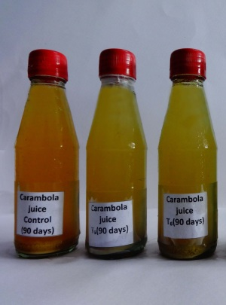
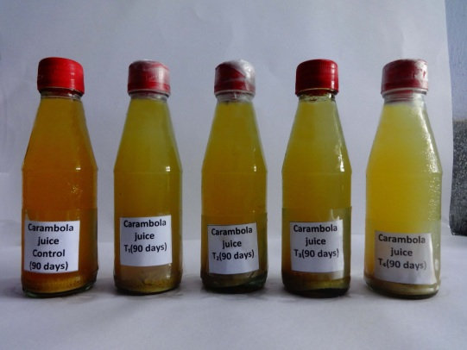

Reference
- AOAC 2010. Official methods of analysis association of official analytical chemists. Washington D.C, USA
- Ayub, M., J. Ullah., A. Muhammad and A. Zeb 2010. Evaluation of strawberry juice preserved with chemical preservatives at refrigeration temperature. Int. J. Nutr. Meta 2: 27-32
- Bhat, R., B. S. Ameran., C.H. Voon., A. Karim and M. L. Tez, 2011. Quality attributes of star fruit (Averrhoa carambola L.) juice treated with ultraviolet radiation. Food Chem. 127: 641- 644
- Polydera, A., N. stoforos and P. Taoukis, 2003. Comparative shelf life study and vitamin C loss kinetics in pasteurised and high pressure processed reconstituted orange juice. J. Food Eng. 60: 21-29

Bibliography
I completed my M.Sc. (Agri.) in Food Science and Technology at the age of 26 from Assam Agricultural University and published one paper in International Journal of Pure and Applied Bioscience.


Presenting author details
Name: Niranjay Kumar Sahu
Contact no: +91 7086816843
Category: e poster presentation
Mail id: niranjaysahu@gmail.com

