Food packaging based on 2-dimensional atomic layers for high-efficiency multi-layer-nanostructure smart sensors

Sung Won Hwang, Department of Nano Science & Mechatronics Engineering, Nanotechnology Research Center, Konkuk University, Chungju-si 27478, Korea

Abstract
Nanotechnology has been applied by packaging industry since some years. Successful technical development of nanostructures for food packaging has to overcome barriers in safety, technology, trained workforce and technology transfer in order that commercial products can benefit from the global market potential and requires therefore a high degree of multidisciplinary. The most widely known theories to explain the improved barrier properties of nanocomposites are based on a theory developed, which focuses on a tortuous path around the two dimensional atomic layers, forcing the gas permeant to travel a longer path to diffuse through the film. Two dimensional (2-D) atomic layers have several advantages such as flexibility in choosing substrates, easy fabrication, large package area, minimum change of components, enhanced expiration date, and reduced defects by oxygen blocking structure for smart packages. The formation of 2-D atomic layers preventing oxygen penetration is crucial for enhancing the efficiency of multi-layer-nanostructures(MLNs). The nanostructures of two types of packages containing defect-free MLNs with atomic layer and defective thin film were determined by scanning electron microscopy and high-resolution transmission electron microscopy. The defective thin film has a porous structure, whereas the defect-free MLNs with atomic layer had a single crystal structure. The device consists of an array of nanosensors extremely sensitive to gases released by spoiling microorganisms, producing a colour change which indicates whether the food is deteriorated. These results suggest that the well-defined 2-dimensional atomic layer of MLNs can be utilized for the high- efficiency smart packages. This work was supported by a grant to the FTA Program (no. PJ011885032018), Rural Development Administration, Republic of Korea.

Image
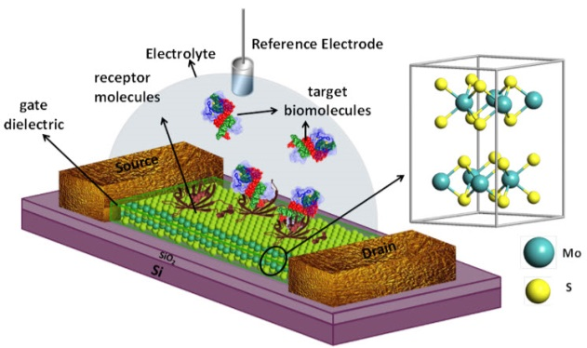
Figure 1 : Concept art of a biosensor based on a molybdenum disulfide field-effect transistor demonstrated by UCSB researchers with ability to detect ultra-low concentrations with sensitivity that is 74-fold higher than that of graphene FET biosensors (credit: Peter Allen/ACS Nano)
Recent Publications
- S. W. Hwang, et al (2016) Targeting Reactive Carbonyl Species with Natural Sequestering Agents. Molecules 21, 280.
- S. W. Hwang, et al (2018) Strong enhancement of emission efficiency in GaN light-emitting diodes by plasmon-coupled light amplification of graphene. Nanotechnology 29, 055201
- S. W. Hwang, et al (2016) Non-catalytic Direct Synthesis of Graphene on Si (111) Wafers by Inductively-coupled Plasma Chemical Vapor Deposition. J. Korean Phys. Soc. 69, 536.
- S. Kim, and S. W. Hwang, et al (2016) Energy transfer from an individual silica nanoparticle to graphene quantum dots and resulting enhancement of photodetector responsivity. Scientific Reports 6, 27145.
- S. W. Hwang, et al (2014) High-performance graphene-quantum-dot photodetectors. Scientific Reports 4, 5603.


Biography
Sung Won Hwang, Ph.D. is an Assistant Professor at the Division of Nano Science and Mechatronics Engineering at Konkuk University in South Korea. Prof. Hwang worked for Samsung Electronics for the last 9 years. He has more than 30 patents related to the nano-materials and nano-structures. He also published 7 peer reviewed scientific articles in this area for the last two years. Prof Hwang is now focusing on development of nano-carriers and smart packages at the Konkuk University in South Korea.

Email: swhwang@kku.ac.kr

Notes/Comments:

