OPTIMIZATION OF OVEN DRYING CONDITIONS OF BANANA (Musa spp., AAA GROUP, cv ‘Luvhele’ AND ‘Mabonde’) USING RESPONSE SURFACE METHODOLOGY

Adewale Olusegun Omolola, PhD, Department of Food Science and Techology, University of Venda, South Africa
Afam Israel Obiefuna Jideani, PhD, Department of Food Science and Techology, University of Venda, South Africa
Patrick Francis Kapila,PhD, Department of Agricultural and Rural Engineering, University of Venda, South Africa
Victoria Adaora Jideani,PhD, Department of Food Technology, Cape Peninsula University of Technology, South Africa

Abstract
Statement of the Problem: Luvhele and Mabonde banana varieties are bananas grown in Limpopo province of South Africa. They are rich in nutriments and antioxidants. Color is a main quality characteristic of food products that are affected by the drying conditions while texture changes in solid foods during processing by drying are an important cause of quality deterioration. Methodology & Theoretical Orientation: Optimization of oven drying conditions of Luvhele and Mabonde banana varieties were studied using response surface methodology. The drying was performed according to a central composite rotatable design to explore two sets of variables: oven temperatures (40, 50 and, 60ºC) and drying time (1260, 1080, and 900 min) for Luvhele; (40, 50 and, 60ºC) and (1260, 900, and 600 min) for Mabonde. The color and texture (hardness) data were analyzed using ANOVA and regression analysis. Findings: Results indicated that L*, a*, b*, hue angle and hardness varied with drying conditions for the two banana varieties. Values to the hue angle ranged between 63.38 – 74.70 and 60.14 - 72.80 to dried slices of the banana varieties Luvhele and Mabonde. The hardness of dried slices of the banana varieties, Luvhele and Mabonde ranged between 1.15 - 14.62 N and 1.28 - 14.29 N, respectively. Oven temperature and drying time had significant (p < 0.05) effects on the overall color (hue) and hardness of Luvhele and Mabonde banana varieties. Models obtained for the prediction of overall color (hue) and hardness of dried slices of both banana varieties as a function of the process variables drying temperature and time had no significant (p > 0.05) lack of fit test, adequate and acceptable regression values: adjusted R² between 078 and 0.80 coefficient of variance (CV) < 10%; hence the models obtained for the responses were adequate and acceptable. The drying conditions of 47.56ºC drying temperature and 944.87 min of drying time were found optimum to obtain a quality at desirability of 0.97 to the Luvhele variety; whereas 40ºC drying temperature and 646.17 min of drying duration with a desirability of 0.83 was predicted as optimum drying for Mabonde. Conclusion: The result of this study could be used as a standard for oven drying of Luvhele and Mabonde banana varieties.

Image
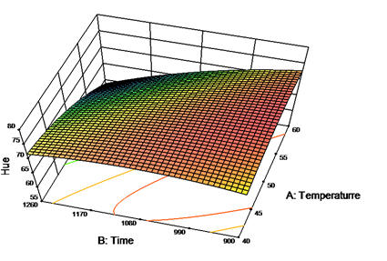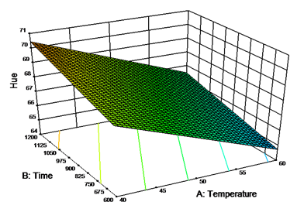
B
A
Figure1. Response surface plot for the effects of drying temperature and time on overall color (hue) of banana slices of Luvhele (A) and Mabonde (B).
Recent Publications
Omolola A.O., Kapila, P.F., and Mchau G.A. 2017. Effect of selected processing and modification methods on quality of cassava and its starch. Asian Journal of Agricultural Research, 11: 48-56.
Omolola, A.O., Kapila, P.F., Anyasi, T.A., Jideani, A.I.O., and Mchau, G.A. 2017. Optimization of color and thermal properties of sweet cassava (Manihot esculenta crantz var. UVLNR 0005) flour using response surface methodology. Asian Journal of Agricultural Research, 11: 57-65.
Omolola A.O.,Jideani, A.I.O & Kapila, P. (2017). Quality properties of fruit as affected by drying operation.Critical Reviews in Food Science & Nutrition http://dx.doi.org/10.1080/10408398.2013.859563.
Omolola A.O.,Jideani, A.I.O & Kapila, P. (2015). Modeling of thin layer drying characteristics of banana cv. Luvhele. Bulgarian Journal of Agricultural Science, 21 (2) http://www.agrojournal.org/

Omolola A.O.,Jideani, A.I.O & Kapila, P.F. (2014).Modeling microwave drying kinetics and moisture diffusivity of banana (Mabonde variety) - International Journal of Agriculture and Biological Engineering, 7(6): 107 – 113.

Biography (150 word limit)
Adewale Omolola is a postdoctoral research fellow in the Department of Agricultural and Rural Engineering, University of Venda. He specializes in modeling and optimization of food processing operations
Email:omololadewale@gmail.com

