Effects of mung bean flour on physicochemical properties and sensory characteristics of cakes
Sibel Bolek, Assist. Prof. Dr. University of Health Sciences, Turkey

Abstract
Statement of the Problem: Thanks to their long shelf life, cheapness and general acceptability, cake is one of the most popular snack foods among all age groups in many countries. However, cakes are low in dietary fiber, protein and antioxidant activity. Given the well‐known advantages of a healthy diet, the food industry has responded by developing new foods with health‐promoting characteristics. Mung bean is a rich source of protein, dietary fiber, phenolic content, and high antioxidant activity.
Methodology & Theoretical Orientation: This study aimed to evaluate the effects of Mung bean flour on the quality, textural properties, and sensory properties of cakes. The cakes were prepared by replacing wheat flour with mung bean flour at levels of 0, 10, 20 and 30%. Effect of mung bean flour on nutritional, textural and sensory properties on cakes was investigated.
Conclusion & Significance: Mung bean flour addition increased the dietary fiber, protein content and antioxidant activity of cakes significantly (p<0.05). Textural hardness was increased, and textural cohesiveness and springiness were decreased with the addition of mung bean flour to the cake formulation. According to results of sensory analysis, wheat flour could be substituted up to 30% by mung bean flour to prepare cakes without causing unacceptable product in terms of sensory properties.

Image

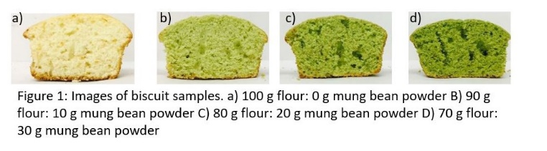
Recent Publications
- Bolek S. (2020). Olive stone powder: A potential source of fiber and antioxidant and its effect on the rheological characteristics of biscuit dough and quality. Innovative Food Science Emerging Technologies, 102423
- Bolek, S. (2020). Consumer knowledge, attitudes, and judgments about food safety: A consumer analysis. Trends in Food Science & Technology.
- Bolek, S., & Ozdemir, M. (2017). Optimization of roasting conditions of microwave roasted Pistacia terebinthus beans. LWT, 86, 327-336.
- Bolek, S., & Ozdemir, M. (2017). Optimization of roasting conditions of Pistacia terebinthus in a fluidized bed roaster. LWT, 80, 67-75.
- Bolek, S., & Obuz, E. (2014). Quality characteristics of Trabzon persimmon dried at several temperatures and pretreated by different methods. Turkish Journal of Agriculture and Forestry, 38(2), 242-249.

Biography
Dr. Sibel Bölek is a Assistant Professor of Food Technology Department, Institute of Health Sciences, at University of Health Sciences, İstanbul, Turkey. She is head of Food Technology Department. Her areas of interest include food drying techniques, coffee technology, bakery products, food safety, food composition, RSM-based experimental design, MATLAB programming.
.
Email: sibel.bolek@sbu.edu.tr.

