

Moringa oleifera- Variety ODC-3

A review on nutritive Importance and its medicinal application

Name – Chaitanya Gandhi

Founder of Sheti Udyog Farmer Producer Company Ltd, India

With an objective to promote the best local resources for improving nutritional status for future generation more emphasis should be given on local food based approaches.
Moringa is one example of a nutrient source that can be grown and used at the individual or societal level. By partnering with appropriate educational modalities to describe its uses and nutritional benefits, communities around the world will be able to participate directly in halving the world’s hunger and improving nutritional deficiencies.

One of the “Farmer variety” that have traditionally been cultivated and developed by the farmers and originated in Oddamchhatram India called ODC-3 has been studied related to growth habits, fruiting capacity, taste of fruits, culinary vegetable and it has found to be one of the best performing genotype.

ODC-3 Moringa is perennial, cluster bearing, drought resistant with the high yield of 600-800 fruits per year and it is most suitable for culinary , vegetable soup, and green leaf. Its nutrient-dense leaves are high in protein quality.

Despite the fact that no rigorous clinical trial has tested its efficacy for treating under-nutrition, the adoption of ODC-3 continues to increase in India and all over the globe.
This highlights the need for a scientific consensus on the nutritional benefits.
Acceptance of ODC-3- M. oleifera as a nutritional supplement or a food additive in undernourished populations is compatible in those cultures that currently use green leafy plant sources in traditional dishes. Rural populations, and those populations who rely heavily on subsistence farming, may find using ODC-3 leaves more compatible than purchasing non-locally produced food. Because households can produce their own ODC-3 M. oleifera or find it in local markets, they are able to use it just as they would with other locally grown foods such as grains, legumes, root and/or tuber vegetables.

Odc-3 variety is relatively easy to obtain, grow, and use on a regular basis. The tree grows well in climates ranging from warm tropical at sea level, to sub tropical climates up to an altitude of 3000 feet. The maximum temperature for growth varies from 38 to 48°C and minimum temperature from -1 to 3°C. Higher leaf production can be achieved if the trees are regularly pruned close to ground level or if individual shoots are regularly harvested. There is an extensive literature, not elaborated upon herein, on proper upkeep and care of this variety.

This variety also has medicinal value. It has lot of nutrients like carbohydrate, fibre, protein , fat and salt apart from these VitaminA, Vitamin E, Vitamin K, VitaminC, Vitamin B1 thiamin,B12, Vitamin B6 and Riboflavin. Minerals like potassium, calcium, magnesium, Iron and Zinc are present .

The lack of robust clinical trials data increases the uncertainty regarding ODC3’s nutritional benefits. Uncertainty about adoption of an innovation can lead both to over adoption by individuals, and to complete lack of adoption due to the inability of thought leaders and lead policy organizations to endorse the innovation.

This will provide the comfort and confidence level required by policymakers and decision makers in large international and governmental organizations to support this variety as a nutrition intervention.

Biography – Author is an agronomist and founder of a farmer producer company currently working as the go between farmers and crop researchers by reviewing research and using this knowledge to help recommend solution to farmers. Suggestion is made to the farmer regarding new scientific developments in order to help the growing operation.

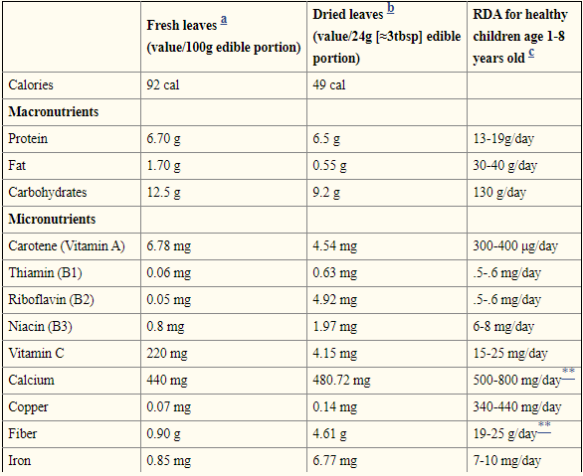
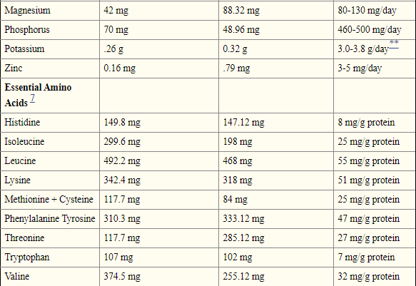

Recommended Daily Allowance (RDA) values are given as an estimate of what an individual’s recommended intake should be. For the purpose of this paper, these values should be interpreted as a general comparison of leaf content to what an average healthy child should intake. Source: Food and Nutrition Board, Institute of Medicine, National Academy of Sciences Dietary Reference Intake database (2002)
⁷Gopalan et al. (1971) originally expressed amino acid content per g N, and have been converted to mg per 100g leaves
*Leaf nutrient composition will vary depending on the geographic region the leaves are sampled from and the type of analysis used. This table acts to give a general idea of the nutrient content of the leaves.
**Represents Adequate Intake (AI) for an individual

Presenting Author Details:
Full Name – Chaitanya Ajitkumar Gandhi
Contact No – +91 8275156393
LinkedIn Account - www.linkedin.com/in/ShetiUdyog

