Does Curcumin Have a Role in the Interaction between Gut Microbiota and Schistosoma mansoni in Mice?
Dr. Mohamed Naguib Mohamed Abdelghany, PhD, Cairo University, Egypt

Abstract (300 word limit)
There is strong correlation between changes in abundance of specific bacterial species and several diseases including schistosomiasis. Several studies have described therapeutic
effects of curcumin (CUR) which may arise from its regulative effects on intestinal microbiota. Thus, we examined the impact of CUR on the diversity of intestinal microbiota with/without infection by Schistosoma mansoni cercariae for 56 days. Enterobacteriaceae was dominating in a naive and S. mansoni infected mice group without CUR treatment, the most predominant species was Escherichia coli with relative density (R.D%) = 80.66% and the least one was Pseudomonas sp. (0.52%). The influence of CUR on murine microbiota composition was examined one week after oral administration of high (40) and low (20 mg/kg b.w.) CUR doses were administered three times, with two day intervals. CUR induced high variation in the Enterobacteriaceae family, characterized by a significant (p < 0.001) reduction in E. coli and asignificant (p < 0.001) increase in Pseudomonas sp. in both naïve and S. mansoni-infected mice, compared to untreated mice, in a dose-dependent manner.
Additionally, our study showed the effects of high CUR doses on S. mansoni infection immunological and parasitological parameters. These data support CUR’s ability to promote Pseudomonas sp. known to produce schistosomicidal toxins and offset the sequelae of murine schistosomiasis.

Image
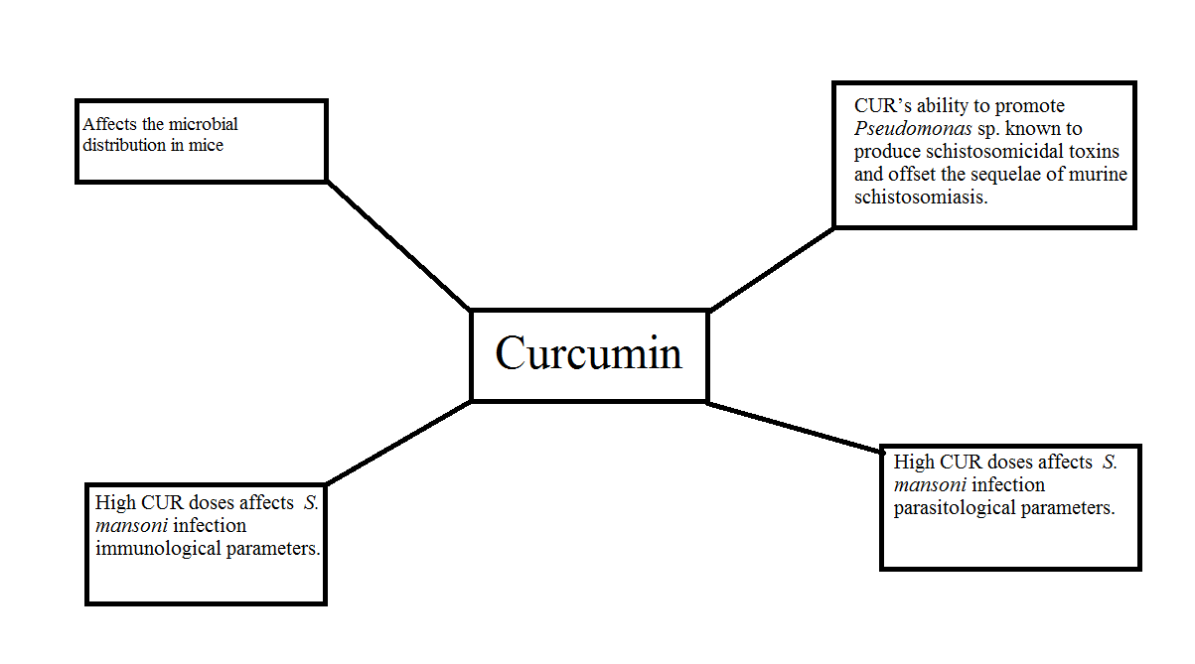

Recent Publications (minimum 5)
1- Purification, characterization and medicinal application of tyrosinase extracted from Saccharomyces cerevisiae, Journal of Innovations in Pharmaceutical and Biological Sciences (JIPBS) 6(1), (2019) 01-11.
2- Antifungal and anti-mycotoxin efficacy of biogenic silver nanoparticles produced by Fusarium chlamydosporum and Penicillium chrysogenum at non-cytotoxic doses, Chemosphere 218 (2019) 477-486.
3- Efficacy of Ozonized Water for Fungal Decontamination of Fresh Fruit Pieces Decorating Dessert Cakes. Egyptian Journal of Botany, 59 (2019)
4- Fungal infections in primary immunodeficiency diseases, Clinical Immunology 19, (2020) 108553.
5- Characterization of Penicillium crustosum L-asparaginase and its acrylamide alleviation eiciency in roasted cofee beans at non-cytotoxic levels, 2021, 2198, 1-13

 B iography (150 word limit)
Dr. Mohamed Abdelghany has his expertise in evaluation and passion in studying microbiology. Microbiology is very important in different fields especially the food sector, medical sector as well as environmental sector.
Email: mabdelghany@sci.cu.edu.eg

Notes/Comments:

