Organic nanoemulsions (Rosa and Saffron) as a New alternative approach to chemical food preservatives

Fereshte Sahraei¹, Hamed Ahari²*, Mahdi Jafari ³, Amirali Anvar⁴, Mehrdad Gavami²

1.PhD student, Department of Food Science and Technology, Science and Research Branch, Islamic Azad University, Tehran, Iran.
2*Professor, Department of Food Science and Technology, Science and Research Branch, Islamic Azad University, Tehran, Iran.
3.professor, Faculty of Food Science and Technology, Gorgan University of Agricultural Sciences and Natural Resources, Gorgan, Iran
4.Accosieted Professor, Department of Hygiene, Science and Research Branch, Islamic Azad University, Tehran, Iran.

Abstract
With the reduction of natural and agricultural resources and the increase of greenhouse gases, and on the other hand, the reduction of underground water resources, we can understand the optimal and maximum use of food resources and reserves on the planet with the approach of nano technology, so that spices and seasonings With this technology, their high price and antioxidant and antibacterial role and even their taste will be multiplied a hundred times and the amount of consumption of these expensive food and medicinal compounds will be very little. On the other hand, maintaining food safety in the world is one of the important public health issues, in order to control the growth of bacteria and fungi, various synthetic preservatives are usually used, while long-term exposure to them can cause serious health risks. The high use of artificial preservatives to preserve the quantitative and qualitative characteristics of food may cause resistance to microbial strains and cause complications related to human health as well as widespread environmental instability. For this purpose, there is an increasing demand for biological food additives that are compatible with the environment, free from side effects and chronic diseases such as cancer, and promote overall health. Today, the use of essential oils as natural antimicrobial compounds for the long-term protection of food and maintaining its quality has been highly regarded, there are various limitations in the use of these compounds, which can be increased by enclosing them in a suitable biodegradable and biocompatible polymer matrix to increase their efficiency and stability. Among the different systems, nanoemulsions effectively help the application of essential oils in food systems. The methods of producing nanoemulsions are divided into two general categories, high energy and low energy, each of which includes several techniques.and Rosa, which have a significant difference in zeta potential and are produced by ultrasonic method as a substitute for synthetic preservatives. Rosemary nanoemulsion is in the form of essential oil, but saffron nanoemulsion is in the form of an extract, which after the production process has shown potential use as a food preservative. Finaly and nowadays, extensive research is done on the combined use of food nanoemulsions, taking into account the particle size and the electric charge tendencies of the nanoparticles, in order to increase the shelf life of food and the optimal use of spices and seasonings in taste, color, smell, but with the aim of at least Consumption and maximum effectiveness of bioactive compounds
.
Keywords: Nanoemulsion, Nanoparticle, Food safety, Peservatives
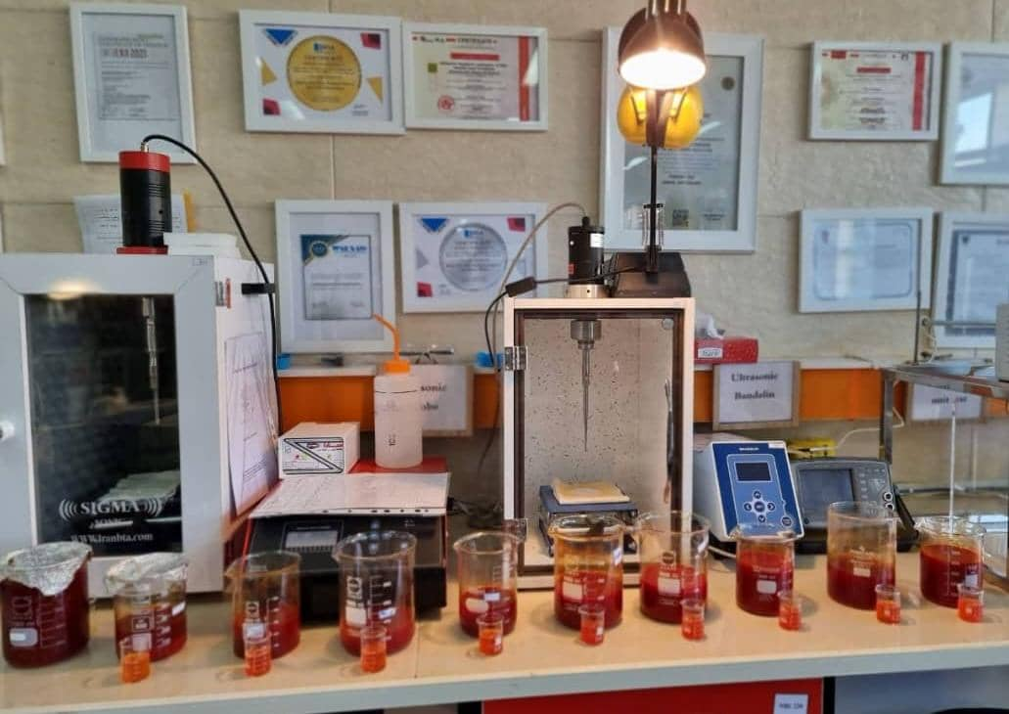
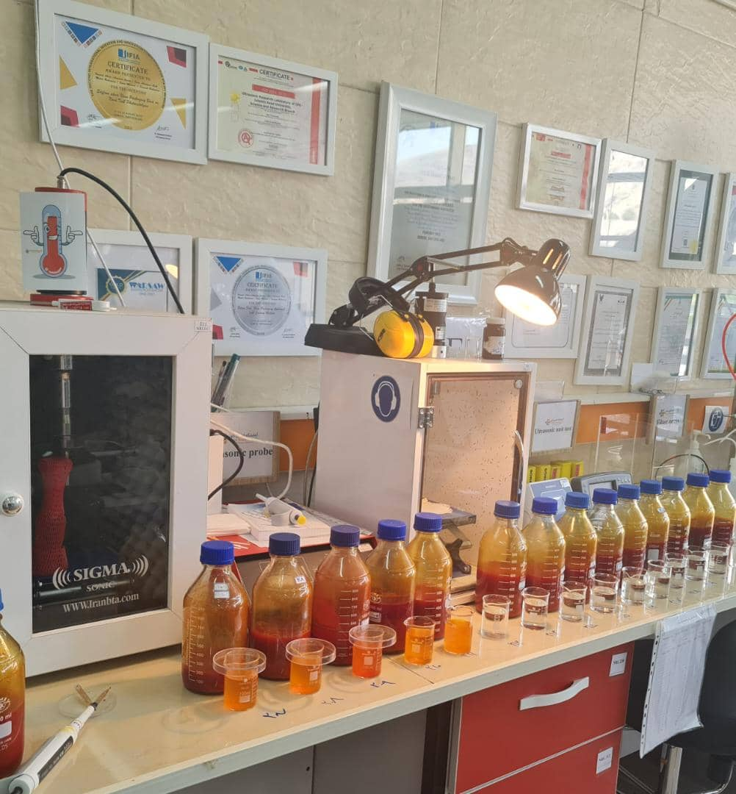

Fig1.producing of Saffron Nanoemulsion by
Probe Ultrasonic method in Nanotechnology Laboratory

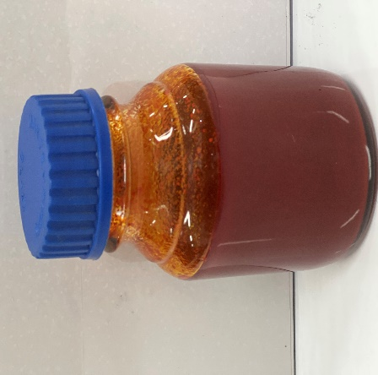
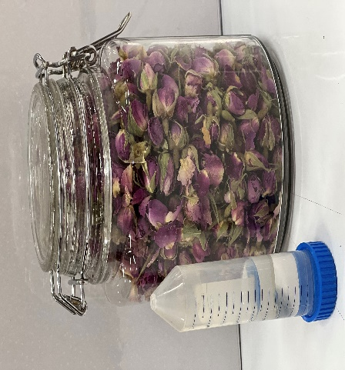

Fig2. Rossa Nanoemulsion Fig3.Saffron Nanoemulsion

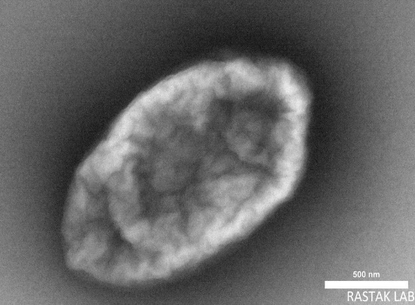
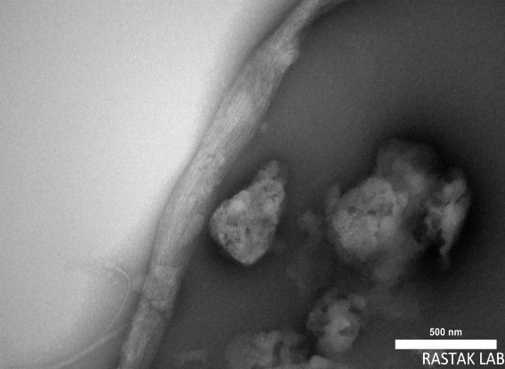

Fig4.TEM picture of Saffron Nanoemulsion

Refe
FORMULATION OF SAFFRON AND A METHOD OF PREPARATION THEREOF, Ahari, Hamed; Anvar, AmirAli; Rahimian, Mahdi; Allahyaribeik, Sara; Moradi, Sima, US Patent, Patent Number: US 10,953,065B2, Application Number: 17/086,763.
FORMULATION OF SAFFRON AND A METHOD OF PREPARATION THEREOF, Ahari, Hamed; Anvar, AmirAli; Rahimian, Mahdi; Allahyaribeik, Sara; Moradi, Sima, PCT, Application Number: PCT/IB2020/061605.
WATER-IN-OIL NANO-EMULSION OF SAFFRON AND A METHOD OF PREPARING THEREOF; Ahari, Hamed; Anvar, AmirAli; Rahimian, Mahdi; Allahyaribeik, Sara; Moradi, Sima, US Patent, Patent Number: US 0161987/2021B2, Application Number: 17/174,340.
Biography:
Dr. Hamed Ahari, professor of food Science and technology, Science and Research, Islamic Azad University, Tehran, Iran. The discipline’s key competencies are in a wide range of food science techniques used in industrial and academic research for food and health, his department is a dynamic and creative team active in a wide range of interdisciplinary programmes. His main focus is on nano packaging and nano emulsions. He completed his postdoctoral degree in nanobiotechnology at Shahid Beheshti University of Medical Sciences in 2016, and since then he has conducted several research projects in the field of food nanotechnology and published the results of his work in several prestigious journals. He has 4- US patents as well as three PCTs. Dr Ahari and his team were able to produce Iranian saffron nanoemulsion using ultrasonic technique, which they successfully registered as a knowledge-based product. This product has been registered with the brand name Delwa) http://Delwaco.com( in the trademark department. He has received several awards for inventions, including Geneva Inventions, Challenge and Innovation Forum (Nuremberg Germany 2021), and the International Federation of Inventors’ Associations. Currently, He is working as an official nanotechnology expert of the Iranian Standards Organization and also a member of the academic staff of the Halal Research Center of the Ministry of Health and Halal Education of the country.Holder of four, 20-year American patents(us) and two European patents(PCT) and 18 gene Registrations in pub med Gene bank and translator of four reference books in the field of nanotechnology and author of one chapter of Elsevier extraction Edited ebook and Top researcher AND Superior professor for four years at the university and two consecutive years in the country and the first winner of the specialized award P.hD,at last main of the funder of the reference lab in the health ministry in Iran approach with nano emulsion.The specialized Nanotechnology laboratory (ultrasonic research) is the only specialized laboratory in the field of nanoemulsion of medicinal herbs used in the food industry in Iran) "https://www.ifia.com/lab/"( .This laboratory is a partner laboratory of the Ministry of Health, Treatment and Medical Education of Iran. In line with its activities and using specialized equipment, it has succeeded in making two products: saffron nanoemulsion and rosehip nanoemulsion.

