EFFECT OF GENETICALLY MODIFIED FOOD ON HUMAN HEALTH
*Khizar Hayat¹, Umar Farooq¹, Afshan Shafi¹, Muhammad Zaki Khan
¹Department of Food Science and Technology, MNS- University of Agriculture, Multan,

Pakistan

*Presenter Email: kizarhayat36@gmail.com

ABSTRACT
Any nutritious substance that people or animals eat or drink or those plants absorb in order to maintain life and growth is called Food. With the huge increasing population of the world, food production from natural resources could not meet their needs. So researchers move to produce more food using molecular-level techniques. This type of food is called genetically modified food (GM food), whose genetic material has been altered which is not present already in nature. GM food is made to increase nutrient content by alternation, has many advantages for humans as it increases the nutritional content and formation of pest, drought, herbicide, and cold resistant plants. For example golden rice made by GM technique to overcome the malnutrition mainly in children’s. Genetically modified golden rice made by inserting the gene with high Vitamin A. Genetically modified tomatoes are made by removing the gene that codes for polygalacturonase, responsible for softening of fruits after harvesting. But at the same time, it has negative impacts also. It is genetically unsafe, causing organ damage and allergic reactions in the digestive tract. The researchers are trying to do their best to produce crops with their desired characteristics by using molecular-level techniques.
Keywords: Genetically modified organisms, Transformation, Food crops, Polygalacturonase.

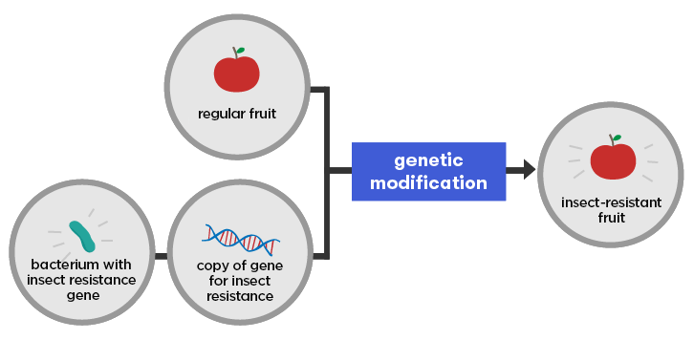

Biography: I am Khizar Hayat, Student of PhD Food Science & Technology, MNS-University of Agriculture, Multan, Pakistan. I would like to present my abstract in the conference. It will be helpful for my best future.
Khizar Hayat
kizarhayat36@gmail.com
Multan, Pakistan.

