Women, trauma and alcohol dependency: Connections and disconnections in alcohol treatment for women
Deanna L Mulvihill, RN PhD, TLI Foundation, USA Deanna L Mulvihill, RN PhD, TLI Foundation, USA

Abstract (300 word limit)
The suitability of some non-linear kinetic models (Weibull {with or without tail}, Log-linear, Log-linear shoulder {with or without tail}, Biphasic linear, Logistic, Multi-target and Single-target models) were evaluated to determine the inactivation kinetics of inoculated E. coli, and natural microbiota (i.e. mesophilic aerobic bacteria, and mold and yeast) on cherry tomato treated with fixed multi-frequency ultrasound. Almost all the studied model fitted well (R2 ≥ 0.9) for the inactivation kinetics; however, the Weibull, Log-linear shoulder, and Biphasic linear model showed the highest statistical parameters (0.9 ≤ adj. R2 ≤ 0.99 and smallest RMSE and SSE values). All the three models could be used to compare the kinetic behavior of E. coli and the first two models for the kinetic behavior of mesophilic aerobic bacteria and mold and yeast during sonication treatment. Two distinctive inactivation curves were obtained for the mono-frequency and the multi-frequency (dual and tri-frequency) for all the microbial inactivation. The remarkable results obtained for dual and tri-frequency sonication shows to be an effective and promising alternative to the traditional microbial inactivation techniques and the common practice of using ultrasound with other sanitizing methods.

Image
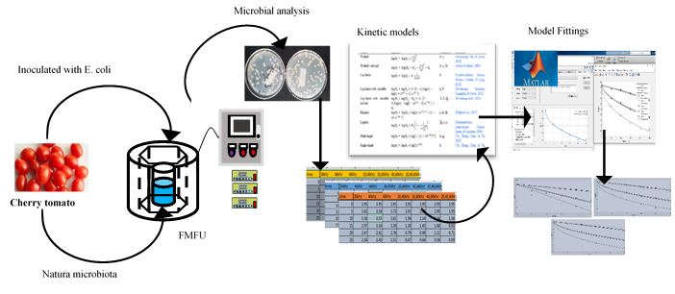
Recent Publications (minimum 5)
- Ali, A. A, T, Mustapha, A. T., Zhou, C., Sun, Y., Ma, H. (2020). Ultrasound and salinity effect on growth of chemical composition and protein quality of clover sprouts. Plant Archives, 20 (1), 2327-2337.
- Hassan, B., Mustapha, A. T., Al-Awaadh, A.M., Ahmed, K.A.M. (2020). Physical and Moisture Sorption Thermodynamics Properties of Sukkari Date(Phoenix dactylifera L) Powder. Journal of Food, 18 (1), 264-273. https://doi.org/10.1080/19476337.2020.1738558
- Mustapha, A. T., Zhou, C., Amanor-atiemoh, R., Otu, P., Qudus, A., Abiola, O., & Ma, H. (2020). Sonozonation : Enhancing the antimicrobial efficiency of aqueous ozone washing techniques on cherry tomato. Ultrasonics - Sonochemistry, (March). https://doi.org/10.1016/j.ultsonch.2020.105059
- Mustapha, A. T., Zhou, C., Amanor-atiemoh, R., Owusu-fordjour, M., Wahia, H., Abiola, O., & Ma, H. (2020). Kinetic modeling of inactivation of natural microbiota and Escherichia coli on cherry tomato treated with fixed multi-frequency sonication. Ultrasonics - Sonochemistry, 64(February), 105035. https://doi.org/10.1016/j.ultsonch.2020.105035
- Mustapha, A. T., Zhou, C., Sun, Y., Wahia, H., Sarpong, F., Owusu-Ansah, P., … Ma, H. (2019). Simultaneous multifrequency : A possible alternative to improve the efficacy of ultrasound treatment on cherry tomato during storage. Journal of Food Processing and Preservation, 14(83), 1–16. https://doi.org/10.1111/jfpp.14083
- Mustapha, A. T., Zhou, C., Wahia, H., Sarpong, F., Nasiru, M. M., Adegbemiga, Y. B., & Ma, H. (2019). Combination of thermal and dual-frequency sonication processes for optimum microbiological and antioxidant properties in cherry tomato. Journal of Food Processing and Preservation, 44(2), 1–12. https://doi.org/10.1111/jfpp.14325
- Mustapha, A. T., Zhou, C., Amanor-atiemoh, R., Ali, A. A, T, Wahia, H., Ma, H., & Sun, Y (2019). Efficacy of dual-frequency ultrasound and sanitizers washing treatments on
quality retention of cherry tomato. Innovative Food Science and Emerging Technologies, 62, 102348. https://doi.org/10.1016/j.ifset.2020.102348

Biography (150 word limit)
Dr. Mustapha, is a researcher in the school of food and biological engineering, China. His area of interest is postharvest processing and preservation. He is currently working on biomass production from Biomass
Email: atmbadmus30@gmail.com

Notes/Comments:

