Antibacterial effect of stainless-steel surfaces treated with a nanotechnological coating approved for food contact
Alessandro Di Cerbo, MS, PhD, PD, School of Bioscience and Veterinary Medicine, University of Camerino
Roberta Stocchi, DVM, PhD, PD, School of Bioscience and Veterinary Medicine, University of Camerino
Stefano Rea, DVM, PhD, ECVPH, School of Bioscience and Veterinary Medicine, University of Camerino
Anna Rita Loschi, DVM, PhD, ECVPH, School of Bioscience and Veterinary Medicine, University of Camerino

Abstract
Stainless steel, widely present in food industry, is frequently exposed to bacterial colonization with possible consequences on consumers’ health. 288 stainless-steel disks with different roughness (0.25, 0.5 and 1 μm) were challenged with four Gram-negative (Escherichia coli ATCC 25922, Salmonella Typhimurium ATCC 1402, Yersinia enterocolitica ATCC 9610 and Pseudomonas aeruginosa ATCC 27588) and four Gram-positive bacteria (Staphylococcus aureus ATCC 6538, Enterococcus faecalis ATCC 29212, Bacillus cereus ATCC 14579 and Listeria monocytogenes NCTT 10888) and underwent three different sanitizing treatments (UVC, alcohol 70% v/v and Gold lotion). Moreover, the same procedure was carried out onto the same surfaces after a nanotechnological surface coating (nanoXHAM® D). A significant bactericidal effect was exerted by all of sanitizing treatments against all bacterial strains regardless of roughness and surface coating. The nanoXHAM® D coating itself induced an overall bactericidal effect as well as in synergy with all sanitizing treatments regardless of roughness. Stainless-steel surface roughness is poorly correlated with bacterial adhesion and only sanitizing treatments can exert significant bactericidal effects. Most of sanitizing treatments are toxic and corrosive causing the onset of crevices that are able to facilitate bacterial nesting and growth. This nanotechnological coating can reduce surface adhesion with consequent reduction of bacterial adhesion, nesting and growth.

Image
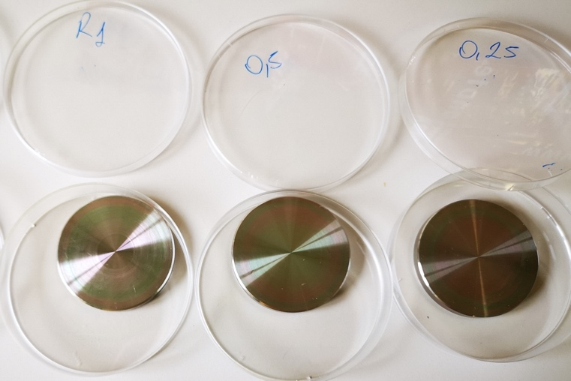
Recent Publications
- Di Cerbo, A.; Pezzuto, F.; Scarano, A. Cytotoxic and Bacteriostatic Activity of Nanostructured TiO2 Coatings. Pol J Microbiol 2016, 65, 225-229
- Rosace, G.; Canton, R.; Colleoni, C. Plasma enhanced CVD of SiOxCyHz thin film on different textile fabrics: Influence of exposure time on the abrasion resistance and mechanical properties. Applied Surface Science 2010, 256, 2509-2516
- Iannitti, T.; Di Cerbo, A.; Loschi, A.R.; Rea, S.; Suzawa, M.; Morales-Medina, J.C. Repeated administration of a flavonoid-based formulated extract from citrus peels significantly reduces peripheral inflammation-induced pain in the rat. Food Sci Nutr 2020, 8, 3173-3180
- Di Cerbo, A.; Mescola, A.; Iseppi, R.; Canton, R.; Rossi, G.; Stocchi, R.; Loschi, A.R.; Alessandrini, A.; Rea, S.; Sabia, C. Antibacterial Effect of Aluminum Surfaces Untreated and Treated with a Special Anodizing Based on Titanium Oxide Approved for Food Contact. Biology 2020, 9, 1-17
- Seeger, H.M.; Di Cerbo, A.; Alessandrini, A.; Facci, P. Supported lipid bilayers on mica and silicon oxide: comparison of the main phase transition behavior. J Phys Chem B 2010, 114, 8926-8933

/Biography
Alessandro Di Cerbo achieved the Master Degree in Medical Biotechnologies in 2007 at University of Modena (Italy), in 2011 he obtained the PhD in nanoscience and nanotechnology at the same University and in 2016 he got the postgraduate diploma in Clinical Biochemistry at University “G. d’Annunzio” of Chieti (Italy). His scientific activities are highly interdisciplinary, ranging from nanotechnology to human and veterinary pharmacology and food safety and current research interests deal with three main topics: 1) development of functional diets; 2) pharmacologic residues detection in animal-derived foods and in vitro toxicological assays; 3) antibacterial effect evaluation of aluminum and stainless-steel surfaces untreated and treated with nanotechnological coatings approved for food contact. He is author or co-author of more than 60 articles in peer-reviewed international journals.
Email: alessandro.dicerbo@unicam.it

