Biotechnological re-cycling of apple by-products: A reservoir model to produce a dietary supplement fortified with biogenic phenolic compounds
Ali Zein Alabiden Tlais, PhD, Free University of Bolzano, Italy

Abstract
Statement of the Problem: Approximately 89 million tonnes of food were lost or wasted annually in the European Union, with associated costs estimated at €143 billion. Apple pomace from apple (Malus domestica sp.) processing represents a by-product model given the ubiquitous presence of the fruit in the diet of all cultures and the high annual harvest. Methodology & Theoretical Orientation: This study is an example of apple by-products (AP) recycling through a well-designed fermentation with selected Lactobacillus plantarum AFI5 and Lactobacillus fabifermentans ALI6 used singly or as binary starters with the selected Saccharomyces cerevisiae AYI7 with the perspective of producing dietary supplements or pharmaceutical preparations. Findings: Compared to Raw-, Unstarted- and Chemically Acidified-AP, Fermented-AP promoted the highest levels of total and insoluble dietary fibers, antioxidant activity, and free phenolics. The binary culture of L. plantarum AFI5 and S. cerevisiae AYI7 had the best effect on the bioavailability phenolic compounds as resulted by the LC-MS/MS validated method. The accumulation of phenolic acids derivatives highlighted the microbial metabolism during AP fermentation. Bio-converted phenolic compounds were likely responsible for the increased antioxidant activity. The potential health-promoting effects of Fermented-AP were highlighted using Caco-2 cells. With variations among single and binary cultures, fermented-AP counteracted the inflammatory processes and the effects of oxidative stress in Caco-2 cells, and preserved the integrity of tight junctions. Conclusion & Significance: We proposed an alternative and suitable model for food by-products recycling to manufacture a dietary supplement fortified with biogenic compounds. Highlighting the microbial metabolism of several phenolic compounds, we created undoubted additional value to such downstream wastes.

Image
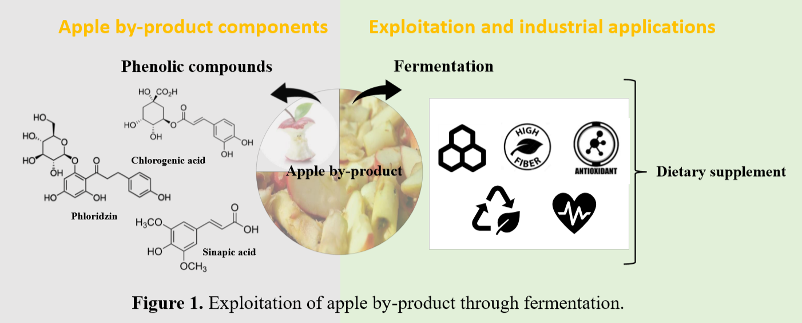
Recent Publications
- Filannino, P., Di Cagno, R., Tlais, A. Z. A., Cantatore, V., & Gobbetti, M. (2019). Fructose-rich niches traced the evolution of lactic acid bacteria toward fructophilic species. Critical reviews in microbiology, 45(1), 65-81.
- Filannino, P., Tlais, A. Z. A, Morozova, K., Cavoski, I., Scampicchio, M., Gobbetti, M., & Di Cagno, R. (2020). Lactic acid fermentation enriches the profile of biogenic fatty acid derivatives of Avocado fruit (Persea americana Mill.). Food Chemistry, 317, 126384.
- Tlais A. Z. A, Fiorino G.M., Polo A., Filannino P., Di Cagni R. (2020) High-Value Compounds in Fruit, Vegetable and Cereal Byproducts: An Overview of Potential Sustainable Reuse and Exploitation. Molecule, 25, 2987.

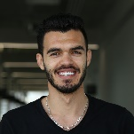Biography
Ali Zein Alabiden Tlais is PhD student at the Faculty of Science and Technology of the Free University of Bozen-Bolzano (UNIBZ) since 2017. The PhD is dedicated to the study of bioactive compounds metabolism during fermentation of fruits and vegetables. His main research activities, conducted over the last 3 years, are focused on culture dependent approach (isolation, DNA extraction and identification of yeast and lactic acid bacteria), culture independent approach (shotgun analysis), exploitation of microorganisms during fermentation and bioactive compounds quantification and characterization (polyphenols, fattyacids, proteins, dietary fibers and exopolysaccharides).Email:atlais@unibz.it

