Recent applications of microbial transglutaminase in food processing
Heba S. Mostafa, PhD, Faculty of Agriculture, Cairo University, Egypt

Abstract (300 word limit)
The glue of proteins (transglutaminase, TGase) has been extensively used in the food processing industries due to its broad enzymatic activity. It is almost produced by microorganisms to decrease the cost of manufacturing animal origin transglutaminase. The net % increase of enzymes applications in the processed food industries is estimated to 21.9% per year, MTG being a major one. In fact, the microbial transglutaminase (MTG) is consumed by most of the food industries, spanning the meat, dairy, sea food and fish, plant proteins and many more. It used to improve gelation and change foaming, emulsification, viscosity, consistence and water-holding capacity. This paper presents an overview of the literature that described and investigates the sources, characteristics and recent applications of microbial transglutaminase.

Image

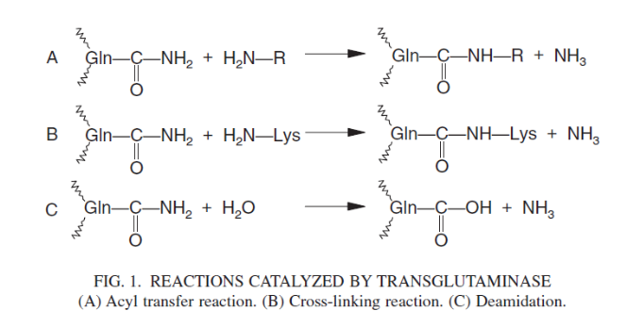

Figure 1: Reaction catalyzed by transglutaminase.

Acyl transferas. (B) Cross-linking reaction. (C) Deamidation.

Recent Publications (minimum 5)
- Mohsen S, El-Shimi N, Abdallah N, Mosatafa H (2009) Selection of high quality baker's yeast mutant for bread-making. Egyptian Journal of Biotechnology 31:314-327..
- Mostafa H (2010) Improvement of Baker's yeast characteristics by mutation and growth factors. M.Sc. Thesis, Food Science Dept., Faculty of Agriculture, Cairo University.
- Mohsen S, Bazaraa W, Khattab A, El-Shimi N, Mostafa H (2015) Mutagenesis and fermentation-optimization of Arthrobacter sp. for improved glucose isomerase synthesis. Egyptian Journal of Biotechnology 50:1-13.
- Bazaraa W, Mohsen S, Khattab A, El-Shimi N, Mostafa H (2016) Protoplast fusion for enhanced glucose isomerase synthesis by Arthrobacter sp. hyper-producing mutants. Egyptian Journal of Biotechnology 50:25-39.
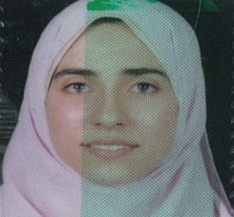
- Mostafa H (2016) Mutagenesis and protoplast fusion of Arthrobacter sp. for improved glucose isomerase production.
Journal of Microbiology and Biochemistry Technology 8:6 (Suppl).

Biography (150 word limit)
Heba Mostafa has her expertise in food microbiology, biotechnology and Enzymology as she has worked as demonstrator then lecturer since 2003 in Food Science Department, Faculty of Agriculture, Cairo University. She has also expertise in many food biotechnology approaches such as mutation and protoplast fusion to improve the characteristics of promising microbial strains. She has many years of experience in research, evaluation, teaching and administration in Food Science Department, Faculty of Agriculture, Cairo University, Egypt.
Email: Hebabiotech@gmail.com

Notes/Comments:

