Situation of heavy metals (Pb, Cd) in the plant-based beverages sold in the city of abidjan, Côte d’Ivoire : case of the Bissap extracted from Hibiscus sabdariffa

M'boh Gervais Melaine^{1*}, N'guessan Ismael Gbabia Zie², Ackah Jacques Auguste Alfred Bognan², Konan Kouassi Martin³, Djaman Allico Joseph^{1,3}

1: Pasteur Institute of Ivory Coast, Department of biochemistry
2: University of Jean Lorougnon Guédé University,faculty of biological science
3: University of Félix Houphouët Boigny, faculty of biological science

*corresponding author: mbohgervais@yahoo.fr

Abstract
The heavy metals present in our environment expose our organism to risks of poisoning at the origin of serious pathologies such as: cancer, respiratory diseases, and disorders of the infertility. Our study aims to search for certain metals such as lead and cadmium in a beverage consumed by Abidjan populations "Bissap juice" extracted from a locally grown plant, its scientific name Hibiscus sabdariffa. The chalices of this plant were collected in three main communes of the city of Abidjan (Adjamé, Yopougon, Abobo). Heavy metals such as lead and cadmium have been evaluated in both the Hibiscus sabdariffa and beverage calyxes by the Atomic Absorption Spectrometry method. The results revealed a presence of these metals in both calices: Cd (23.14 ± 13.33 mg / kg), Pb (77.94 ± 15.62 mg / kg), and the extracted beverage (Bissap): Pb (0.54 ± 0.14 mg / L) and Cd (0.22 ± 0.06 mg / L).These data compared to Codex Alimentarius and European Commission standards revealed a significant risk of lead and cadmium intoxication in the calyx and Bissap juice. Our study requires more investigation in order to evaluate the factors involved in the chain of contamination, and to measure the toxicological and physiopathological risks incurred by an excessive consumption of this drink.

Image

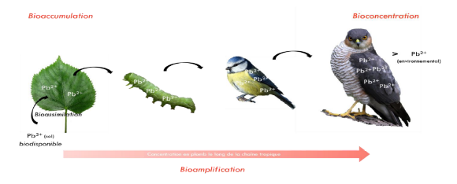
Figure 1: Bioaccumulation cycle of heavy metal
Recent publications

Recent publications
M’boh Gervais Melaine, N’guessan Ismael Gbabia Zie, Ackah Jacques Auguste Alfred Bognan, Konan Kouassi Martin and Djaman Allico Joseph. Assessment of Trace Elements in Bissap (Hibiscus sabdariffa) Sold in the City of Abidjan in Cote d’Ivoire. Journal of Plant Biochemistry & Physiology. 2017 ; 5: 197. doi: 10.4172/2329- 9029.1000197.

Gauthier C (2013) The impact of urban pollution on urban food production.Final report of the research carried out on behalf of the Brussels Institute for Environmental Management, Green Loop, p: 35.

WHO (2017) International Program on Chemical Safety, Sections: Ten chemicals that pose a major public health problem.

Kouakou KJ, Sika AE, Gogbeu SJ, Yao KB, Bounakhla M, et al. (2015) Level of exposure to metallic trace elements (Cd, Cu, Pb, Zn, Ni) of amaranth (Amaranthus paniculatus L.) and lettuce (Lactuva sativa L.) grown on marshy sites in the city of Abidjan (Abidjan, Ivory Coast). International Journal of Innovation and Applied Studies 10: 21-29.

Ministry of Health and Public Hygiene (2016) National policy to improve the quality of health care and services in Côte d’Ivoire. Abidjan, p: 68.

Kouamé KB, Koné WM (2017) Evaluation of the treatment and storage conditions of medicinal plants in the markets of the District of Abidjan (Côte d’Ivoire). European Scientiic Journal 13: 396-415
Jafiol C (2016) Chronic Diseases: The New Challenge for Health in the 21st Century. Academy of Sciences and Letters of Montpellier (France), pp: 241- 252.

Biography
I have a PhD in biochemistry obtained since 2011 at the University of Abidjan; Cocody in Côte d’Ivoire. Since 2011, I work as a researcher at the Pasteur Institute of Côte d'Ivoire in the department of Biochemistry. I was appointed in 2016 as the head of the Training Department and I worked in 2017 as a consultant in the framework of the West African laboratory network, for the training of laboratory technicians in Guinea Bissau and Cape Verde. My interest research Micronutrients biomolecules and infectious diseases, Heavy metals-food safety and health, Natural substances and development of new therapeutics.

