Process optimization for preparation of IgG enriched bovine colostrum whey powder

Harish Kumar, PhD, Amity University Rajasthan, India
Naveen Kumar, PhD, Amity University Rajasthan, India
Raman Seth, PhD, National Dairy Research Institute, Karnal, India

Abstract
Colostrum is the mammary secretion produced during the 72 hours after parturition which provides nourishment to the newborn. Colostrum has antioxidant and anti-inflammatory properties and a good source of many vitamins, minerals, enzymes and amino acids. Colostrum has a therapeutic role to fight against AIDS, heart disease. Colostrum contains powerful immune factors (immunoglobulins, cytokines and lactoferrin) that work to restore the immune function. Growth factors in colostrum not only helps in building and restoring bone, muscles, nerve tissues, connective tissues, skin, cartilage, but also helps in the proliferation and differentiation of cells and tissues. These growth factors have also been shown to help in increasing lean muscle and assist in wound healing. The objective of present study was to prepare the bovine colostrum whey powder and IgG enriched whey colostrum powder an alternative source of passive immunity for bovine calf, considering newborns consuming non-maternal colostrum. Colostrum-based products are commercially available as a health food supplement and are marketed as a general “health promoting” product, particularly suitable for athletes. The study was conducted on fifteen Karan Swiss dairy cows at National Dairy Research Institute, Karnal, India. Bovine colostrum whey powder was prepared from colostrum by renneting and obtained whey was ultrafiltered by using 100 kDa membranes in order to enrich IgG. Colostrum whey and processed ultrfiltrate whey were lyophilized to prepared powder. Lyophilized IgG enriched whey colostrum powder had higher IgG concentration (P<0.05) and protein (P<0.05) compared to the colostrum whey powder. The high IgG and the protein composition of colostrum whey powder and IgG enriched whey colostrum powder suggests it could be used as a health supplement that helps in the development of immunity in the newborn.

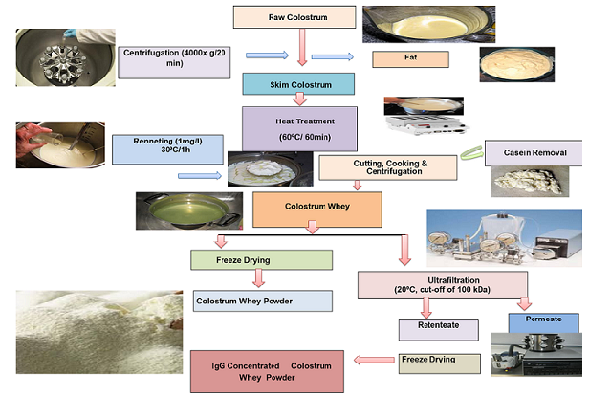
Figure1Preparation of Bovine colostrum whey powder & IgG enriched colostrum whey powder
Recent Publications

- Buckley J, Brinkworth G and Abbott M (2003). Effect of bovine colostrum on anaerobic exercise performance and plasma insulin-like growth factor. Journal of Sports Sciences 21: 577-588.
- Bhushan S and Etzel M (2009). Charged ultrafiltration membranes increase the selectivity of whey protein separations. Journal of Food Science 74:131-139.
- Baldasso-Canovas G, Barros T and Tessaro I (2011). Concentration and purification of whey proteins by ultrafiltration. Desalination 278: 381-386.
- Kumar H, Kumar N, Seth R, Goyal A (2014). Chemical and immunological quality of goat colostrum: 67: 33-38
- Menchetti L, Traina G, Tomasello G, Casagrande- Proietti P, Leonardi L, Barbato O, Brecchia G (2016). Potential benefits of colostrums in gastrointestinal diseases. Frontiers Bioscience. 8: 331–351.

 Biography
Harish Kumar has expertise in the field of dairy chemistry. He did PhD from National Dairy Research Institute (NDRI) Karnal, India. He published more than 20 research articles in national and international journals. Currently, he is working as an Assistant Professor in Amity University Rajasthan, India. Previously he worked as Assistant Manager in Paras Dairy, Madhya Pradesh India. He has collaborated with eminent researchers from India and Abroad. Recently he is running a research project funded by SERB Government of India.
Email: harishkanwar3@gmail.com

Notes/Comments

