Cover-ED: Polymeric edible coatings for enhanced preservation of meat
Elodie Melro, Luis Alves, Gabriela Martins, Artur Valente, Filipe E. Antunes
University of Coimbra, Portugal.

Maria Ines Cruz, Phillippe Ramos, Fatima Carvalho Primor Charcutaria Prima SA, Portugal

Abstract (300 word limit)
The way human beings feed themselves strongly influences their physical and emotional balance. Meat products are an excellent source of nutrients and are widely consumed around the world. However, these products are also susceptible to chemical and microbiological deterioration, which creates health risks. Consumption of contaminated food and water kills 1.8 million people annually. In addition, each person is wasting an average of 150kg of food per year, also due to lack of food conservation. Packaged meat products arrive at the consumer's house in good food safety conditions. However, food contamination is a serious concern at the post-opening stage of the package. It is thus urgent to create more advanced solutions of food preservation, which reduce the contamination and increase the shelf-life after the package is opened. This project addresses this problem. New systems were developed to promote longer shelf life through the incorporation of consumer safe edible coatings in the meat products. Furthermore, this coating prevents the use of the protective N2/CO2 atmosphere in the packaging, which leads to the reduction of the amount of plastic used in the packaging, yielding a better environmental impact. The various types of performed assays included: chemical, physical and microbiological tests to identify coatings with improved bacterial elimination, light scattering and rheology tests to identify the best suited coatings for spray application, and electron microscopy to compare the level of meat degradation with and without coating. Color, taste, texture and odor were continuously monitored throughout the project. After the laboratory tests, the best performance coatings were applied in semi-industrial environment.
Based on the results of Cover-ED Project, meat products with a new generation of preservation, will be available to consumers.
The results of Cover-ED Project allowed the development of a new generation of preservation meat products soon available to the consumers.

Image
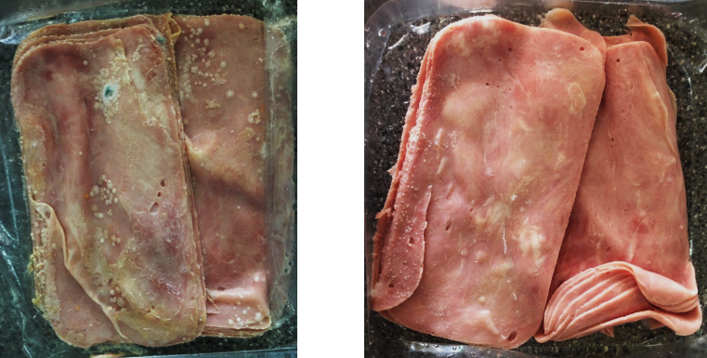

Fig: Influence of the designed coating in the preservation of meet based products without protective N2/CO2 atmosphere. Left: Without coating. Right: With coating.
Recent Publications
- Delahunty, C., et al., Sensory characterisation of cooked hams by untrained consumers using free-choice profiling. Food Quality and Preference, 1997. 8(5-6): p. 381-388.
- Katsaras, K. and K.-D. Budras, The relationship of the microstructure of cooked ham to its properties and quality. LWT-Food Science and Technology, 1993. 26(3): p. 229-234.
- Toldr, F., Handbook of Meat Processing. 2010: Wiley.
- Los, F.G.B., et al., Characterization of commercial cooked hams according to physicochemical, sensory, and textural parameters using chemometrics. Food Science and Technology (Campinas), 2014. 34(3): p. 577-584.
- Barbieri, S., et al., Sensory and rapid instrumental methods as a combined tool for quality control of cooked ham. Heliyon, 2016. 2(11): p. e00202.
- Hui, Y.H., et al., Handbook of Food Products Manufacturing, 2 Volume Set. 2007: John Wiley & Sons.Heilig M, Egli M (2006) Pharmacological treatment of alcohol dependence: Target symptoms and target mechanisms. Pharmacology and therapeutics 111:855-876.


Biography (150 word limit)
Filipe E. Antunes has his expertise on Polymer Chemistry. His research includes polymer-surfactant association, polymeric coatings, nano and microencapsulation, rheological control and gelation of polymeric systems. Most of his research is developed within multinational consortiums with worldwide companies. He is the project leader of COLLING (Colloids and Innovative Nanomaterials Group) at University of Coimbra, Portugal.
Email: filipe.antunes@ci.uc.pt

