Development of a new winemaking lees based emulsion.
Sancho-Galán, P. (MSc), Amores-Arrocha, A. (MSc), Jiménez-Cantizano, A (PhD). and Palacios, V (PhD).
Department of Chemical Engineering and Food Technology, Faculty of Sciences, University of Cádiz, Agri-food Campus of International Excellence (CeiA3), IVAGRO, P.O. Box 40, 11510 Puerto Real, Cádiz, Spain.

Abstract
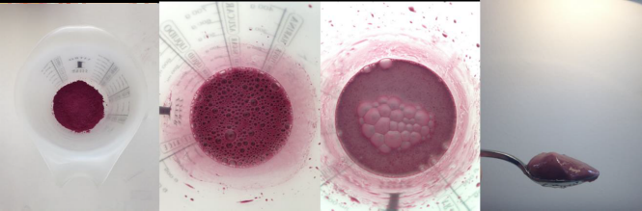
Vinification lees are a residue generated after the vinification process (Pérez-Serradilla & Luque de Castro, 2008). According to Pérez-Bibbins (2015), winemaking lees represent 6% of each winemaking grapes ton. This value implies a high percentage of waste which must be managed by the winery itself. However, unlike the uses given to other by-products generated in the wine industry, new winemaking lees uses are not currently developed.
Figure 1. Development process of a new food emulsion based on winemaking lees
Winemaking lees has a heterogeneous composition (Peralbo-Molina & Luque de Castro, 2013). In addition, several studies have shown that they present high antioxidant power due to the content in polyphenols and anthocyanin (Pérez-Serradilla & Luque de Castro, 2011), therefore they could be considered of high alimentary level interest. On the other hand, previous studies have shown modification of the technological properties and sensory profile into a food matrix, improving the food properties (Hwang, Shyu, & Hsu, 2009).

The objective of this study is the physical-chemical and nutritional characterization of the lees obtained in different vinifications, as well as their technological potential, for the development of a mayonnaise-type emulsion formulation using wine lees as a substitute for the eggs. The product obtained showed high antioxidant values compared to commercial mayonnaises, besides similar values of pH and texture.
Image
Recent Publications
- Pérez-Serradilla, J. A., & Luque de Castro, M. D. (2008). Role of lees in wine production: A review. Food Chemistry.
- Pérez-Bibbins, B., Torrado-Agrasar, A., Salgado, J. M., Oliveira, R. P. de S., & Domínguez, J. M. (2015). Potential of lees from wine, beer and cider manufacturing as a source of economic nutrients: An overview. Waste Management, 40, 72–81.
- Peralbo-Molina, Á., & Luque de Castro, M. D. (2013). Potential of residues from the Mediterranean agriculture and agrifood industry. Trends in Food Science & Technology, 32(1), 16–24.
- Pérez-Serradilla, J. A., & Luque de Castro, M. D. (2011). Microwave-assisted extraction of phenolic compounds from wine lees and spray-drying of the extract. Food Chemistry.
- Hwang, J. Y., Shyu, Y. S., & Hsu, C. K. (2009). Grape wine lees improves the rheological and adds antioxidant properties to ice cream. LWT - Food Science and Technology.

 Biography
Pau Sancho, together with the Food Engineering and Technology research group of the University of Cádiz (Spain), has worked during the last year in the development of new foods from wine by-products. His research has received the award in The Vine Science Award (Amsterdam, 2017), At the same time, he has continued working on the extraction polyphenols from wine lees. He is currently finishing the master's degree in Agri-food production and developing his research on the influence of bee pollen presence in the development of Sherry wines biological aging.
Email: pau.sanchgalan@alum.uca.es

Notes/Comments:

