Abstract Template

Title: Structural and heat transfer modelling of lighter expanded polystyrene boxes

Bjorn Margeirsson^{1,2}, Sigurdur Jakob Helgason¹, Helga Lilja Jonsdottir¹, Sigurdur Brynjolfsson¹, Halldor Palsson¹, Sigurjon Arason^{3,4}
¹Faculty of Industrial Engineering, Mechanical Engineering and Computer Science, University of Iceland, Reykjavik, Iceland
²RPC-Tempra, Hafnarfjordur, Iceland
³Matis, Reykjavik, Iceland
⁴Faculty of Food Science and Nutrition, University of Iceland, Reykjavik, Iceland

Keywords: Expanded polystyrene boxes, Fresh fish, Heat transfer modelling, Structural modelling, Packaging weight
- Abstract Body (up to 250 words)
Discussion about the environmental impact of single use plastic packaging has increased during recent years. Due to its high insulation value and strength to weight ratio, expanded polystyrene (EPS) boxes are the industry standard for packing fresh fish and the recommended choice worldwide, especially in case of poor temperature control during distribution. EPS boxes are available in different size ranges but the most common ones are designed for 3 to 25 kg of fish. For packing fresh, whole salmon, typically 20-22 kg of fish is packed with 4-5 kg of ice or ice packs on top in an EPS box with volume capacity of around 40 L and weight of around 650-900 g. The aim of the project Lighter salmon box is to integrate the methods of computational heat transfer modelling, structural analysis and laboratory experiments and in the real supply chain in order to improve the design of expanded polystyrene boxes used for export of fresh, farmed fish. The effects of decreased EPS density on strength and insulation are also studied. The cooperative partners are University of Iceland, the largest fresh fish box manufacturer in Iceland, Tempra ltd., and the largest farmed fish exporter in Iceland, Arnarlax ltd. The higher order objective is to decrease the environmental impact of fresh fish packaging.

- Image:

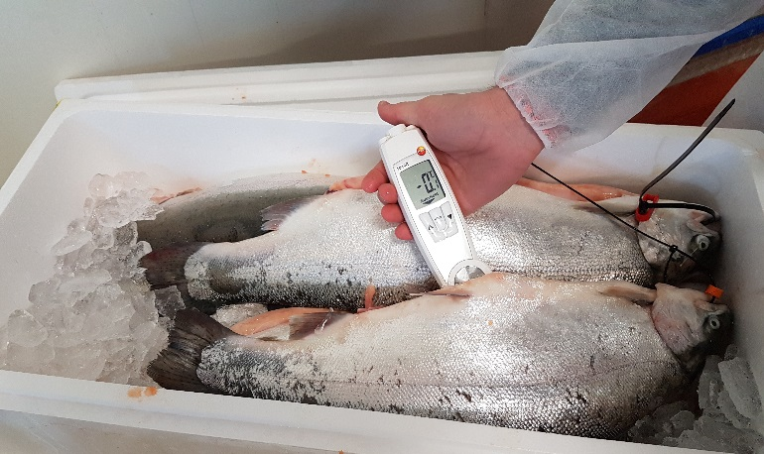
Figure 1. Temperature measured in farmed fish packed in ice in the current version of the 40-L EPS box manufactured by Tempra as at January 2018.
References:
- Seafish Industry Authority. 1996. Fresh Fish Wholesale Packaging. Available at http://www.seafish.org/media/Publications/datasheet_96_03_FT.pdf [accessed Jan 23, 2018].
- Mai, N.T.T, Margeirsson, B., Margeirsson, S., Bogason, S., Sigurgísladóttir, S., Arason, S. 2011. Temperature Mapping of Fresh Fish Supply Chains – Air and Sea Transport. Journal of Food Process Engineering 35(4):622-656.

- Padade, A.H., Mandal, J.N. 2012. Behavior of Expanded Polystyrene (EPS) Geofoam Under Triaxial Loading Conditions. Elec. J. Geotech. Eng., 17:2543-2553.

- Margeirsson, B., Gospavic, R., Pálsson, H., Arason, S., Popov, V. 2011. Experimental and numerical modelling comparison of thermal performance of expanded polystyrene and corrugated plastic packaging for fresh fish. International Journal of Refrigeration 34 (2):573-585.

- Margeirsson, B., Pálsson, H., Popov, V., Gospavic, R., Arason, S., Sveinsdóttir, K., Jónsson, M.Þ. 2012. Numerical modelling of temperature fluctuations in superchilled fish loins packaged in expanded polystyrene and stored at dynamic temperature conditions. International Journal of Refrigeration 35(5):1318-1326.

- Margeirsson, B., Pálsson, H., Gospavic, R., Popov, V., Jónsson, M.Þ., Arason, S. 2012. Numerical modelling of temperature fluctuations of chilled and superchilled cod fillets packaged in expanded polystyrene boxes stored on pallets under dynamic temperature conditions. Journal of Food Engineering 113(1):87-99.

- Marine Harvest. 2017. Salmon Farming Industry Handbook. Available at http://marineharvest.com/globalassets/investors/handbook/salmon-industry-handbook-2017.pdf [accessed Jan 23, 2018].
- Biography:
Bjorn Margeirsson is a mechanical engineer holding an MSc degree from Chalmers University of Technology in Gothenburg, Sweden and a PhD from University of Iceland since 2012. He serves as Assistant Professor at the University of Iceland since 2016 and Research Manager at the plastic manufacturers RPC-Saeplast and RPC-Tempra in Iceland since 2013. He has been involved in research, development and teaching within the field of heat transfer modelling, fresh fish processing, packaging and transport for 10 years.

- Presenting author details

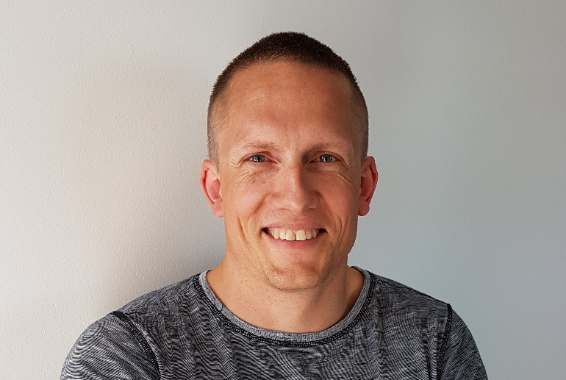
Full Name: Bjorn Margeirsson
Contact number: +354 8984901
Twitter account: https://twitter.com/bjornmarg
Linked In account: https://www.linkedin.com/in/bj%C3%B6rn-margeirsson-b3a81424/
Session name/ number: Session 1. Food Preservation / Session 5. Food Quality, Safety and Preservation
Category: Oral presentation
Passport Number: A3182111

