Abstract Template

Title: Volume utilization and fresh fish quality during transport in different food containers

Bjorn Margeirsson^{1,2}, Dagur Oskarsson², Sigurjon Arason^{3,4} , Magnea Karlsdottir³, Ogmundur Knutsson⁵
¹Faculty of Industrial Engineering, Mechanical Engineering and Computer Science, University of Iceland, Reykjavik, Iceland
²RPC-Saeplast, Dalvik, Iceland
³Matis, Reykjavik, Iceland
⁴Faculty of Food Science and Nutrition, University of Iceland, Reykjavik, Iceland
⁵School of Business and Science, University of Akureyri, Akureyri, Iceland

Keywords: Food containers, Fresh fish, Fish Quality, Volume utilization, Superchilling
- Abstract Body (up to 250 words)
Insulated plastic containers with volume capacity of 300–600 L have replaced smaller, more primitive wooden and single wall plastic containers in many fish industries worldwide. The main reasons are faster and easier handling and transport of the fish and improved temperature control, traceability, grading and quality. The current work is conducted in cooperation between Sæplast, Matís, Innovation Center Iceland, University of Iceland, University of Akureyri, ITUB and Icefresh in Germany. The aim is to develop new twin-transport tubs, which are intended to improve volume utilization during transport and storage and decrease transport cost, preserve food quality as well or better and improve stacking safety compared to existing packaging solutions. Transport of both wild cod and farmed fish are studied and the new tubs compared to the widely used 460-L tubs and 25-kg expanded polystyrene boxes with regard to cost, quality and handling safety. The main results obtained show that the new twin transport containers, which were placed on the market in 2018, offer around 50% better volume exploitation then the traditional 460-L tubs during transport of empty tubs in trucks. It has also been shown that the quality preservation of superchilled fish during one-week transport is similar in tubs with depth of 29-40 cm as compared to expanded polystyrene boxes with depth of 17 cm.

- Image:

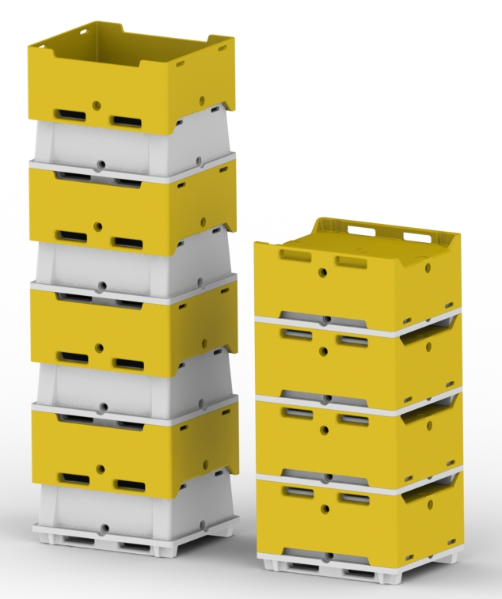
Figure 1. Stacking of the new twin-transport tubs as they would contain food products (left) and empty (right).

- References:
- Brox, J., Kristiansen, M., Myrseth, A., Aasheim, P.W. 1984. Planning and engineering data. Containers for fish handling. FAO. Available at http://www.fao.org/docrep/003/r1263e/ r1263e03.htm.

- Mai, N.T.T, Margeirsson, B., Margeirsson, S., Bogason, S., Sigurgísladóttir, S., Arason, S. 2011. Temperature Mapping of Fresh Fish Supply Chains – Air and Sea Transport. Journal of Food Process Engineering 35(4):622–656.

- Seafish. 2013. Improving catch quality on inshore vessels. Industry fact sheet. http://www.seafish.org/media/Publications/FS76_ImprovingCatchQualityonInshoreVessels_201311.pdf
- Jónsson, Á. 2016. Optimized sea transport of fresh fish fillets and loins – quality and cost. Master’s thesis. University of Iceland.
- Jónsson, Á., Margeirsson, B., Arason, S., Karlsdóttir, M.G., Þórðarson, G., Knútsson, Ö. 2017. Gæða- og kostnaðargreining á ferskum sjófluttum flökum og bitum (Quality and cost assessment of fresh sea transported fillets and portions). In: Spring Conference of the School of Business at the University of Iceland, 19 April 2017. Reykjavík, Iceland.

- Margeirsson, B., Þórðarson, G., Guðjónsson, A.H. 2017. Transport of chilled and superchilled rainbow trout in insulated containers and expanded polystyrene boxes – Trial shipment from Westfjords, Iceland to Slupsk, Poland. Technical report. Sæplast, University of Iceland.

- Margeirsson, B. New fresh fish containers for lower transport costs and improved quality. Presentation given at the World Seafood Congress 2017, 12 Sept 2017. Reykjavík, Iceland.

- Biography:
Bjorn Margeirsson is a mechanical engineer holding an MSc degree from Chalmers University of Technology in Gothenburg, Sweden and a PhD from University of Iceland since 2012. He serves as Assistant Professor at the University of Iceland since 2016 and Research Manager at the plastic manufacturers RPC-Saeplast and RPC-Tempra in Iceland since 2013. He has been involved in research, development and teaching within the field of heat transfer modelling, fresh fish processing, packaging and transport for 10 years.

- Presenting author details

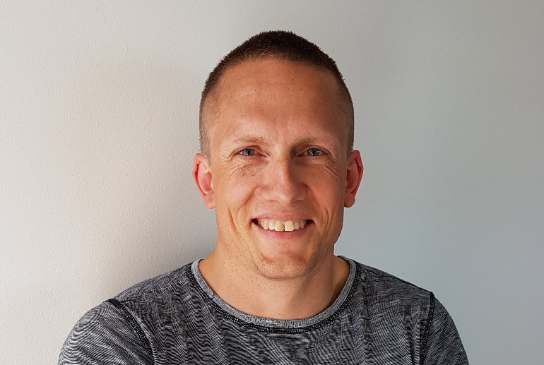
Full Name: Bjorn Margeirsson
Contact number: +354 8984901
Twitter account: https://twitter.com/bjornmarg
Linked In account: https://www.linkedin.com/in/bj%C3%B6rn-margeirsson-b3a81424/
Session name/ number: Session 1. Food Preservation / Session 5. Food Quality, Safety and Preservation
Category: Poster presentation
Passport Number: A3182111

