Title: Composition and In-Vitro Protein Digestibility of Provitamin A-Biofortified Amahewu, a Non-Alcoholic Maize Based Beverage

Temitope D. AWOBUSUYI
University of KwaZulu-Natal, South Africa
Keywords: Provitamin A-biofortified maize, Amahewu, Vitamin A Deficiency

- Abstract
Amahewu, a lactic acid fermented non-alcoholic maize based beverage is widely consumed in Southern Africa (Chelule et al., 2010). It is a very popular sour gruel produced by the lactic fermentation of a cereal grain. (Nyanzi et al., 2010). The proximate composition, mineral profile, amino acid profile and in vitro protein digestibility of raw, fermented and provitamin A-biofortified amahewu produced using provitamin A-biofortified maize was studied. Provitamin A-biofortified amahewu was processed by fermenting maize porridge using malted provitamin A maize, wheat bran and lactobacillus starter culture with either malted maize or wheat bran. Protein digestibility of amahewu (approx. 91%) was slightly higher compared to unprocessed provitamin A maize (86%). The mineral profile of amahewu samples did not very much differ after fermentation. The concentration of essential amino acids such as lysine, tryptophan and methionine increased in all amahewu samples after fermentation. The gross energy of amahewu products was about 20 MJ/kg. These results suggests that provitamin A-biofortified maize amahewu is much better than white maize amahewu in terms of its nutritional quality and can be used to alleviate protein energy malnutrition among vulnerable groups.

II. Fermented Amahewu:
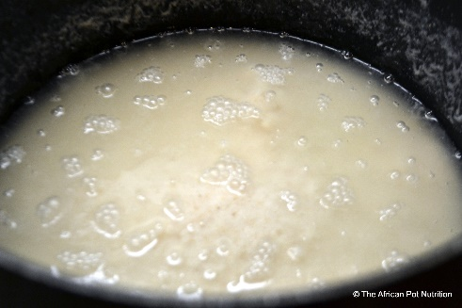

III. References
- Nyanzi, R., Jooste, P. J., Abu, J. O. and Beukes, E. M. 2010b. Consumer acceptability of a symbiotic version of the maize beverage mageu. Development Southern Africa, 27 (3): 447-463.

- Chelule, P. K. Mbongwa, H. P. Carries, S. and Gqaleni, N. 2010b. Lactic acid fermentation improves the quality of amahewu, a traditional South African maize-based porridge. Food Chemistry, 122: 656-661.
IV. Biography
The author is a young female PhD student at the University of Kwazulu-Natal in South Africa. Her area of expertise includes, Human Nutrition, cereal technology, food product development and sensory techniques. She is currently researching on using insects protein to develop novel and functional foods for the alleviation of protein energy malnutrition which could help in aiding food security among vulnerable population.

V. Presenting author details



Full Name: Temitope D. Awobusuyi
Contact number: +27836614973
Session name/ number: Food, Nutrition & Health.
Category: Oral presentation
Passport Number: A08514759

