Abstract Template
Title: A new perspective on Navier-Stokes equation
Sheng W
SW MARE Marine Technology, Ireland
Abstract Body (up to 300 words):
The Navier-Stokes (N-S) equation has been a well-accepted mathematical equation for governing fluid motion since Navier in 1822 and Stokes in 1845 (and others) successfully added the fluid viscous force to Euler equation, and numerous successes of using N-S equation in practical applications have been attained. However, there are still a lot of challenges in fluid dynamics, especially in seeking the solutions of the N-S equation in the areas related to the complicated flows involving in turbulence, unsteady flows, and flow separations. Nowadays with the advances in computation platforms and computing technologies, the complicated problems are normally solved using numerical simulation, namely computational fluid dynamics (CFD), but we are still facing huge challenges in the turbulence modelling, grid qualities and computer capacities. In contrast, the N-S equation and their related principles are so well accepted that few people dare to question whether there may be some misunderstandings behind the equation.
The author has recently made an effort to derive and better understand the N-S equation. It is found that, although the N-S equation is proven to be correct (the author agrees to it), some concepts behind the equation may not be correct. The author realises that the symmetric viscous stress tensor for fluids which was adopted fully from the solids may be actually in contradicting with the definition of fluids, since fluids can not resist a shear stress at rest, or in other word, a shear stress would cause a flow in fluids, a permanent deformation, rather than inducing a symmetric counter stress (this is very different from the solids, see Figures 1 and 2). Moreover, the author finds that even in the simple classic Couette flow, the requirement of the symmetric stress tensor is conflicting with the solution of the Couette flow.
Based on a better physical understanding to the forces acting on the fluids, the author is able to reformulate the total tensor for accommodating the surface force for fluids, and this new formulation could solve the inconsistencies we found in the practical problems. Using the newly defined surface forces based on the direct physical understanding, the exact same N-S equation to the original form of N-S equation (Stokes) can be derived for incompressible flows. For compressible flows, to achieve the same N-S equation as the original N-S equation, a slightly different assumption is made, which is in a similar manner as the assumption Stokes made, but bears better physics. All these mean that the N-S equations are same, but some concepts behind them are different.
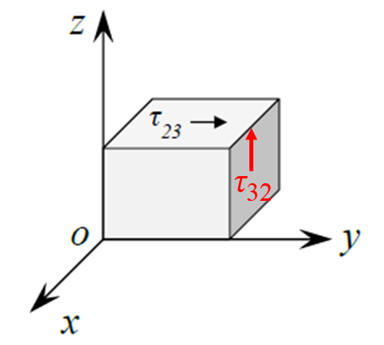
Figure 1 An applied stress τ₂₃ and a counter (symmetric) stress τ₃₂ in solids
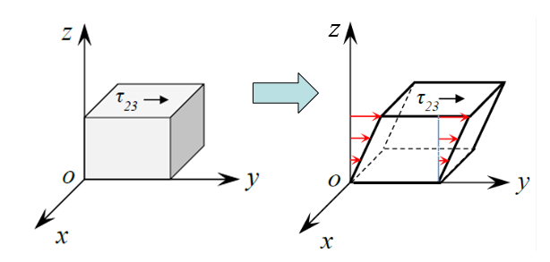
Figure 2 An applied stress τ₂₃ and a flow motion in fluids

Biography:
Dr. Wanan Sheng (Prof. ) has completed his PhD in 2004 and Postdoctoral Studies at the from Glasgow University (UK) and then senior research fellow in University College Cork, Ireland. He is currently the owner and consultant of SW MARE Marine Technology, a premier consultancy organization. He has published more than 44 papers in reputed journals and has been serving as an editorial board member of repute: Renewable and Sustainable Energy Reviews and Renewable Energy.

Presenting author details:
Full Name: Wanan Sheng
Contact number: 00353 868859750
Email Id: wanan_sheng@outlook.com
Category: Keynote

