In vitro modeling of aniridia-related keratopathy by the use of CRISPR/Cas9 on limbal epithelial cells and rescue
Daniel Aberdam
INSERM U976, Hôpital St-Louis, Paris, France

Abstract (300 word limit)
Statement of the Problem: Haploinsufficiency of PAX6 in humans is the main cause of congenital aniridia, a rare eye disease characterized by iris hypoplasia and reduced visual acuity. Patients have also progressive disorders including cataract, glaucoma and corneal abnormalities making their condition very challenging to manage. Aniridia-related keratopathy (ARK), caused by a combination of factors including limbal stem-cell deficiency, impaired healing response, abnormal differentiation, and infiltration of conjunctival cells onto the corneal surface, affects up to 95% of patients. It usually begins in the first decade of life resulting in recurrent corneal erosions, sub-epithelial fibrosis with corneal decompensation and opacification. Unfortunately, current treatment options for aniridia patients are currently limited. Although animal models partially recapitulate this disease, there is no in vitro cellular model of AKT needed for drug/therapeutic tools screening and validation. Methodology & Theoretical Orientation: We used genome editing (CRISPR/Cas9 technology) to introduce a nonsense mutation into one allele of the PAX6 gene in TERT-immortalized limbal cells, which remain identical to primary limbal cells able to differentiate into corneal cells upon calcium raise at confluency. A resulting mutated clone, expressing half of the amount of PAX6 protein and thus representative of haploinsufficiency, was further characterized. Findings: Sequencing analysis showed that no off-target mutations were induced. The mutated cells displayed reduced cell proliferation and cell migration but enhanced cell adhesion. Known PAX6 targets expression was also reduced. Remarkably, addition of recombinant PAX6 protein was able to activate endogenous PAX6 gene and, as a consequence, rescue the phenotype. Conclusion & Significance:Our in vitro model will be powerful to identify drugs that could rescue the corneal defect.

Recent Publications (minimum 5)
1. Moussaieff A, Meshorer E, Rouleau M, Nahmias Y and Aberdam D, (2016) Glycolysis-mediated Changes in Acetyl-coA and Histone Acetylation Control the Early Differentiation of Embryonic Stem Cells. Cell Metab. 21:392-402
3. Moussaieff A, Kogan NM and Aberdam D. (2015) Energy metabolites: key mediators of the epigenetic state of pluripotency. Stem cells 33:2374-80
4. Freije A., Ceballos L., Cagigas M., Molinuevo R., Menendez P., Aberdam D., De Diego E. and Gandarillas A. (2014) Inactivation of p53 in human keratinocytes leads to squamous differentiation and shedding via replication stress and mitotic slippage. Cell Report. 9:1349-1360.
5. Shalom-Feuerstein R, Müller FJ, van Bokhoven H, Wiman KG, Zhou H, Petit I and Aberdam D. (2013) Impaired epithelial differentiation of induced pluripotent stem cells from EEC patients is rescued by APR-246/PRIMA-1MET. Proc Natl Acad Sci U S A, 110:2152-2156.
6. Petit I, N. Salman Kesner, R. Karry, O. Robicsek, E. Aberdam, FJ Müller, D. Ben Shachar and D. Aberdam. (2012) Induced Pluripotent Stem Cells from hair follicles as a novel cellular model for neurodevelopmental disorders. Stem Cell Research 8:134-140.

Image

 | LSC | ARK-LSC | Rescued ARK-LSC
Pax6 protein level | 100% | 50% | 90%
cell proliferation | +++ | + | ++
cell migration | +++ | + | +++
Pax6-target gene expression | +++ | + | +++
Figure 1. Limbal stem cells (LSC) were mutated in one allele by genome editing (Crispr/Cas9) to insert a non sens mutation found in patients with Anidiria-related keratopathy (ARK). The resulting clones (ARK-LSC) dispay Pax6 haploinsufficiency, reduced cell proliferation, cell migration and Pax6-target gene expression. Treatment of theses clones with soluble recombinant Pax6 protein rescued the phenotype (Rescued ARK-LSC).

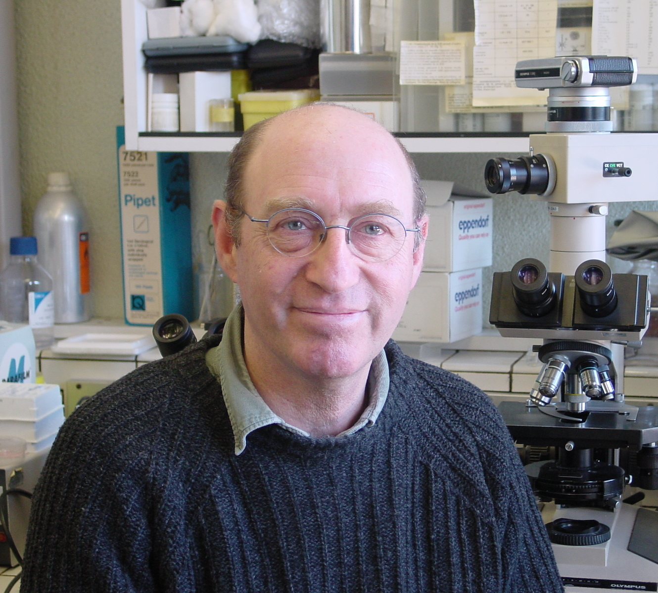 Biography
Prof. Daniel Aberdam is an expert in stem cells and epithelial physiopathology. He discovered the identity of genes responsible for severe human skin diseases that then allowed the first antenatal diagnosis for junctional epidermolysis bullosa syndromes. Then, his group has focused on the physiopathology of stem cells and designed original cellular models from embryonic stem cells that recapitulate embryonic normal and pathological skin and cornea formation. This team was the first to demonstrate the ability of pluripotent stem cells to produce a full thickness skin, pure corneal cell population and to use unusual metabolic pathway fo pluripotency. More recently, the group used genome editing to model diseases and identified small compounds able to rescue the phenotypes.
Email:umr976@gmail.com

Notes/Comments:

