

Bioinformatics analysis of ATOH7 mutation during retinogenesis

Shouhartha Choudhury¹ and Supriyo Chakraborty^{2*}

¹Department of Biotechnology, Assam University, Silchar-788011, Assam, India
² School of Life Sciences, Assam University, Silchar-788011, Assam, India

Keywords: ATOH7, Atonal gene family, bHLH transcription factor and, Retinogenesis

Abstract

The present study investigates ATOH7 (atonal homolog 7) gene encodes a transcription factor induce determining the fate of retinal progenitor cells and required for optic nerve formation and ganglion cell development. The basic helix–loop–helix transcription factor ATOH7 (Math5) is specifically expressed in the embryonic neural retina and required for the genesis of retinal ganglion cells and optic nerves. The retinal ganglion cells (RGCs) are the first neurons in the vertebrate eyes and conserved during evolution. ATOH7 is highly homologous to the atonal gene family, which is critically required for neuron formation during eye development. The evolutionarily diverse eye types require atonal gene function at the earliest stages of retinal neuron formation. During retinogenesis, ATOH7 is expressed significantly before NeuroD and Ngn. Retinal neuron differentiation requires both intrinsic and extrinsic factors, yet a few intrinsic gene products have been identified in Homo sapiens, Pan troglodytes, Gorilla, Ailuropoda melanoleuca, and Mus musculus. Our comparative and functional analysis suggested the mutation of ATOH7 and their conserved bHLH domain, motifs, phylogeny, chromosome location, and gene expression. Our bioinformatics analysis can be adapted in a meaningful way to the study of particular genes of interest.

Image
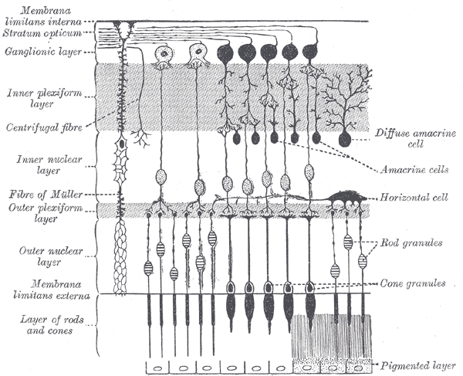

Reference

- Nadean L. Brown1, Susan L. Dagenais2, Chuan-Min Chen3, and Tom Glaser2,3, Molecular characterization and mapping of ATOH7, a human atonal homolog with a predicted role in retinal ganglion cell development. Mamm Genome. 2002 February; 13(2): 95–101.
- Noor M. Ghiasvand1,2, Dellaney D. Rudolph3, Mohammad Mashayekhi4, Joseph A. Brzezinski IV3,6, Daniel Goldman5, and Tom Glaser3,* Deletion of a remote enhancer near ATOH7 disrupts retinal neurogenesis, causing NCRNA disease. Nat Neurosci. 2011 May; 14(5): 578–586. doi:10.1038/nn.2798.
- Kamron Khan1,2, Clare V. Logan1, Martin McKibbin1,2, Eamonn Sheridan1, Nursel H. Elc¸ioglu3, Ozlem Yenice4, David A. Parry1, Narcis Fernandez-Fuentes1, Zakia I.A. Abdelhamed1,5, Ahmed Al-Maskari1,2, James A. Poulter1, Moin D. Mohamed1,6, Ian M. Carr1, Joanne E. Morgan1, Hussain Jafri7, Yasmin Raashid8, Graham R. Taylor1, Colin A. Johnson1, Chris F. Inglehearn1, Carmel Toomes1, and Manir Ali1* . Next generation sequencing identifies mutations in Atonal homolog 7 (ATOH7) in families with global eye developmental defects. Human Molecular Genetics, 2012, Vol. 21, No. 4

Biography

Shouhartha Choudhury has completed his B.Tech, M.Tech in Bioinformatics, and M.Phil in Life Science and Bioinformatics from India, and now pursuing Ph.D. from School of Life Sciences, Department of Biotechnology, Assam University, Silchar-788011 (India)

Author details



Full Name: Shouhartha Choudhury
Contact number: +91-9954411181
Twitter account: Shouhartha Choudhury
Linked In account: Shouhartha Choudhury
Session name/ number:
Category: (Oral presentation)
Passport Number:



