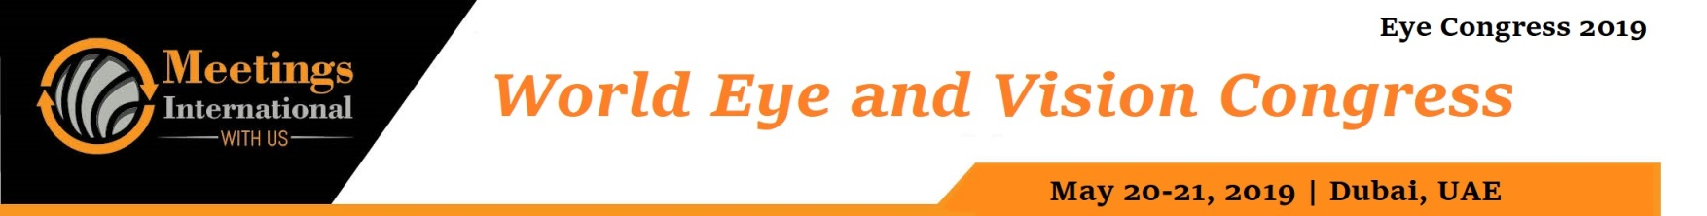

Abstract

Title: 90‐degree vs. 360‐degree selective laser trabeculoplasty (SLT)

Kozar Tawfique,¹ Pardis Khademi,² Laurence Quérat,² Joobin Khadamy³ and Enping Chen²

1 Mälar Hospital, Eskilstuna, Sweden

2 St. Erik Eye Hospital, Karolinska Institutet, Stockholm, Sweden

3 Ophthalmologist, Stockholm, Sweden

Keywords: Optical coherence tomography angiography (OCTA), Eye, Diabetic Retinopathy Staging, Diabetic Maculopathy, Macular Edema

- Abstract Body (up to 250 words)

Purpose: To compare the effect of 90- and 360-degree trabeculoplasty (SLT) as primary or supplement therapy in patients with glaucoma and ocular hypertension (OHT).

Methods: Patients (>30 years old) with OHT, primary open-angle glaucoma (OAG), pigmentary glaucoma, or pseudoexfoliative glaucoma were enrolled in a prospective randomized clinical trial. Patients were sequentially randomized to either 90- or 360-degree SLT. Their intraocular pressure (IOP) was monitored.

Results: The survival periods (in days) of the two extents (90 or 360 degrees) of treatment were not statistically significantly different (p = 0.85); only pre- treatment IOP level could predict survival of treatment (p = 0.02).

Conclusions: The 90-degree SLT is as effective as 360-degree SLT. Further studies are warranted to confirm the findings. High baseline IOP could be a factor that predicts treatment success.

Image:

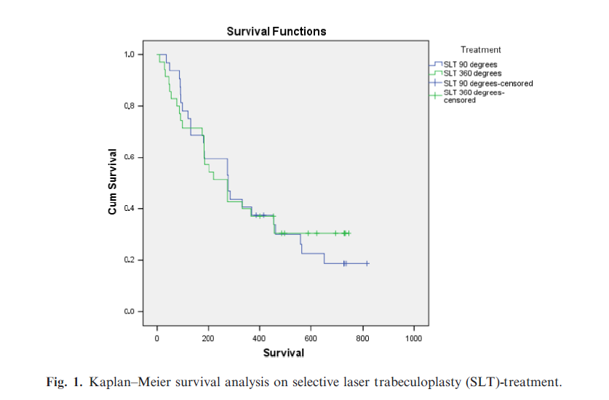

Reference:
- Chen E, Golchin S & Blomdahl S (2004): A comparison between 90 degrees and 180 degrees selective laser trabeculoplasty. J Glaucoma 13: 62–65.
- Chun M, Gracitelli CP, Lopes FS, Biteli LG, Ushida M & Prata TS (2016): Selective laser trabeculoplasty for early glaucoma: analysis of success predictors and adjusted laser outcomes based on the untreated fellow eye. BMC Ophthalmol 16: 206.
- CNTG-Study-Group (1998): Comparison of glaucomatous progression between untreated patients with normal-tension glaucoma and patients with therapeutically reduced intraocular pressures. Collaborative Normal-Tension Glaucoma Study Group. Am J Ophthalmol 126: 487–497.
- Goyal S, Beltran-Agullo L, Rashid S, Shah SP, Nath R, Obi A & Lim KS (2010): Effect of primary selective laser trabeculoplasty on tonographic outflow facility: a randomized clinical trial. Br J Ophthalmol 94:1443–1447.
- Tawfique, K, Khademi, P. , Quérat, L. , Khadamy, J. and Chen, E. (2019), Comparison between 90‐degree and 360‐degree selective laser trabeculoplasty (SLT): A 2‐year follow‐up. Acta Ophthalmol. doi:10.1111/aos.13949

Biography:
Doctor Joobin Khadamy is young talented Ophthalmologist who has completed his MD at the age of 2010 years from Tehran University Medical Science then straight he started his Ophthalmology. His research interest is retinal imaging and diabetic retinopathy and he has published 17 articles in well-known international journals and in cooperation with contribution of scientists from USA, Sweden and Iran. Joobin Khadamy is member of board of Behjoo Gruppen AB, a medical consulting company in Sweden. He has been serving as an editorial board member and reviewer of reputed journals.

Presenting author details


Full Name: Joobin Khadamy Contact number:+46736236368 Linked In account: Joobin Khadamy
Session name/ number:
Category: (Oral presentation/ Poster presentation) Passport Number:



