

Abstract

Title: Optical coherence tomography angiography (OCTA) role in management of diabetic retinopathy

Khadamy J .MD1, Aghdam KA .MD 2, Falavarjani KGH .MD 2

¹ Ophthalmologist, Stockholm, Sweden

2Eye Research Center, Rassoul Akram Hospital, Iran University of Medical Sciences, Tehran, Iran

Keywords: Optical coherence tomography angiography (OCTA), Eye, Diabetic Retinopathy Staging, Diabetic Maculopathy, Macular Edema

- Abstract Body (up to 250 words)
Optical coherence tomography angiography (OCTA) is a novel non‑invasive imaging modality for
3‑dimensional visualization of retinal and optic nerve capillary networks. In this presentation, a rapid and comprehensive update on the role of OCTA in management of Diabetic Retinopathy (DR) will be addressed. OCTA is found to be successful to detect early microvascular changes in diabetes mellitus (even before it become clinically evident). Morphological and qualitative assessment of vascular changes can help to determine the pathophysiological processes, activity, treatment, and follow‑up of diabetic retinopathy (DR).Vessel density and foveal avascular zone are the most investigated quantified indices shown to be early
predictors of DR, correlated to DR severity and visual function, and useful in predicting response to
treatment. OCTA has shown to be a promising alternative to fluorescein angiography in the management of DR. Further studies are merited to determine the role of OCTA in the routine clinical management of retinal diseases.

Image:
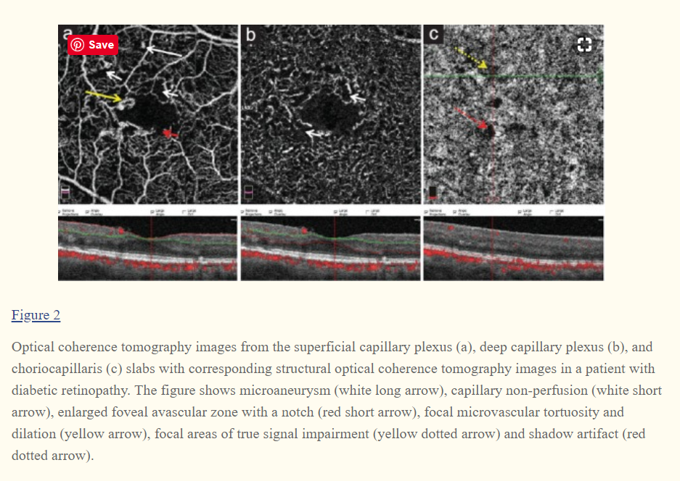
- Reference:

- Khadamy J, Abri Aghdam K, Falavarjani KG. An Update on Optical Coherence Tomography Angiography in Diabetic Retinopathy. J Ophthalmic Vis Res. 2018;13(4):487-497.
- Khadamy J. Optical Coherence Tomography Angiography (OCTA) in Ophthalmology; Technology, Pros, Cons and Commercial Prototypes. JOJ Ophthal 2017;2(5):555598.
- Khadamy J. Can Foveal Avascular Zone (FAZ) Assessment By OCT Angiography, Used For Grading Of Diabetic Retinopathy? Advances in Ophthalmology & Visual System 2016;5(3):00160.

Biography:
Doctor Joobin Khadamy is young talented Ophthalmologist who has completed his MD at the age of 2010 years from Tehran University Medical Science then straight he started his Ophthalmology. His research interest is retinal imaging and diabetic retinopathy and he has published 17 articles in well-known international journals and in cooperation with contribution of scientists from USA, Sweden and Iran. Joobin Khadamy is member of board of Behjoo Gruppen AB, a medical consulting company in Sweden. He has been serving as an editorial board member and reviewer of reputed journals.

Presenting author details


Full Name: Joobin Khadamy Contact number:+46736236368 Linked In account: Joobin Khadamy
Session name/ number:
Category: (Oral presentation/ Poster presentation) Passport Number:



