

Bioinformatics analysis of ATOH7 mutation during retinogenesis

Shouhartha Choudhury¹ and Supriyo Chakraborty^{2*}

¹Department of Biotechnology, Assam University, Silchar-788011, Assam, India
² School of Life Sciences, Assam University, Silchar-788011, Assam, India

Keywords: ATOH7, Atonal gene family, Neuronal bHLH transcription factor and, Retinogenesis

Abstract

The present study investigates the vertebrate retina that contains seven major neuronal glial cell types and interconnected network. This network collects processes and sends visual signals through the optic nerve to the brain. Retinal neuron differentiation requires both intrinsic and extrinsic factors, yet a few intrinsic gene products have been identified in Homo sapiens and Mus musculus. ATOH7 encodes a basic helix-loop-helix (bHLH) transcription factor that specifically expresses by retinal progenitors and is conserved during evolution. ATOH7 is highly homologous to atonal gene family, which is critically required for neuron formation during eye development. The retinal ganglion cells (RGCs) are the first neurons in the vertebrate eyes. The evolutionarily diverse eye types require atonal gene function at the earliest stages of retinal neuron formation. During retinogenesis, ATOH7 is expressed significantly before NeuroD and Ngn. Our comparative and functional analysis suggested mutation of ATOH7 and their conserved bHLH domain, motifs, phylogeny, chromosome location and gene expression. Our technique can be adapted in a meaningful way to the study of particular genes of interest.

Image
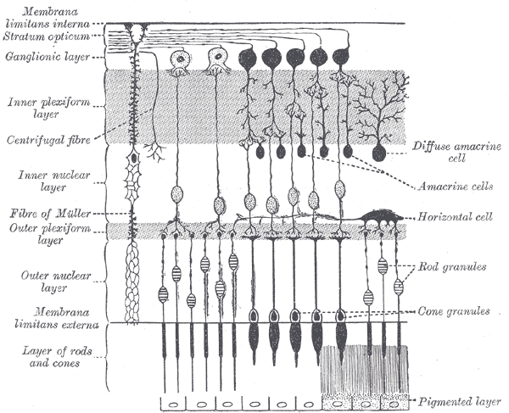

Reference

- Nadean L. Brown1, Susan L. Dagenais2, Chuan-Min Chen3, and Tom Glaser2,3, Molecular characterization and mapping of ATOH7, a human atonal homolog with a predicted role in retinal ganglion cell development. Mamm Genome. 2002 February; 13(2): 95–101.
- Nadean L. Brown1, 2,*, Sima Patel2, Joseph Brzezinski1, and Tom Glaser1,*Math5 is required for retinal ganglion cell and optic nerve Formation. Development. 2001 July; 128(13): 2497–2508.
- Kamron Khan1,2, Clare V. Logan1, Martin McKibbin1,2, Eamonn Sheridan1, Nursel H. Elc¸ioglu3, Ozlem Yenice4, David A. Parry1, Narcis Fernandez-Fuentes1, Zakia I.A. Abdelhamed1,5, Ahmed Al-Maskari1,2, James A. Poulter1, Moin D. Mohamed1,6, Ian M. Carr1, Joanne E. Morgan1, Hussain Jafri7, Yasmin Raashid8, Graham R. Taylor1, Colin A. Johnson1, Chris F. Inglehearn1, Carmel Toomes1, and Manir Ali1* . Next generation sequencing identifies mutations in Atonal homolog 7 (ATOH7) in families with global eye developmental defects. Human Molecular Genetics, 2012, Vol. 21, No. 4

Biography

Shouhartha Choudhury has completed his B.Tech and M.Tech in Bioinformatics from India and now pursuing integrated pre-Ph.D. program in School of Life Sciences, Department of Biotechnology, Assam University, Silchar-788011.

Author details



Full Name: Shouhartha Choudhury
Contact number: +91-9954411181
Twitter account: Shouhartha Choudhury
Linked In account: Shouhartha Choudhury
Session name/ number:
Category: (Oral presentation)
Passport Number:



