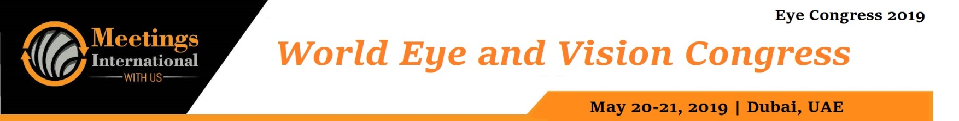

Abstract

Title: Conformational and thermodynamic features of meibum in adolescents and adults with graft-versus-host disease.

Sledge SM1,2, Borchman DB1,
1Department of Ophthalmology and Visual Sciences, University of Louisville School of Medicine, Louisville, KY., USA
2Department of Physiology, University of Louisville School of Medicine, Louisville, KY., USA

Keywords: Graft-versus-Host disease (GvHD), Meibum, Dry Eye Disease (DED), Spectroscopy

- Abstract Body
Graft-versus-host disease (GvHD) is a common complication of allogenic hematological stem cell transplantations that is often associated with dry eye disease (DED) with mixed Meibomian gland dysfunction and aqueous tear deficiency. The temperature-dependence of conformational changes in human meibum (hM) was measured in a comparative study to elucidate the potential impact of GvHD on hM composition, structure and function with DED. A total of 28 donors without DED and 15 donors with DED separated into adolescent and adult pools, were analyzed by Fourier Transform Infrared Spectroscopy. Both age and DED lead to conformational and thermodynamic differences in hM. Increases in lipid order and transition temperatures were observed in hM with GvHD. However, these relative increases were more pronounced in hM from adolescents than from adults. The decrease of change in enthalpy for adolescents was more pronounced compared with adults. The conformational and thermodynamic differences observed with age and, importantly, with DED/GvHD are indicative of compositional changes in hM that could impact tear film stability. We decided to test this theory. We hypothesize that the hM layer alone or hM layer interacting with phospholipids (PLs) in the aqueous portion of tears act as a barrier to tear evaporation; and that in patients with DED/GvHD, either altered composition of the hM and/or its interaction with PLs in tears, lead to a greater rate of evaporative fluid loss from tears. Our studies suggest that the hM alone does not retard the evaporation of water from a saline solution used as an aqueous phase.

Image:

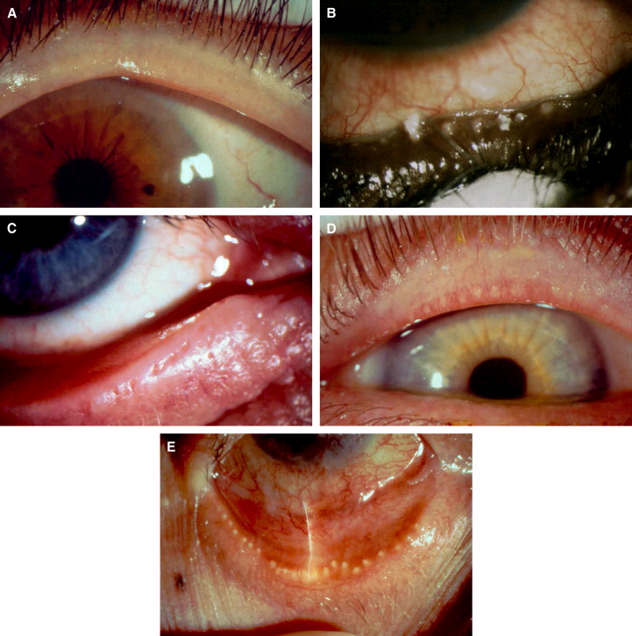
- Reference:

- Butovich IA, Arciniega JC, Wojtowicz JC. Meibomian lipid films and the impact of temperature. Invest Ophthalmol Vis Sci 2010;51(11):5508–5518.
- Ferrara JL, Levine JE, Reddy P, Holler E. Graft-versus-host disease. Lancet. 2009;373(9674):1550-1561.
- Lemp MA, Boudoin C, Baum J, et al. Definition and classification of dry eye disease: report of the Definition and Classification Subcommittee of the International Dry Eye Workshop (2007). Ocul Surf 2007;5(2):75-92.
- Ogawa Y, Okamoto S, Wakui M, et al. Dry Eye After hematopoietic stem cell transplantation. Br J Ophthalmol 1999;83(10):1125-30.
- Pasquini M, Zhu X. Current uses and outcomes of hematopoietic stem cell transplantation: CIBMTR Summary Slides, 2015. http://www.cibmtr.org
- Pucker AD, Haworth KM. The presence and significance of polar meibum and tear lipids. Ocul Surf 2015;13(1):26–42.
- Sledge SM, Borchman D, Oliver A, Michael H, Dennis EK, Gerlach D, Bhola R, Stephen E. Evaporation and hydrocarbon chain conformation of surface lipid films. Ocul Surf 2016;14(4):447-459.
- Sledge S, Henry C, Borchman D, et al. Human meibum age, lipid-lipid interactions and lipid saturation in meibum from infants. Int J Mol Sci 2017;18(9): E1862.

Biography:
Samiyyah Sledge received her master’s in Physiology and Biophysics from the University of Louisville School of Medicine just last year. Currently she is a doctoral candidate in the Department of Physiology and she researches in the Department of Ophthalmology and Visual Sciences under the guidance of Dr. Douglas Borchman. To date, Samiyyah has published at least five papers in several well regarded journals.

Presenting author details

Full Name: Samiyyah M. Sledge
Contact Number: 1-615-424-3331
Category: Poster presentation
Passport Number: 503545418



