

Bioinformatics analysis of ATOH7 mutation during retinogenesis

Shouhartha Choudhury¹ and Supriyo Chakraborty^{2*}

¹Department of Biotechnology, Assam University, Silchar-788011, Assam, India
² School of Life Sciences, Assam University, Silchar-788011, Assam, India

Keywords: ATOH7, Atonal gene family, Neuronal bHLH transcription factor and, Retinogenesis

Abstract

The present study investigated vertebrate retina contains seven major neuronal and glial cell types and interconnected network that collect processes and sends visual signals through the optic nerve to the brain. Retinal neuron differentiation is required both intrinsic and extrinsic factors, yet few intrinsic gene products have been identified in Homo sapiens and Mus musculus. ATOH7 encodes a basic helix-loop-helix (bHLH) transcription factor that is specifically express by retinal progenitors and conserve in evolution. ATOH7 is highly homologous to atonal gene family, which is critically required neuron formation during eye development. The retinal ganglion cells (RGCs) are the first neurons in the vertebrate eyes. The evolutionarily diverse eye types require atonal gene function for the earliest stages of retinal neuron formation. During retinogenesis, ATOH7 is express significantly before NeuroD and Ngn. Our comparative and functional analysis suggested mutation of ATOH7 and their conserve bHLH domain, motifs, phylogeny, chromosome location and gene expression. In this study, we performed bioinformatics and computational technique to the current knowledge of atonal gene family. Our technique can be adapted in a meaningful way to the study of particular genes of interest.

Image
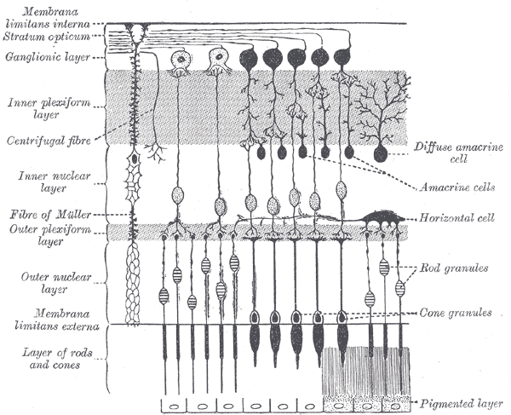

Reference

- Nadean L. Brown1, Susan L. Dagenais2, Chuan-Min Chen3, and Tom Glaser2,3, Molecular characterization and mapping of ATOH7, a human atonal homolog with a predicted role in retinal ganglion cell development. Mamm Genome. 2002 February; 13(2): 95–101.
- Noor M. Ghiasvand1,2, Dellaney D. Rudolph3, Mohammad Mashayekhi4, Joseph A. Brzezinski IV3,6, Daniel Goldman5, and Tom Glaser3,* Deletion of a remote enhancer near ATOH7 disrupts retinal neurogenesis, causing NCRNA disease. Nat Neurosci. 2011 May; 14(5): 578–586. doi:10.1038/nn.2798.
- Kamron Khan1,2, Clare V. Logan1, Martin McKibbin1,2, Eamonn Sheridan1, Nursel H. Elc¸ioglu3, Ozlem Yenice4, David A. Parry1, Narcis Fernandez-Fuentes1, Zakia I.A. Abdelhamed1,5, Ahmed Al-Maskari1,2, James A. Poulter1, Moin D. Mohamed1,6, Ian M. Carr1, Joanne E. Morgan1, Hussain Jafri7, Yasmin Raashid8, Graham R. Taylor1, Colin A. Johnson1, Chris F. Inglehearn1, Carmel Toomes1, and Manir Ali1* . Next generation sequencing identifies mutations in Atonal homolog 7 (ATOH7) in families with global eye developmental defects. Human Molecular Genetics, 2012, Vol. 21, No. 4

Biography

Shouhartha Choudhury has completed his B.Tech and M.Tech in Bioinformatics from India and now pursuing integrated pre-Ph.D. program in School of Life Sciences, Department of Biotechnology, Assam University, Silchar-788011

Author details



Full Name: Shouhartha Choudhury
Contact number: +91-9954411181
Twitter account: Shouhartha Choudhury
Linked In account: Shouhartha Choudhury
Session name/ number:
Category: (Oral presentation)
Passport Number:



