

Abstract

Title: Assessment of Intraocular pressure using Ocular Response Analyzer and Goldman Applanation Tonometry before and after Penetrating Keratoplasty (PKP)

Wassef A¹, Mansour K¹, Essmat S¹, Magdy H¹
1Department of Ophthalmology, Cairo University, Cairo, Egypt

Keywords: Intraocular pressure – Penetrating Keratoplasty – Ocular Response Analyzer – Goldmann Applanation Tonometry – Cornea biomechanical factors

Abstract
Purpose: To compare the obtainability and values of IOP measurements by Goldmann Applanation Tonometry (GAT) and Ocular Response Analyzer (ORA) before and after penetrating keratoplasty (PKP) testing the degree of their agreement and the impact of corneal biomechanical factors on IOP measurement. Patients and Methods: The study is a comparative prospective study in which patients scheduled for penetrating keratoplasty (PKP) undergo intraocular pressure measurement (IOP) using the Ocular Response Analyzer (ORA) then the Goldman applanation tonometer (GAT) one day before surgery to be repeated one month after their surgery. Results: Forty patients undergoing PKP were enrolled in the study, 28 males (70%) and 12 females (30%). The mean age of patients involved is 42.8 ± 15.4, ranging between 9 and 75 years. Obtainability of ORA (92.5% of the patients) was significantly higher than GAT (60%) postoperatively (p<0.001), while no significant difference was elicited preoperatively. The mean cornea corrected IOP (IOPcc) was significantly higher than GAT and Goldmann related IOP (IOPg) both pre and postoperatively. In addition, both mean IOPcc and GAT postoperatively (19.2 ± 8.31, 15.65 ± 6.99 mmhg respectively) were significantly higher than their preoperative values (14.44 ± 7.03, 11.78 ± 4.55 mmhg respectively). Strong correlations existed between GAT and ORA measurements both pre and postoperatively. The level of agreement between GAT and IOPg was higher than IOPcc. Conclusion: ORA has proven to be superior to GAT in the ability to obtain reliable IOP measurements post PKP. IOPcc measurements also prooved to be relavant, independent on corneal biomechanical factors (CH and CRF) but judging the accuracy of its values needs further large scale studies.

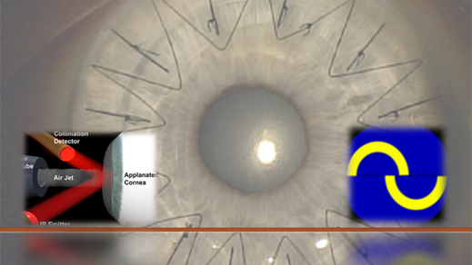

Biography:
Wassef A, a young ophthalmologist, graduated medical school in 2014, completed Master degree (M.sc.) in ophthalmology in May 2017 from Cairo University. working as an ophthalmology resident in Kasr Alainy medical school, Cairo university for three years and still. With special interest in cornea. Knowing that assessment of IOP post PKP poses a special challenge, motivated us to carry this research to test the different methods of assessment of IOP post PKP.

Presenting author details


Full Name: Amr Wassef
Contact number: +20 - 01006244527
Twitter account: Simplygunner
Linked In account: Amr Wassef
Session name: Glaucoma and Orthokeratology
Category: Oral presentation/ Poster presentation Passport Number: A19355875



