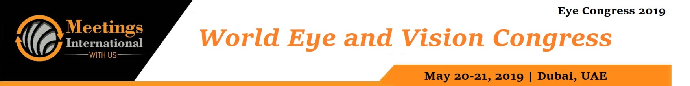

Abstract

Title: Repeatability and inter-examiner reliability of non-corneal tonometry using Diaton.

Rozhdestvenskaya M.1, Dashevsky A. ² Kotliar K. ³
1 Tonom GmbH, EU REP of the technology, Münster, Germany
2 Ophthalmology center of Dr. med. Alexej Dashevsky, Munich, Germany,
3 Aachen University of Applied Sciences, Campus Juelich, Department of Biomedical Engineering
and Technomathematics, Juelich, German

Keywords: Glaucoma, intraocular pressure measurement, tonometry, NON-corneal trans-palpebral trans-scleral tonometry.

- Abstract Body
The present study is concerned with the reproducibility and inter-examiner reliability of intraocular pressure measurement with Diaton tonometer as well as with the possibility to use the procedure while outpatient management.

The NON-corneal trans-palpebral Diaton tonometry is indicated for corneal diseases (ulcers, keratitis, keratoconus) and postoperative conditions of the cornea. The handy, small "Diaton" tonometer is also used in bed rest patients.

Results of Diaton tonometer measurements: [Median (1st quartile - 3rd quartile)]. For the tree examiner difference was not significant (p = 0.645, Kendall's W-test, power> 0.8). The inter-examiner variability coefficient was 7% (4% -9%). The intra-class correlation coefficient and associated 95% confidence interval were 0.935 (0.871-0.971) (p <0.001).

Moreover, for separately considered GAT control group no significant differences in Diaton tonometer measurement results was found: GAT values: 15.5 (14.0-17.0) mmHg. Diaton values - Examiner 1: 16.0 (15.0-19.0) mmHg; Examiner 2: 16.0 (14.8-19.3) mmHg; Examiner 3: 16.5 (13.0-19.0) mmHg (p = 0.530,
Kendall's W-test, power> 0.8

Our results showed that NON-corneal Diaton tonometry is a reliable method of intraocular pressure measurement, which is not depended from the biomechanical parameters of the cornea. In particular, Diaton tonometer allows determine IOP pressure values in patients who have contraindications to standard tonometry methods (eg, ulcer). For correct Diaton tonometer handling participation in a special user course is recommended. It goes without saying that examiners must familiarize themselves with the measurement procedure: a learning phase is also required for Goldmann applanation tonometry.

Image:
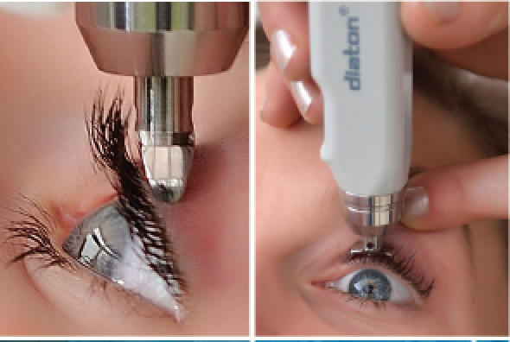
- Reference:

1 Margarita Rozhdestvenskaya; Alla Illarionova; Alexey Dashevsky; Konstantin E Kotliar.
Evaluation of modern trans-palpebral trans-scleral tonometry before and after keratorefractive surgery.
ARVO Annual Meeting Abstract June 2017 Invest. Ophthalmol. Vis. Sci.. 2017; 58(8):3406. doi:

- Cacho I, Sanchez-Naves J, Batres L, Pintor J, Carracedo G. Comparison of Intraocular Pressure before and after Laser In Situ Keratomileusis Refractive Surgery Measured with Perkins Tonometry, Noncontact Tonometry, and Transpalpebral Tonometry. Ophthalmol. 2015;2015:683895. doi: 10.1155/2015/683895. Epub 2015 Jun 8.

- Risma JM, Tehrani S, Wang K, Fingert JH, Alward WL, Kwon YH. The Utility of Diaton Tonometer Measurements in Patients With Ocular Hypertension, Glaucoma, and Glaucoma Tube Shunts: A Preliminary Study for its Potential Use in Keratoprosthesis Patients. J Glaucoma. 2016; 25(8):643-7.

Biography:

Margarita Rozhdestvenskaya has an expertise in regulatory strategies, medical device registration standards, quality management system compliance and in-country regulatory representation. From 2013 she is a director of the Tonom GmbH that is the European Authorized Representative for trans-palpebral trans-scleral tonometer Diaton. Tonom GmbH fulfills the obligations of the Medical Device Directive MDD 93/42/EEC and acts as legal entity towards the European authorities as well as providing additional services regarding the technical information of the medical devices within the European Community. Her expertise and proficiency as well as interest to science, innovation and a culture of operational excellence contribute to offer technology, services and support in order to improve the quality of people's lives.

Presenting author details

Full Name: Margarita Rozhdestvenskaya
Contact number: +49 (0) 251 872 51 393
Linked In account: https://www.linkedin.com/in/margarita-rozhdestvenskaya-3b43ab100/
Session name/ number: Glaucoma
Category: Oral presentation/ Poster presentation



