Graft polymerization of styryl bisphosphonate monomer onto polypropylene films for inhibition of biofilm formation

Hanna P. Steinmetz, The Institute of Nanotechnology and Advanced Materials, Department of Chemistry, Bar-Ilan University, Ramat-Gan 52900, Israel

Abstract
There has been increased concern during the past few decades over the role bacterial biofilms play in causing a variety of health problems, especially since they exhibit a high degree of resistance to antibiotics and are able to survive in hostile environments. Biofilms consist of bacterial aggregates enveloped by a self-produced matrix attached to the surface. Ca²⁺ ions promote the formation of biofilms, and enhance their stability, viscosity, and strength. Bisphosphonates exhibit a high affinity for Ca²⁺ ions, and may inhibit the formation of biofilms by acting as sequestering agents for Ca²⁺ ions. Although the antibacterial activity of bisphosphonates is well known, research into their anti-biofilm behavior is still in its early stages. In this study, we describe the synthesis of a new thin coating composed of poly(styryl bisphosphonate) grafted onto oxidized polypropylene films for anti-biofilm applications. This grafting process was performed by graft polymerization of styryl bisphosphonate vinylic monomer onto O₂ plasma-treated polypropylene films. The surface modification of the polypropylene films was confirmed using surface measurements, including X-ray photoelectron spectroscopy, atomic force microscopy, and water contact angle goniometry. Significant inhibition of biofilm formation was achieved for both Gram-negative and Gram-positive bacteria.

Image
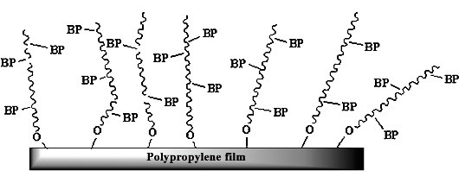
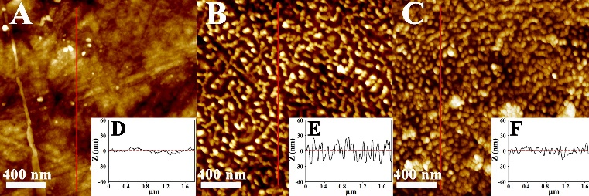

Poly(styryl bisphosphonate) (BP) grafted onto oxidized polypropylene film for anti-biofilm applications. AFM images (A, B, C) and the cross-section profiles (D, E, F) of the PP, oxidized PP, and PP/PStBP films, respectively.
Recent Publications
- Steinmetz, H. P., Rudnick-Glick, S., Natan, M., Banin, E., & Margel, S. (2016). Graft polymerization of styryl bisphosphonate monomer onto polypropylene films for inhibition of biofilm formation. Colloids and Surfaces B: Biointerfaces, 147, 300-306.‏

Biography
Hanna P. Steinmetz is PhD Candidate from The Institute of Nanotechnology and Advanced Materials, Department of Chemistry, Bar-Ilan University. Her research focuses on the design of bisphosphonate coating and polymeric bisphosphonate nanoparticles grafted onto polymeric films for biomedical applications. This work is carried out under the supervision of Prof. Shlomo Margel.
Email: hannasht8@gmail.com

Notes/Comments:

