Title: An experimental study on the effect of channel height on dielectrophoresis manipulation of particles

Arash Dalili, Mina Hoorfar
School of Engineering, The University of British Columbia, Kelowna, Canada

Keywords: Dielectrophoresis, Microfluidics, Particle manipulation

- Abstract Body
A critical parameter in DEP-based manipulation is the channel height. Previous studies have examined the effect of the height on the levitation distance [1] and capture time [2] of particles. However, the reported effects depend on specific conditions and methods implemented. This paper experimentally investigates the effect of the microfluidics channel height on nDEP continuous manipulation of particles using co-planar electrodes, which are chosen based on our previous studies [3].
Particles enter the micro-device, Figure 1, while a sheath flow pushes them towards one side of the channel. As the particles reach the electrodes, the DEP force pushes them laterally towards a target outlet, Figure 2. The particles also experience drag force, which acts against the DEP force. As the channel height decreases, the particles are expected to experience greater DEP and drag forces. The experimental, using the setups shown in Figure 3, goal was to determine the maximum throughput as a function of the applied voltage resulting in a particle collection efficiency of more than 99%. Each of the tests was repeated three times to make sure that the experiments were reproducible. Figure 4 shows the effect of the applied voltage on the maximum effective throughput for four different particle sizes and 25 μm micro-channel height. The results illustrated that for larger particles, the DEP force is stronger; hence, the effective flow rate is higher. The same trend was observed for larger heights. Figure 5 compares the maximum flow rates obtained from the largest voltage for different particle sizes as a function of the channel height. As the height increased the throughput decreased. Taken together these results can lead to the selection of an optimal channel height to achieve the desired throughput based on the applied voltage and the particle sizes in applications that require efficient manipulation of particles/cells.

Image:

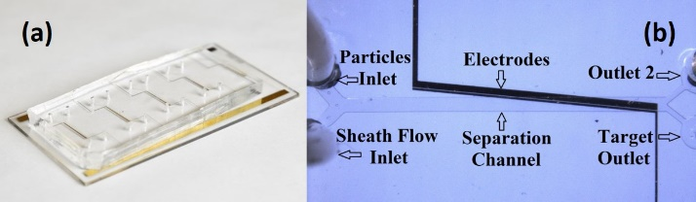
Fig. 1: (a) A sample of the chips fabricated by photolithography. (b) The DEP-based micro-separator under a microscope.
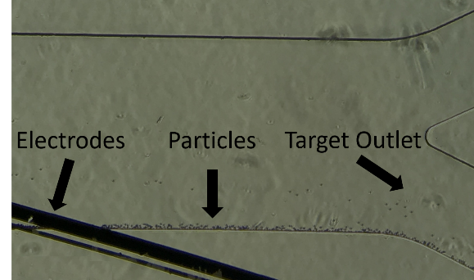
Figure 2: The polystyrene particles under the effect of the DEP force are guided effectively towards the target outlet.
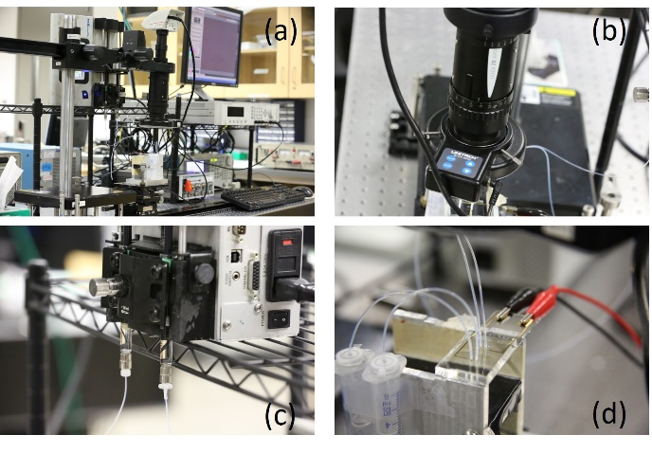
Fig. 3: (a) The experimental setup including (b) an APO microscope, (c) a KD Scientific syringe pump for infusing the flow, (d) a close-up view of the chip. The outlets are collected for further analysis.
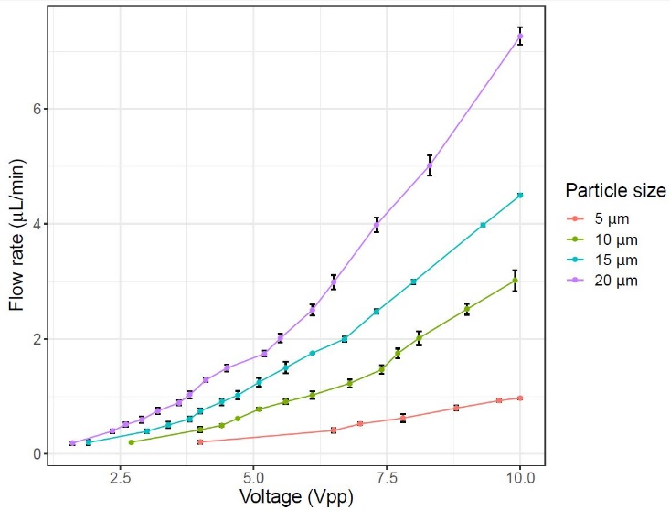
Fig. 4: The effect of the applied voltage on the particle throughput for a 25-μm channel height
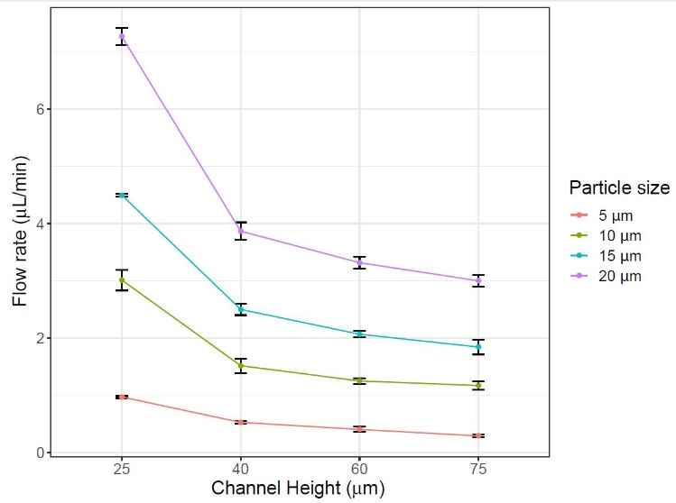
Fig. 5: The effect of the channel height on the particle throughput for an applied voltage of 10 V_pp

Reference:

- Cao, J., P. Cheng, and F. Hong, "A numerical analysis of forces imposed on particles in conventional dielectrophoresis in microchannels with interdigitated electrodes," Journal of Electrostatics, 2008. 66(11-12): p. 620-626.

- Sadeghian, H., Y. Hojjat, and M. Soleimani, "Interdigitated electrode design and optimization for dielectrophoresis cell separation actuators," Journal of Electrostatics, 2017. 86: p. 41-49.

- Senguttuvel, P., M. Raveendran, C. Vijayalakshmi, K. Thiyagarajan, J.R.K. Bapu and B.C. Viraktamath, 2010. Molecular mechanism of salt tolerance for genetic diversity analysed in association with Na+/K+ ratio through SSR markers in rice (Oryza sativa L.). Int. J. Agric. Res., 5: 708–719

Biography:
Mina Hoorfar is a Professor and Director of the School of Engineering, The University of British Columbia (UBC), Canada. She received her PhD and MASc degrees in Mechanical Engineering from the University of Toronto in 2005 and 2001, respectively. Her current research focuses on the development of portable devices for biomedical applications and the design and fabrication of biosensors for environmental and agricultural applications. Since joining UBC in 2006, she has trained around 120 highly qualified personnel and disseminated her research in 250 publications (journals, proceedings, book chapters, and patents).

Presenting author details

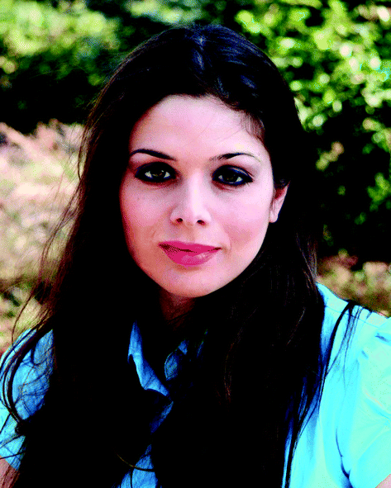

Full Name: Mina Hoorfar
Contact: mina.hoorfar@mail.ubc.ca
Session name/ number:
Category: Oral presentation

