Abstract

Title: Modular Non-contact and Non-intrusive Microwave-Microfluidic Sensing Platform for Energy and Biomedical Engineering

Sadabadi H1,2, Sanati Nezhad A2, Zarifi MH 3,
1 Wireless Fluidics Inc, Edmonton, AB, Canada, Canada
² Department of Mechanical and Manufacturing Engineering, University of Calgary, Calgary, Alberta T2N 2N1, Canada
3 Department of Electrical Engineering, University of British Columbia, Kelowna, BC, V1V 1V7, Canada

Keywords: Microwave-Microfluidic, Sensing, Non-contact

- Abstract
A novel flow sensor is presented to measure the flow rate within microchannels in a real-time, noncontact and nonintrusive manner. This patented sensing technology can be further used in measuring a physical characteristic of a fluid in a microfluidic system. The sensing platform includes a microfluidic chip that has a thin deformable membrane that separates a microfluidic channel from a microwave resonator sensor. The membrane is deformable in response to loading from interaction of the membrane with the fluid. Loading may be fluid pressure in the channel, or shear stress or surface stress resulting from interaction of the membrane with the fluid. The deformation of the membrane changes the permittivity in the region proximate the sensor. A change in permittivity causes a change in the electrical parameters of the sensor, thereby allowing for a characteristic of the fluid, such as flow rate, or a biological or chemical characteristic, to be measured.

Image:

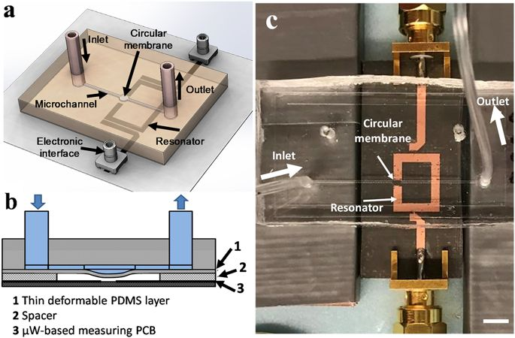
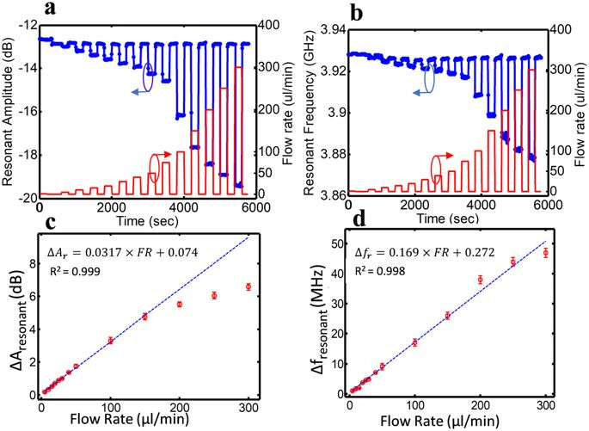
- Reference:

1 Sadabadi H., et al. “Hybrid and modular thin film microfluidic-microwave sensing apparatus, systems, and methods”, US Patent Publication, PCT/US2017/67264 (2018).

Zarifi, M.H., Sadabadi, H., Hejazi, S.H. et al. Noncontact and Nonintrusive Microwave-Microfluidic Flow Sensor for Energy and Biomedical Engineering. Sci Rep 8, 139 (2018).

- Narang, R., Mohammadi, S., Ashani, M.M. et al. Sensitive, Real-time and Non-Intrusive Detection of Concentration and Growth of Pathogenic Bacteria using Microfluidic-Microwave Ring Resonator Biosensor. Sci Rep 8, 15807 (2018).

Biography:
Hamid Sadabadi is an entrepreneur and researcher in the field of Microfluidics, Lab-on-a-chip and sensors/biosensors. He has completed his PhD in microfluidic from Concordia University in Montreal. He is recipient of 8 prestigious awards/scholarships inducing Quebec Doctoral Merit Scholarship and University of Calgary Eyes High Postdoctoral Fellowship where he did his postdoc researches. He is the currently CTO of Wireless Fluidics, a sensing technology development start-up. He has published more than 12 US patents, book chapters, and more than 16 papers in reputed journals.

Presenting author details


Full Name: Hamid Sadabadi
Session name/ number: Multidisciplinary Sensing Technologies
Category: Oral presentation

