On-chip alginate microencapsulation of anaerobic probiotics

Seyedehhamideh Razavi¹, Candice Quin², , Ryan Bonnie³, Arash Dalili ⁴, Bahram Talebjedi⁵, Kabilan Sakthivel⁶, Jacqueline A. Barnett⁷, Sajjad Janfaza^{8,},Nishat Tasnim⁹, Mina Hoorfar¹⁰, Deanna Gibson¹¹

School of Engineering, University of British Columbia, Kelowna, BC, Canada^{1, 4, 5, 6, 8, 9,10}
Department of Biology, IKBSAS, University of British Columbia, Okanagan campus, Kelowna V1V 1V7, Canada ^{2, 3, 7, 11}

Keywords: lactobacillus; anaerobic probiotics; microfluidics; microcapsules.

- Abstract Body

Microencapsulation of probiotics using biomaterials such as alginate is a highly effective strategy for probiotic delivery to prevent the degradation of probiotics from harsh conditions in the gastrointestinal tract.1, 2 This work demonstrates an efficient method for the encapsulation of anaerobic Lactobacillus probiotics in calcium cross-linked alginate microparticles by using on-chip microfluidics to form monodisperse and highly-stable microbeads. In this study, we performed the numerical simulation of the droplet formation method (Fig 1). Following this, we investigated the size variation of microdroplets with different ratios of flow rates of the dispersed and continuous phases (Fig 3). The morphology of the microparticles was characterized using optical microscopy and scanning electron microscopy (SEM). We assessed the viability of encapsulated bacteria using SYTO 9 dye and fluorescence microscopy. The chemical structure of the microparticles containing Lactobacillus was analyzed via Fourier transform infrared spectroscopy (FTIR). We also calculated the encapsulation efficiency of bacteria by measuring their survival after encapsulation. The survival rate percentage of encapsulated versus non-encapsulated probiotic cells was determined at various storage times (at 7, 14, 21 and 28 days). The results indicated the successful entrapment of Lactobacillus within highly stable and uniform microdroplets using the developed microfluidic platform. The optical microscopy and SEM images determined that the probiotic bacteria occupied almost all of the inner space of hydrogel alginate microbeads and the morphology of microparticles were regular spherical structures (Fig 2). Fluorescent images revealed the presence of living bacteria inside the microbeads (Fig 4). The encapsulation yield of the freshly prepared alginate microparticles was 86.95 %. The storage results confirmed that the encapsulated cells stored at -15 ºC showed a relatively high survival rate compared to free cells (Fig 6). SEM results indicated that bacterial cells were successfully entrapped, and freeze-dried microbeads exhibited irregularly shaped with cracks on the surface (Fig 5). The Lactobacillus-encapsulated in alginate microparticles also provided prolonged viability and enhanced shelf-life. Taken together, the results demonstrate the promising potential of our microfluidic flow-focusing system to be used as a high-throughput single-step process that provides stable and uniform microparticles containing anaerobic probiotic bacteria.

- Images:

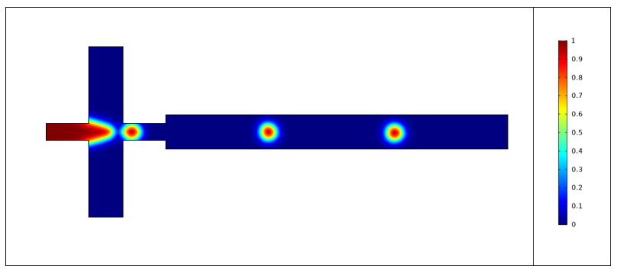
Fig 1. Numerical simulation of the droplet formation
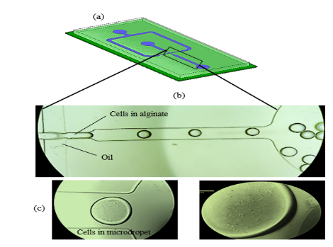
Fig 2. a) PDMS microfluidic flow-focusing device for droplet generation. (b) Generation of monodisperse microdroplets through a narrow orifice on the microfluidic device. (c) Representative images of cells in microdroplets.

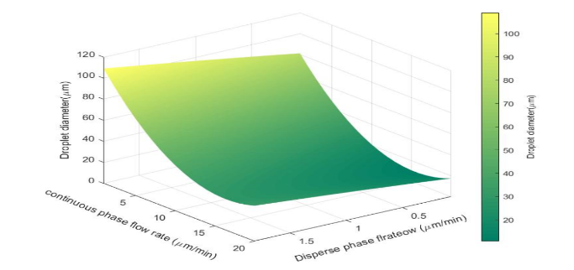

Fig 3. Microdroplets size variation graph with different ratios of flow rates of CP and DP

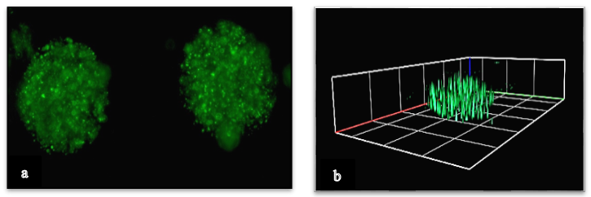

Fig 4. (a) Fluorescent microscope images of microcapsules. (b) 3D constructed image of cells in the microgel.

Fig 5. SEM micrographs of Lactobacillus-loaded microcapsules

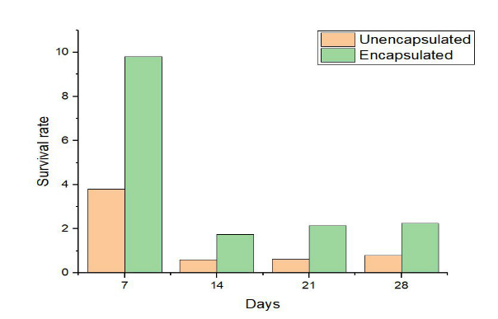

Figure 6. Survival rate of free and encapsulated Lactobacillus during 28 days storage at -15 ºC.

III. Reference:
1. Yao M, Li B, Ye H, Huang W, Luo Q, Xiao H, McClements DJ, Li L. Enhanced viability of probiotics (Pediococcus pentosaceus Li05) by encapsulation in microgels doped with inorganic nanoparticles. Food hydrocolloids. 2018 Oct 1;83:246-52.

- Prakash KS, Chavan R, Mishra V. Microencapsulation of Probiotics and Its Applications. InFrontier Discoveries and Innovations in Interdisciplinary Microbiology 2016 (pp. 33-44). Springer, New Delhi.

IV. Biography:

Dr. Hoorfar is a Professor in the School of Engineering at the University of British Columbia Okanagan and the head of the Advanced Thermo-Fluidic Laboratory (AFTL). After joining UBC, Dr. Hoorfar established a microfluidics group specializing in the development of portable devices for biomedical applications ranging from DNA purification from saliva, acetone detection from the exhale breath of a diabetes patient, circulating tumor cells detection from the blood of a metastatic patient, and cell patterning on the digital microfluidic platforms for tissue engineering. She has published more than 200 papers in reputed journals.

V. Presenting author details

Full Name: Mina Hoorfar
Contact number: mina.hoorfar@ubc.ca
Twitter account: Linked In account:
Session name/ number:
Category: (Oral presentation/ Poster presentation) Passport Numb:

