Title: Chip electrophoresis sensor implementing artificial intelligence for soil nutrient sensing

KOKKINIS G1, SCHEIDL D1, KRIECHHAMMER G1, SMOLKA M²
1Pessl Instruments, Weiz, Austria
2Joanneum Research, Graz, Austria

Keywords: Microfluidic, Electrophoresis, Artificial intelligence, Soil nutrient sensor

- Abstract
We present a soil nutrient sensor based on the capillary electrophoresis chip technology. As a product intended for commercial use in soil nutrient analysis, we focused on the analysis of -NO₃ and -SO₄. The chip manufacturing was a big part of the development process and is shown here along with the device n detail. An important feature of our concept is that is utilizing state of the art machine learning for one dimensional signal analysis which significantly improves the accuracy, repeatability and reproducibility.
The sensing core of the device is the microfluidic chip. The chip production had to go through different phases, starting with the laboratory version of the chip. As many laboratory prototypes do it was implemented using glass and polydimethylsiloxane (PDMS). An intermediate (prior to mass manufactured) chip design utilized rapid prototyping techniques such as laser milling, for grafting the channel on a thin PET foil. Inkjet printing was used for producing the electrodes. Current development in under way for scaling up the chip production, experimenting with the roll-to-roll imprint method [1], hot embossing and injection molding. The device itself is seen on the figure. A lot of development effort has been put into designing a reliable encasement for the chip in terms of electrical and fluidic interconnection, injection of sample in the chip and generally keeping the device from forming bubbles and other nuisances which would hinder the repeatable operation of the device.
Lastly, we sued artificial intelligence (AI) and machine learning (ML) for the detection of the peaks of the electropherogram and the subsequent deduction of the concentration. In particular a residual neural network [2] has been trained with numerous curves and data from measurements. Soon enough the algorithm, implemented on the Keras framework in Python, could overperform the traditional algorithms.

Image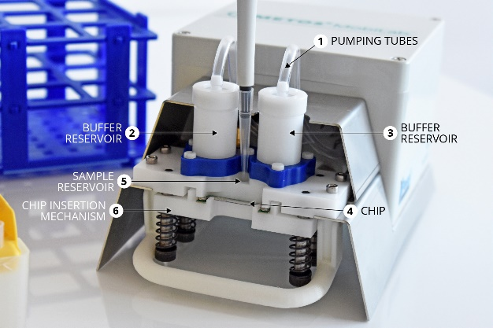

Reference:

- Smolka M, Ruttloff S, Nees D, Prietl C, Satzinger V, Lamprecht B, Hütter P, Hesse J, Kokkinis G, Kriechhammer G, Scheidl D, Wilfing B. High Throughput Roll-to-Roll Production of Microfluidic Chips. Proceedings. 2018; 2(13):1054.
- He, Kaiming, et al. "Deep residual learning for image recognition." ​Proceedings of the IEEE conference on computer vision and pattern recognition​, 2016.

Biography:
KOKKINIS G has been an associate researcher in the electronic materials research group of the NTUA, Athens, Greece then in the GREYC – Electronics research group of the University of Caen, France. He received his PhD in April 2016 by the Technische Universitaet Wien. His research interests are focused in the area of Microsystems for Lab-on-chip applications and sensor technology.

Presenting author details


Full Name: Georgios Kokkinis
Contact number: +4369917001457
Category: Oral presentation

