A SIMPLE MICROFLUIDICS-ASSISTED SYNTHESIS OF POLAR ZINC OXIDE MICROSPHERES

Najla Ghifari1,2, Adil Chahboun2, Abdel El Abed1,*
1Laboratoire Laboratoire de Photonique Quantique et Moléculaire, ENS Paris Saclay & CentraleSupélec, 61 Av. Président Wilson, 94235 Cachan, France, * abdel.el-abed@ens-paris-saclay.fr
2laboratoire Laboratoire des Couches Minces et Nanomatériaux, Faculté des Sciences et Techniques de Tanger,
Université Abdelmalek Essaadi, Tangier, Morocco

Keywords: Droplet-based microfluidics, ZnO microspheres.

- Abstract Body (up to 300 words)
In this work, we report a straightforward approach using a combined sol-gel droplet-based microfluidics technology to synthesize zinc oxide (ZnO) microcapsules. As the fabrication of metal oxides with high uniformity in size, composition, and morphology is challenging at the micrometer-scale because of the limitation of conventional methods to a nanometer range. We believe that our approach has proven to be simpler, powerful and promising technique for the synthesis of ZnO. Our approach is different from other techniques involving the addition of external parameters, such as an external electric field, deposition in high vacuum or the application of a frequency, etc. We demonstrated that this technique plays a crucial role in the synthesis of tunable zinc oxide microspheres. More importantly, it allows for a systematically manipulation and monitoring of droplets in real time, also allowing the production of highly monodisperse ZnO droplets in a reproducible manner at low temperature. The results showed that the produced ZnO droplets were organized in square lattice, highlighting the polar aspect of ZnO and thus in the liquid phase as shown in figure 1. In addition, the as-prepared ZnO particles using the microfluidic synthetic system exhibit a practically spherical shape and uniform size of 16.6 µm as shown in figure 2. Furthermore, the effect of charged ZnO microspheres was investigated by means of the Fluorescence Recovery After Photobleaching (FRAP) technique using two different fluorescent probes namely rhodamine B and fluorescein. We showed in this study that that the charge effect results on the aggregation of ZnO electrical charged nanocrystals. Since this II–VI n-type semiconductor has attracted intense interest due to its low-cost, unique electrical, optical and piezoelectric properties. Thus, for many applications including acoustics, sensing, electronics and photonics, etc. We anticipate therefore using this technique to produce highly efficient and low-cost ZnO coatings for photovoltaic applications.

Image:
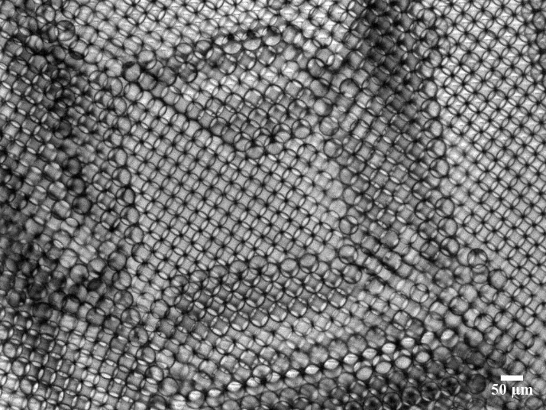
Figure 1: Optical microscopy image of ZnO droplets organized
in square lattice
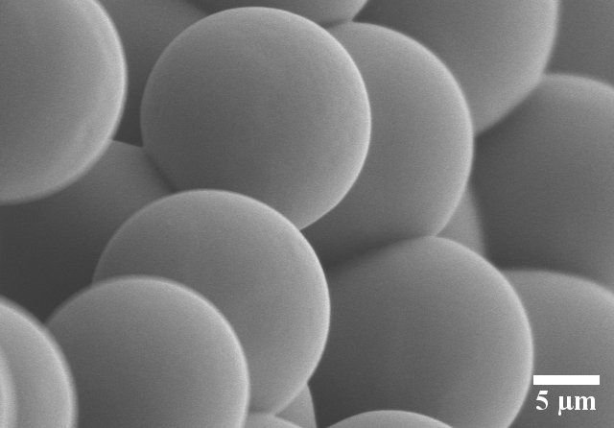
Figure 2: SEM photographs of the as-prepared ZnO
microspheres through sol-gel droplet based microfluidics

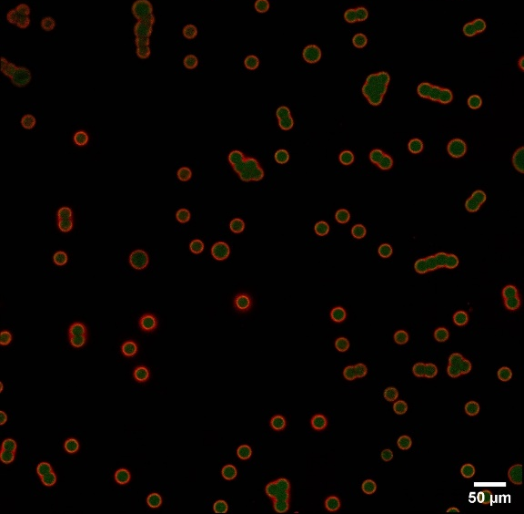
a
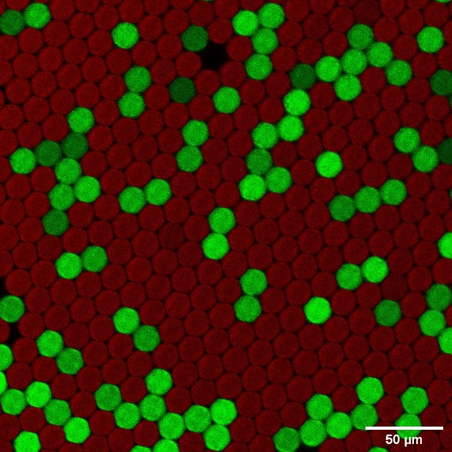
b

Biography:
Najla Ghifari is currently a PhD student in an international joint PhD programs, between Paris-Saclay University (France) and Abdelmalek Essaadi University (Morocco) in Electronics and Optoelectronics, Nano- and Microtechnologies. She has a great interest in scientific research and contributes significantly to the research community. She is conducting a research project on the development and characterization of microstructured surfaces based on microparticles and nanoparticles of oxides for photovoltaic applications. She is developing a simple approach to apply droplet-based microfluidic technology in order to fabricate and characterize microstructured surfaces of zinc oxide for photovoltaic technology.

Presenting author details

Full Name: Najla Ghifari
Contact number: +33755017769
Session name/ number: Droplet-based microfluidics
Category: Poster presentation
Passport Number: BZ7832539

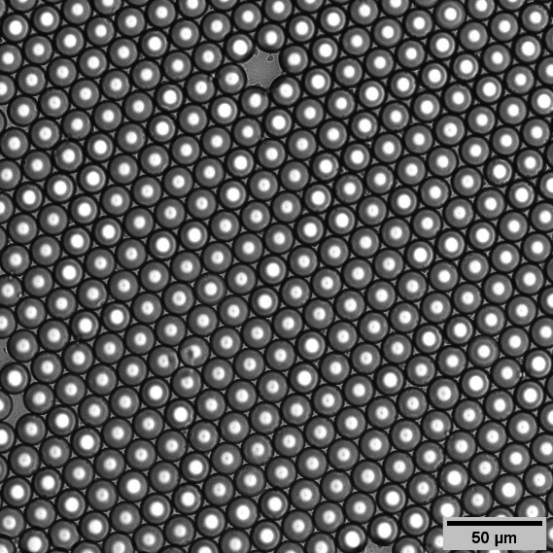
c

Figure 3: a,b) Confocal and c) bright field microscope images of
ZnO doped with rhodamine (red microspheres) and fluorescein
(green microspheres)

