Evaluation of Mixing Efficiency of Shear-thinning Fluid Through a Micromixer with Rectangular Baffles

Pir Khoshghiafeh R.1, Alizadeh Bayancholi T.² Sakkak Moghaddam P. 3, Zahedi Y.³, , Jafargholinejad S.^{3*}
1Department of Mechanical Engineering, University of Tabriz, Tabriz, Iran
2Turbo Teknoloji Research and Development Department, Istanbul, Turkey
3Department of Mechanical Engineering, Ardebil Branch, Islamic Azad University, Ardebil, Iran

Keywords: Micromixer, Shear Thinning Fluids, Rectangular Baffles

- Abstract
The present study investigated the effect of Power-law index on the mixing efficiency of a micromixer with rectangular baffles is investigated. Shear-thinning region are taken into account in numerical simulation.
It is found that decreasing the power-law index for shear-thinning fluids increases mixing efficiency of micromixer. The shear stress versus the channel length is shown in the figure. The shear stress peak values in this figure is related to channel region with rectangular baffles. It can be seen that the peak value of shear stress reduces for smaller power-law index.
Shear rate and accordingly apparent viscosity decreases with decreasing the power-law index and consequently cause to easily development of secondary flow near the baffles resulting in greater mixing performance.

Image:
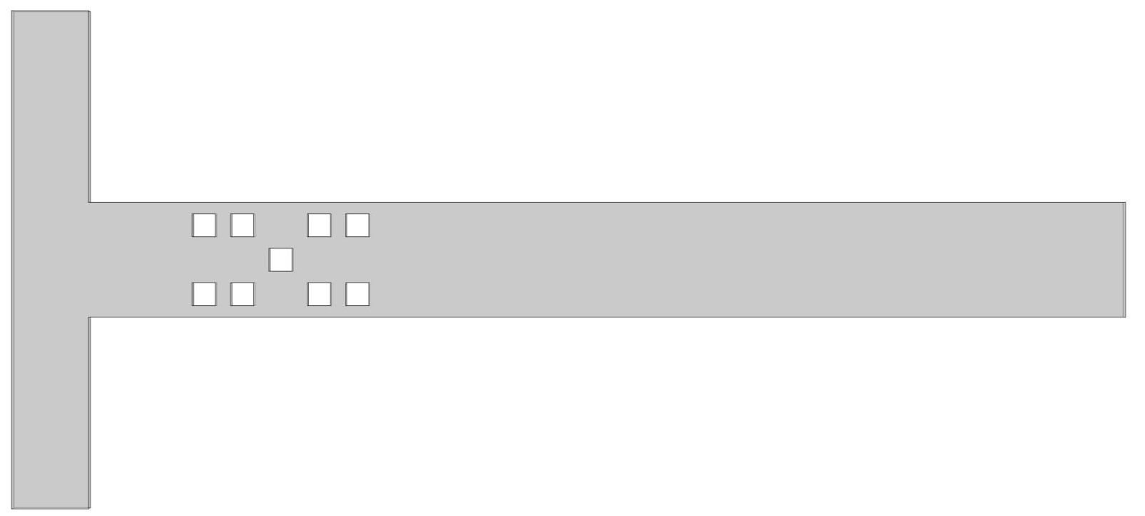
(a)
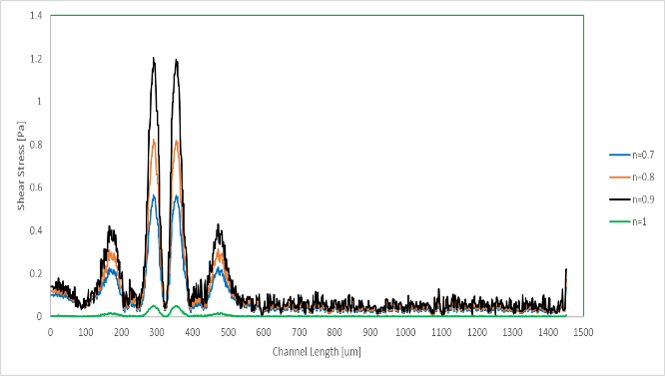
(b)
Figure (1): (a) Micromixer with baffles, (b) Shear stress vs. microchannel length.

- Reference:

1. Cho, C. C., Chen, C. L., & Chen, C. O. K. (2012). Mixing of non‐Newtonian fluids in wavy serpentine microchannel using electrokinetically driven flow. Electrophoresis, 33(5), 743-750.
- Hadigol, M., Nosrati, R., Nourbakhsh, A., & Raisee, M. (2011). Numerical study of electroosmotic micromixing of non-Newtonian fluids. Journal of Non-Newtonian Fluid Mechanics, 166(17-18), 965-971.
- Lam, Y. C., Gan, H. Y., Nguyen, N. T., & Lie, H. (2009). Micromixer based on viscoelastic flow instability at low Reynolds number. Biomicrofluidics, 3(1), 014106.
- Afzal, A., & Kim, K. Y. (2014). Flow and mixing analysis of non-Newtonian fluids in straight and serpentine microchannels. Chemical Engineering Science, 116, 263-274.
- Tran-Minh, N., & Karlsen, F. (2017, June). Computational fluid dynamics approach for modeling a non-Newtonian blood flow in a split and recombine micromixer. In International Conference on the Development of Biomedical Engineering in Vietnam (pp. 319-323). Springer, Singapore.

Biography:
Shapour Jafargholinejad has completed his PhD at the age of 35 years from Islamic Azad University, Iran. He is the leader of micro/nano Fluidic laboratory, located in faculty of engineering in Azad Universiry, Ardebil branch.

Presenting author details
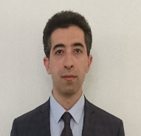
Full Name: Shapour Jafargholinejad
Contact number: +989144511632
Linked In account:
https://www.linkedin.com/in/shapour-jafargholinejad-aba85459/
Session name/ number: M
Category: (Oral presentation)
Passport Number: A34015556

