Abstract Template

Title: Microfluidic Preparation of Smart Emulsions and Functional Microparticles

Jianhong Xu, Professor PhD,
1 The State Key Lab of Chemical Engineering, Department of Chemical Engineering, Tsinghua University, Beijing 100084, China

Keywords: Microfluidic；Smart Emulsion

- Abstract Body (up to 300 words)
Droplet-based microfluidics has recently emerged as a new and promising area of science and technology in the last decades. Preparation of functional materials with microfluidics has attracted great interest from scientist and technologists with different backgrounds and occupations. This work will systematically introduce the recent progress in multiphase flow control in droplet-based microfluidics and preparation of smart emulsions and functional materials with microfluidics mainly by the authors’ research group. Controlled multiphase flow with different flow patterns by multiphase microfluidics will be introduced. They have been utilized in novel materials preparation of considerable fields such as optics, biomedicine, controlled porous material and drug release.

Image:
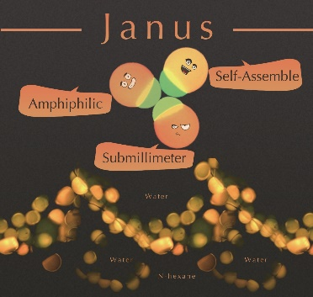
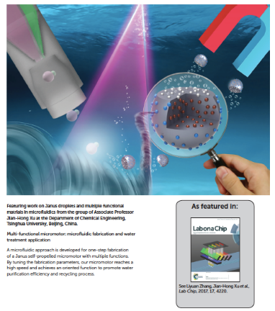

- Reference:

- 1 Anqi Chen, XueHui Ge, Jian Chen, Liyuan Zhang* and Jianhong Xu*. Multi-functional micromotor: Microfluidic fabrication and water treatment application. Lab Chip, 2017,17, 4220-4224
- Ge X H, Geng Y H, Zhang Q C, et al. Four reversible and reconfigurable structures for three-phase emulsions: extended morphologies and applications. Sci Rep, 2017, 7, 42738
- Ge X H, Huang J P, Xu J H, et al. Water-oil Janus emulsions: microfluidic synthesis and morphology design. Soft Matter, 2016, 12(14):3425-3430
- S-B. Zhang, X-H. Ge, Y-H. Geng, G-S. Luo, J. Chen, J-H. Xu, From Core-shell to Janus: Microfluidic Preparation and Morphology Transition of Gas/Oil/Water Emulsions, Chem Eng Sci, 2017, 172, 100-106
- Ge X H, Huang J P, Xu J H, et al. Controlled stimulation-bursttargeted release by smart decentered core-shell microcapsules in gravity and magnetic field. Lab Chip, 2014, 14(23): 4451-4454

Biography:
Dr. Jianhong XU received his B.Sc. and Ph.D. at Tsinghua University in 2002 and 2007 respectively. He continued his research in Tsinghua University as a postdoctor after graduation. He had studied as a visiting scholar at Prof. David Weitz lab in Harvard University during 2012.7~2013.6. At present, his research areas are focusing on the microstructured chemical system, multiphase microfluidic technology and functional materials synthesis. He has more than 100 peer-reviewed publications. He got the “Excellent Young Scientists Fund” from the National Natural Science Foundation of China (NSFC) in 2013. In 2016, he was awarded as Young Scholar of “Chang Jiang Scholars Program of China” of MOE. (Up to 100 words)

Presenting author details

Full Name:Jianhong XU
Contact number: +8610-62781490
Twitter account:
Linked In account:
Session name/ number: Droplet-Based Microfluidics
Category: Oral presentation/
Passport Number

