Lactic acid fermentation enriches the proﬁle of biogenic fatty acid derivatives of avocado fruit (Persea americana Mill.)
Ali Zein Alabiden Tlais, PhD, Free University of Bolzano, Italy

Abstract
Statement of the Problem: Avocado is rich in oil (15–30 g per 100 g), mainly consisting of monounsaturated fatty acids with oleic (the main fraction) linoleic, palmitoleic and linolenic acids in decreasing order of abundance. Its nutritional value is also associated with other nutrients, such as vitamins, minerals, dietary ﬁbre and phenolic compounds. Overall, a diet rich in avocado is associated to hypoglycemic, antihypertensive, antioxidant, anti-obesity, antimicrobial, and hepatic-protective eﬀects. One of the main constraints for consuming and marketing avocado fruits is the long-term storage. Approximately, 25% of the worldwide production is lost due to the high perishability of the fruit. Methodology & Theoretical Orientation: Developing new processing biotechnologies would increase the shelf life and enhance the nutritional value, thus disclosing new market and business opportunities. This study investigated the capability of selected autochthonous lactic acid bacteria to enrich the portfolio of bioactive compounds of avocado fruit (Persea americana Mill.), with the perspective of producing dietary supplements or pharmaceutical preparations. Findings: Fermented avocado puree resulted in high levels of total free amino acids. Fermentation also led to a marked increase of antioxidant activity, with the highest levels found in water and hexane soluble extracts. Bio-converted phenolic compounds and fatty acids derivatives resulting from bacterial metabolism were likely responsible for the increased antioxidant activity. Fermentation caused the fortiﬁcation of avocado puree with some hydroxy fatty acids, which deserved marked attention due to their health-promoting activities. Oleic and linoleicacids werehighly metabolized by Lactobacillus plantarum AVEF17, leading to high levels of mono, di-, and tri-hydroxy-octadecenoic acids. Conclusion & Significance: By using tailored lactic acid bacteria strains to the diverse plant environmental conditions, the development of novel fermented foods enriched in functional fatty acids derivatives is expected in the future.

Image
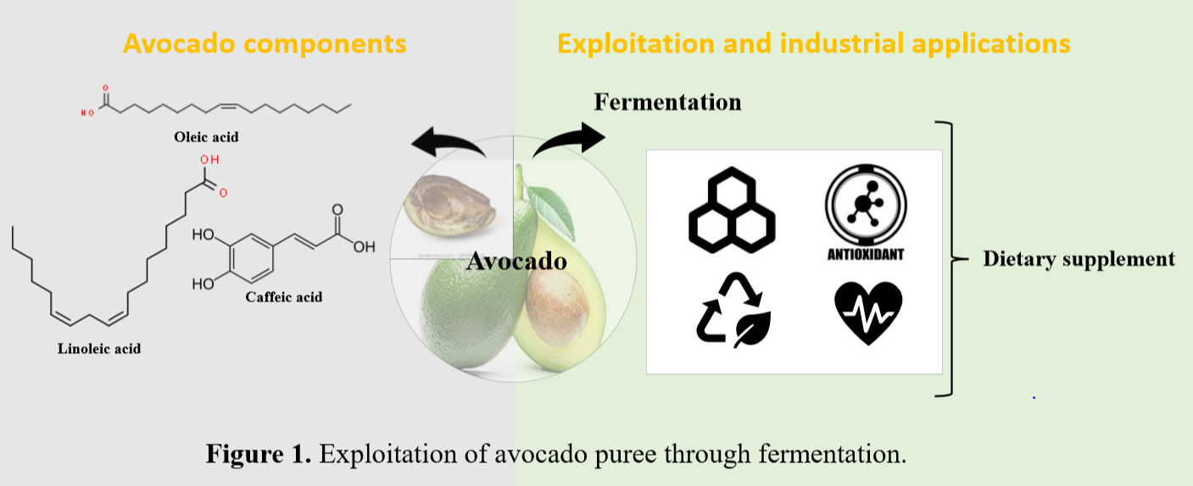
Recent Publications
- Filannino, P., Di Cagno, R., Tlais, A. Z. A., Cantatore, V., & Gobbetti, M. (2019). Fructose-rich niches traced the evolution of lactic acid bacteria toward fructophilic species. Critical reviews in microbiology, 45(1), 65-81.
- Filannino, P., Tlais, A. Z. A, Morozova, K., Cavoski, I., Scampicchio, M., Gobbetti, M., & Di Cagno, R. (2020). Lactic acid fermentation enriches the profile of biogenic fatty acid derivatives of Avocado fruit (Persea americana Mill.). Food Chemistry, 317, 126384.
- Tlais A. Z. A, Fiorino G.M., Polo A., Filannino P., Di Cagni R. (2020) High-Value Compounds in Fruit, Vegetable and Cereal Byproducts: An Overview of Potential Sustainable Reuse and Exploitation. Molecule, 25, 2987.

 Biography
Ali Zein Alabiden Tlais is PhD student at the Faculty of Science and Technology of the Free University of Bozen-Bolzano (UNIBZ) since 2017. The PhD is dedicated to the study of bioactive compounds metabolism during fermentation of fruits and vegetables. His main research activities, conducted over the last 3 years, are focused on culture dependent approach (isolation, DNA extraction and identification of yeast and lactic acid bacteria), culture independent approach (shotgun analysis), exploitation of microorganisms during fermentation and bioactive compounds quantification and characterization (polyphenols, fattyacids, proteins, dietary fibers and exopolysaccharides).Email:atlais@unibz.it

