Epigenetics for Precision Health & Performance
Dr. Mickra Hamilton
Apeiron Center for Human Potential, USA

Abstract
A precision, whole systems genomics approach to thriving health and wellbeing has enormous clinical applications in the emerging field of environmental epigenetics research. We can now look at all aspects of an individual’s life, their medical and family history, occupation, their lifestyle, the environments they function in, individual systems diagnostics and genetics along with real time markers from sensor and mobile data to provide precise lifestyle interventions to optimize and enhance gene expression. This new precision offers high specificity on health, tracks how individual choices affect health now and how that translates to the future. It also provides new insights about how we are interacting with our environment, in real time and in detail. The interplay of our genes and our experiences, of nature and how it interacts with nurture, has now moved from the mysterious to the knowable.

The Science of Epigenetics assists us to create precise optimization strategies by taking the reigns of gene expression to adapt and thrive under modern environmental pressures. Every decision we make contributes to this process in some way. The food we eat, the quality of sleep we experience, the cars we drive, the products we clean with and put on our skin, the thoughts we think, the levels of stress we carry and the chemicals and medications we dump into our water supply, all have an effect.

This discussion will detail the evidence-based use of precision epigenetics and genomics as strategies to mitigate the effects of environmental toxins in the human system. Additionally, we will discuss actionable lifestyle modifications and system support processes to fine tune and enhance our human experience as we interact with our environment.

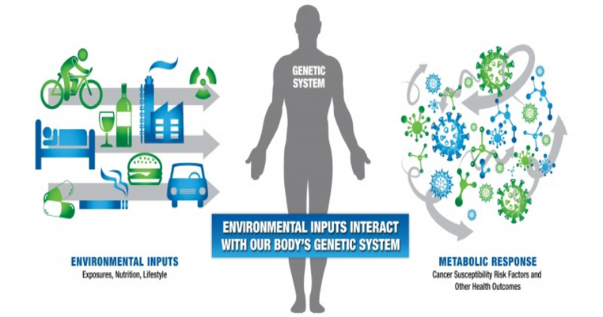
Human Systems Epigenetic Environmental Interaction
Recent Publications (minimum 5)
- Bollati V, Baccarelli A. Environmental epigenetics. Heredity (Edinb). 2010;105(1):105-12.
- Marsit CJ. Influence of environmental exposure on human epigenetic regulation. J Exp Biol. 2015;218(Pt 1):71-9.
- Brieño-enríquez MA, García-lópez J, Cárdenas DB, et al. Exposure to endocrine disruptor induces transgenerational epigenetic deregulation of microRNAs in primordial germ cells. PLoS ONE. 2015;10(4):e0124296.
- Stein RA. Epigenetics and environmental exposures. J Epidemiol Community Health. 2012;66(1):8-13.
- Baccarelli A, Bollati V. Epigenetics and environmental chemicals. Curr Opin Pediatr. 2009;21(2):243-51.
- Meeker JD, Sathyanarayana S, Swan SH. Phthalates and other additives in plastics: human exposure and associated health outcomes. Philos Trans R Soc Lond, B, Biol Sci. 2009;364(1526):2097-113.
- Fénichel P, Chevalier N. Environmental endocrine disruptors: New diabetogens?. C R Biol. 2017;340(9-10):446-452.

 Biography
Dr. Mickra Hamilton is Co-Founder and CEO of Apeiron Center for Human Potential/Apeiron Academy, and a Colonel and Human Performance Subject Matter Expert in the United States Air Force Reserves. She is a Master Coach and creative disruptor in the field of Epigenetic Human Potential Coaching creating a new paradigm for what is possible for human health and well-being. Dr. Hamilton skillfully works with the individual DNA blueprint to optimize human performance through epigenetic lifestyle genomics. This precision, evidence-based approach addresses the physiological, emotional, mental, and energetic aspects of the “human system.” Dr. Hamilton knows that thriving health is the very scaffolding of a life well lived and the beginning of a remarkable journey into the realms of limitless human potential. This new paradigm for living focuses on the science of epigenetics to move beyond health and wellbeing into all possibilities. This precision, whole systems approach optimizes and enhances all aspects of the human experience that encompasses us as individuals, how we interact with our environment both internally and externally and how this impacts the collective environment.

Email: drhamilton@apeironcenter.com

Notes/Comments

