Title: Outbreak of Guillain Barre Syndrome (GBS) in a Northern District of Bangladesh, 2018
Authors: Dr. Sohel Raman¹, Dr. Monalisa¹, Dr. Tanzila Naureen¹, Dr. M H K Jony¹, Dr. Mallick Masum Billah², Prof Tahmina Shirin¹ Prof. M S Flora¹.
Affiliations: ¹Institute of Epidemiology Disease Control and Research (IEDCR) ²TEPHINET Secretariat, A program of The Task Force for Global Health.

Key words: Guillain Barre Syndrome (GBS), Campylobacter, Outbreak, Bangladesh.

Guillain-Barre-Syndrome (GBS) is an acute autoimmune disease with 5-7% case fatality ratio (CFR). Neuromuscular respiratory failure is a poor prognostic factor in GBS usually develops 17-30% cases. In November 2018, six patients with GBS were reported from a district of northern Bangladesh. We investigated the event to identify causative agent. We identified GBS patients through passive surveillance from 1st September to 15th November, 2018 and diagnosis made by a registered physician. We interviewed cases and conducted verbal autopsies of deceased to collect demographic, clinical information, and exposure history (water and food). Enzyme-linked Immunosorbent Assay (ELISA) for campylobacter and molecular testing of dengue, zika and chikungunya were done in collected blood samples. Stool samples were tested for poliovirus. Five death were found out of 13 reported GBS cases (CFR 38%). Median age was 30 years (range 03-55 years) and 67% were male. Clinical findings included areflexia (100%), bulbar palsy (77%), respiratory muscle paralysis (61%), symmetrical ascending paralysis (54%), and autonomic disturbance (38%). Respiratory muscle paralysis was reported within a median 38 hours (8-120 hours) of illness onset. Although samples of dead cases were not available, ELISA confirmed presence of Campylobacter spp. in 42% (n=7) of cases. Molecular test for dengue, zika and chikungunya were negative. Stool samples were negative for poliovirus. This outbreak of GBS was likely due to Campylobacter spp. Rapid respiratory paralysis contributed to high mortality in this outbreak. Early identification of Campylobacter spp. associated GBS was recommended to take quick measures against respiratory paralysis to decrease case fatality.

- Image

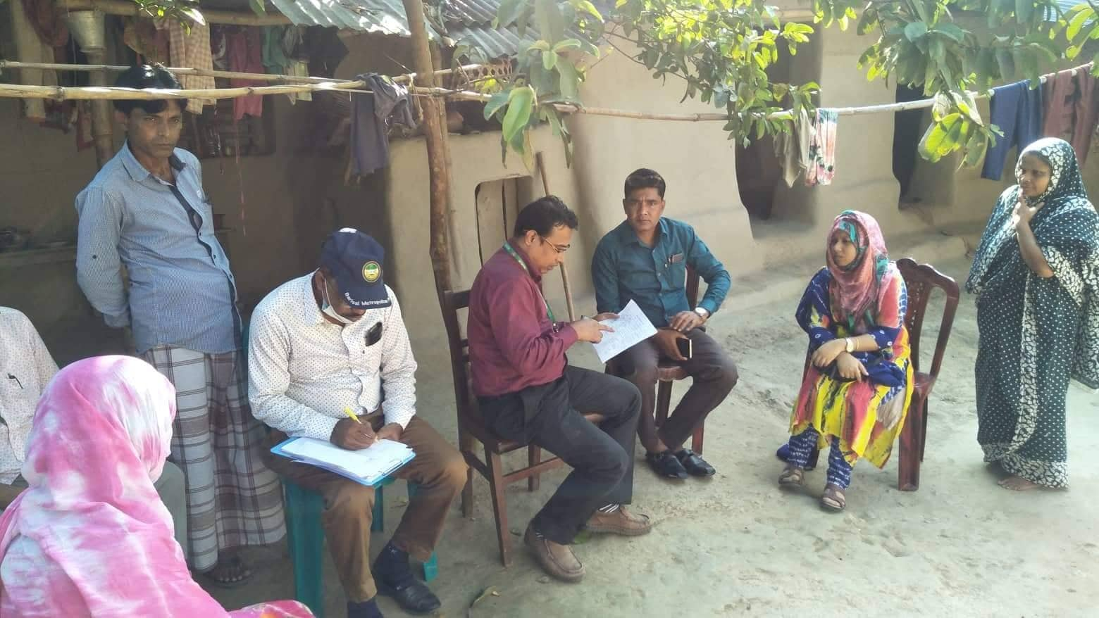

III. Reference
- Ishaque, T., B. Islam, M., Ara, G., Endtz, H., D. Mohammad, Q., Jacobs, B., & Islam, Z. (2017). High mortality from Guillain-Barré syndrome in Bangladesh: GBS mortality in Bangladesh. Journal of the Peripheral Nervous System, 22. https://doi.org/10.1111/jns.12215
- Sharshar, T., Chevret, S., Bourdain, F., Raphaël, J.-C., & French Cooperative Group on Plasma Exchange in Guillain-Barré Syndrome. (2003). Early predictors of mechanical ventilation in Guillain-Barré syndrome. Critical Care Medicine, 31(1), 278–283. https://doi.org/10.1097/00003246-200301000-00044
- Islam, Z., Gilbert, M., Mohammad, Q. D., Klaij, K., Li, J., Rijs, W. van, Jacobs, B. C. (2012). Guillain-Barré Syndrome-Related Campylobacter jejuni in Bangladesh: Ganglioside Mimicry and Cross-Reactive Antibodies. PLOS ONE, 7(8), e43976. https://doi.org/10.1371/journal.pone.0043976
- Garg M. (2017). Respiratory Involvement in Guillain-Barre Syndrome: The Uncharted Road to Recovery. Journal of neurosciences in rural practice, 8(3), 325–326. doi:10.4103/jnrp.jnrp_96_17R1
- J. Kalita, A. Ranjan, U.K. Misra, Outcome of Guillain–Barre syndrome patients with respiratory paralysis, QJM: An International Journal of Medicine, Volume 109, Issue 5, May 2016, Pages 319–323, https://doi.org/10.1093/qjmed/hcv190
6 Islam, Z., Papri, N., Ara, G., Ishaque, T., Alam, A. U., Jahan, I., Mohammad, Q. D. (2019). Risk factors for respiratory failure in Guillain‐Barré syndrome in Bangladesh: a prospective study. Annals of Clinical and Translational Neurology, 6(2), 324–332. https://doi.org/10.1002/acn3.706
- Islam, Z., Jacobs, B. C., Islam, M. B., Mohammad, Q. D., Diorditsa, S., & Endtz, H. P. (2011). High Incidence of Guillain-Barré Syndrome in Children, Bangladesh. Emerging Infectious Diseases, 17(7), 1317–1318. https://doi.org/10.3201/eid1707.101999
- Islam, Z., Gilbert, M., Mohammad, Q. D., Klaij, K., Li, J., Rijs, W. van, Jacobs, B. C. (2012). Guillain-Barré Syndrome-Related Campylobacter jejuni in Bangladesh: Ganglioside Mimicry and Cross-Reactive Antibodies. PLOS ONE, 7(8), e43976. https://doi.org/10.1371/journal.pone.0043976

Iv. Biography:
Dr Sohel Rahman has completed his MPH at the age of 27 years from National Institute of Preventive and Social Medicine (NIPSOM) under Bangabandhu Sheikh Mujib Medical University (BSMMU).He also obtained MSc in Disaster Management and MSc in Applied Epidemiology from University of Dhaka. He is going to be a graduate of Field Epidemiology Training Program (FETP,B) conducted by US-CDC. He is serving govt. of Bangladesh and Ministry of Health (MoH&FW) science 2014. Now he is working at Institute of Epidemiology Disease Control and Research (IEDCR) as a member of outbreak investigation team.

V. Presenting author details


Full Name: Dr Sohel Rahman
Contact number: +8801555009903
Twitter account: https://twitter.com/ drsohel33
Linked In account: https://www.linkedin.Com/in/sohel-rahman-0501224b
Session name/ number: Epidemiology and Health Care
Category: Oral presentation
Passport Number: BX0426056

