Abstract

Title: Development of Food frequency questionnaire to study association between dietary patterns across pregnancy and fetal growth – A hospital based prospective cohort study

Neera Parmar¹, Dr. Shinjini Bhatnagar¹, Dr. Uma Chandra Mouli Natchu², Dr. Nitya Wadhwa¹, Dr. Ramachandran T¹

¹Pediatric Biology Center, Translational health science & technology Institute, Faridabad, Haryana, India
² Division of Infectious disease, St. John’s research institute, Bangalore, Karnataka, India

Keywords: Food frequency questionnaire, 24 hour dietary recall, dietary patterns, market survey

- Abstract Body
This study deals with the methodological development and standardization of a semi quantitative food frequency questionnaire (FFQ) for pregnant women. This FFQ is based on two 24-hour dietary recall of 100 subjects visiting the antenatal clinic of Gurugram Civil Hospital, which is situated in a semi urban district of Haryana (Gurugram), India. The final FFQ evolved through focused group discussions based on 24 -hour dietary recall provided by the subjects as well as market survey to validate the availability of seasonal fruits and vegetables. This final list of 199 food and beverage items was further ratified by the domain experts. Given that the population for the purpose of research is mixed migrant low-income group from various parts of India, this FFQ uniquely attempts to create a true representative questionnaire. A validated FFQ is important for assessment of dietary patterns and nutrient intake for pregnant women because demands for macro & micronutrients increase during pregnancy but vary during each trimester. This FFQ would finally contribute to establishing a relationship between dietary patterns and birth outcomes for the given population. Which, in turn will allow healthcare practitioners to prescribe appropriate dietary intake for future pregnancies. What has largely been observed for the women interviewed so far, a third of their dietary intake consists of green leafy/other vegetables (30.11%), around a fourth consisted of processed food (22.15%). They least consumed egg, fish and meat (3.40%) followed by dairy products (7.95%). This FFQ will now be administered to pregnant women visiting the antenatal clinic at each trimester to capture trimester specific dietary intake.

- Image:
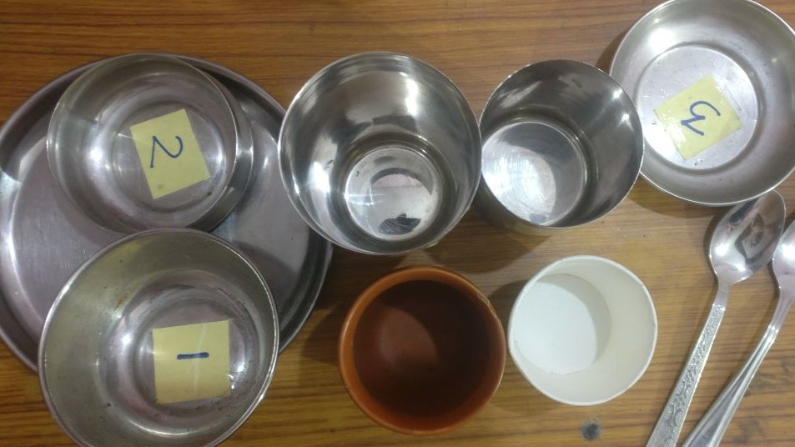

- Reference:
- Jayawardena, R., Swaminathan, S., Byrne, N. M., Soares, M. J., Katulanda, P., & Hills, A. P. (2012). Development of a food frequency questionnaire for Sri Lankan adults. Nutrition journal, 11, 63. doi:10.1186/1475-2891-11-63
- Dwarkanath, P., Soares, M. J., Thomas, T., Vaz, M., Swaminathan, S., & Kurpad, A. V. (2014). Food Frequency Questionnaire Is a Valid Tool for the Assessment of Dietary Habits of South Indian Pregnant Women. Asia Pacific Journal of Public Health, 26(5), 494–50
- Neelakantan, N.; Whitton, C.; Seah, S.; Koh, H.; Rebello, S.A.; Lim, J.Y.; Chen, S.; Chan, M.F.; Chew, L.; Van Dam, R.M. (2014). Development of a Semi-Quantitative Food Frequency Questionnaire to Assess the Dietary Intake of a Multi-Ethnic Urban Asian Population. Nutrients 8, 528.
- Biography:
Neera Parmar is pursuing her PhD from Translational health science & technology institute (THSTI), Haryana, India in the area of maternal & child health. She has earned her masters in foods & nutrition from Chaudhary Charan Singh Haryana Agricultural University (CCSHAU), Haryana, India. She has also served as an assistant professor in the department of nutritional biology in Central university of Haryana and as an academic consultant to nutrition post graduate students in Indira Gandhi National Open University (IGNOU), Delhi, India

- Presenting author details

Full Name: Neera Parmar
Contact number: 91-858-6077-974
Twitter account: @neera_parmar
Linked In account: Neeraparmar20
Session name/ number: Nutritional epidemiology
Category: (Poster presentation)
Passport Number: Z4217559

